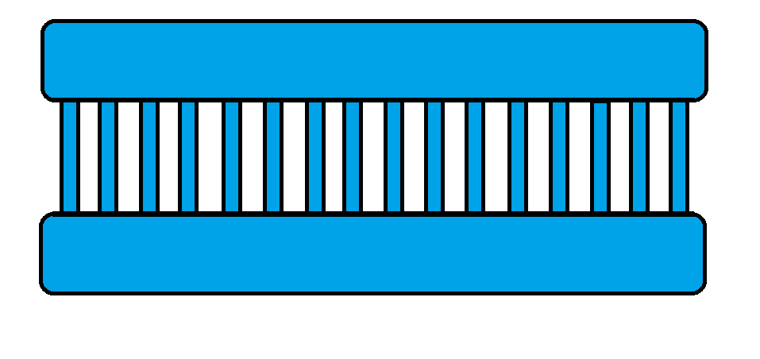

Cancer DNA Template
Original DNA Strand


Primer
Taq DNA polymerase
Taq DNA polymerase
Primer
Original DNA Strand

Original DNA Strand
New Strand
New Strand
Original DNA Strand

