GFP production by transcription

${\dot{p}}_{G}=s_{G}-d_{G}p_{G}$

$\frac{k_{T}k_{TO}}{d_{TO}}$
function p_gprime = fp_gprime(t,p_g)
% GFP prodn

s_g = 1.5; % prodn rate of GFP by transcription
d_g = 0.1; % deg rate of GFP

p_gprime = s_g - d_g*p_g;
end

ODE:

t=0:0.1:60; % time span of simulation
[t,p] = ode45(@fp_gprime,t,0);
% calling the function

figure
plot(t,p(:,1))

Production of split GFP
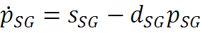

function p_sgprime = fp_sgprime(t,p_sg)
% split GFP prodn

s_sg = 1; % prodn rate of split GFP by transcription
d_sg = 1; % deg rate of split GFP

p_sgprime = s_sg - d_sg*p_sg;
end

Production of TEV and fused GFP
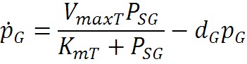
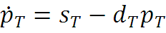

function p_gtevprime = fp_gtevprime(t,p)
% fused split TEV prodn

s_t = 2; % prodn rate of TEV by transcription
d_t = 0.1; % deg rate of TEV

s_sg = 1; % prodn rate of split GFP by transcription
d_sg = 0.1; % deg rate of split GFP

d_gs = 0.1; % deg rate of fused split GFPs
k_ts = 5; % kcat for prodn of fused split TEVs catalysed by TEV
km_ts = 1; % km for prodn of fused split TEVs catalysed by TEV

p_gtevprime = zeros(3,1);

p_gtevprime(1) = s_t - d_t*p(1); % p_t = p (1)
p_gtevprime(2) = s_sg - d_sg*p(2); % p_sg = p (2)
p_gtevprime(3) = ((k_ts * p(1) * p(2)) / (km_ts + p(2))) - d_gs*p(3) ;
% p_gs = p (3)

end

ODE:

t=0:0.1:60; % time span of simulation
[t,p] = ode45(@fp_gtevprime,t,[0 3 0]);
% calling the function

figure
subplot(3,1,1), plot(t,p(:,1))
title('Production of TEV')
subplot(3,1,2), plot(t,p(:,2))
title('Production of split GFP')
subplot(3,1,3), plot(t,p(:,3))
title('Production of GFP')

Production of GFP from both TEV and fused split TEVs
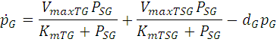
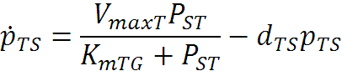

function p_gprime = fp_stevsgprime(t,p_g)
% GFP prodn

s_t = 2; % prodn rate of TEV by transcription
d_t = 0.1; % deg rate of TEV

s_st = 0.8; % prodn rate of split TEV by transcription
d_st = 0.1; % deg rate of split TEV

d_ts = 0.1; % deg rate of fused split TEVs
k_ts =10; % kcat for prodn of fused split TEVs catalysed by TEV
km_ts = 1; % km for prodn of fused split TEVs catalysed by TEV

s_sg = 0.8; % prodn rate of split GFP by transcription
d_sg = 0.1; % deg rate of split GFP

d_g = 0.1; % deg rate of GFP
k_tg = 10; % kcat for prodn of GFP catalysed by TEV
km_tg = 1; % km for prodn of GFP catalysed by TEV
k_tsg = 0.4*k_tg; % kcat for prodn of GFP catalysed by fused split TEV
km_tsg = 1; % kcat for prodn of GFP catalysed by fused split TEV

p_gprime = zeros(5,1);

p_gprime(1) = s_t - d_t*p_g(1); % p_t = p_g(1)
p_gprime(2) = s_st - d_st*p_g(2); % p_st = p_g(2)
p_gprime(3) = ((k_ts * p_g(1) * p_g(2)) / (km_ts + p_g(2))) - d_ts*p_g(3);
% p_ts = p_g(3)
p_gprime(4) = s_sg - d_sg*p_g(4); % p_sg = p_g(4)
p_gprime(5) = ((k_tg * p_g(1) * p_g(4)) / (km_tg + p_g(4))) + ((k_tsg * p_g(3) * p_g(4)) / (km_tsg + p_g(4))) - d_g*p_g(5) ;
% p_g = p_g(5)
end

ODE:
t=0:0.1:60;

[t,p] = ode45(@fp_stevsgprime,t, [0 3 0 6 0]);

figure

subplot(3,2,1), plot(t,p(:,1))
title('Production of TEV')
subplot(3,2,2), plot(t,p(:,2))
title('Production of split TEV')
subplot(3,2,3), plot(t,p(:,3))
title('Production of fused split TEVs')
subplot(3,2,4), plot(t,p(:,4))
title('Production of split GFP')
subplot(3,2,5), plot(t,p(:,5))
title('Production of GFP')

Production of HIV to activate split TEV which further activates split GFP

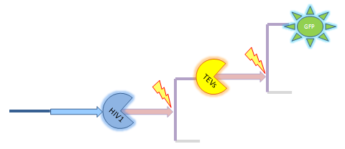
function p_gprime = fp_htgprime(t,p_g)
% HIV1->sTEV->sGFP

s_h = 2; % prodn rate of HIV1 by transcription
d_h = 0.1; % deg rate of HIV1

s_st = 0.8; % prodn rate of split TEV by transcription
d_st = 0.1; % deg rate of split TEV

d_ts = 0.1; % deg rate of fused split TEVs
k_hs =10; % kcat for prodn of fused split TEVs catalysed by HIV1
km_ht = 1; % km for prodn of fused split TEVs catalysed by TEV

s_sg = 0.8; % prodn rate of split GFP by transcription
d_sg = 0.1; % deg rate of split GFP

d_g = 0.1; % deg rate of GFP
k_tg = 10; % kcat for prodn of GFP catalysed by TEV
k_tsg = 0.4*k_tg; % kcat for prodn of GFP catalysed by fused split TEV
km_tsg = 1; % kcat for prodn of GFP catalysed by fused split TEV

p_gprime = zeros(5,1);

p_gprime(1) = s_h - d_h*p_g(1); % p_h = p_g(1)
p_gprime(2) = s_st - d_st*p_g(2); % p_st = p_g(2)
p_gprime(3) = ((k_hs * p_g(1) * p_g(2)) / (km_ht + p_g(2))) - d_ts*p_g(3) ;
% p_ts = p_g(3)
p_gprime(4) = s_sg - d_sg*p_g(4); % p_sg = p_g(4)
p_gprime(5) = ((k_tsg * p_g(3) * p_g(4)) / (km_tsg + p_g(4))) - d_g*p_g(5) ;
% p_g = p_g(5)
end

ODE:
t=0:0.1:60;

[t,p] = ode45(@fp_htgprime,t, [0 3 0 6 0]);

figure

subplot(3,2,1), plot(t,p(:,1))
title('Production of HIV1')
subplot(3,2,2), plot(t,p(:,2))
title('Production of split TEV')
subplot(3,2,3), plot(t,p(:,3))
title('Production of fused split TEVs')
subplot(3,2,4), plot(t,p(:,4))
title('Production of split GFP')
subplot(3,2,5), plot(t,p(:,5))
title('Production of GFP')

