Nick Broadbent
Kelsey Lees
Tami Reuter
Recombinant DNA Technique
Fall 2009

Project Proposal

Our objective is to construct a system containing the Fragaria x ananassa quinone oxireductase gene (FaQR) gene that is testable through a green fluorescent protein (GFP) marker. Our second objective is to create a system containing the Strawberry alcohol acyltransferase gene (SAAT) testable through scent or gas chromatography.
Strawberry scent is a combination of linalool, nerolidol, 4-hydroxy-2,5-dimethyl-3(2H)-furanone (HDMF) and other terpenes. FaQR synthesizes HDMF from 4-hydroxy-5-monomethyl-2-methylene-3(2H)-furanone (HMMF) (Figure 1). HMMF is produced biochemically from d-fructose-1,6-diphosphate. The biochemical pathway is unknown, therefore HMMF is not available.
SAAT causes the formation of fruity esters. It completes a transacylation from acyl-CoA to alcohols. FaQR experiments will be completed before SAAT.
The FaQR (DNA accession number AY158836; mRNA accession number AY048861) and the strawberry alcohol acyltransferase gene (SAAT; mRNA accession number AF193789) will be used. The following biobricks will be used: a tetracycline repressible promotor (BBa_R0040), an inducible pBad/araC promotor (BBa_I0500) and a green fluorescent protein (BBa_E0040).
DNA will be extracted from Fragaria x ananassa (Weston) Duchesne ex Rozier tissue (fruit or leaves) using protocol from Mercado et al (1999). The FaQR gene region will be amplified through a polymerase chain reaction (PCR) using template jump PCR to remove introns or will be amplified using mRNA utilizing the protocols of Kiefer et al (2008). The mRNA PCR products will be made into DNA using reverse transcriptase. PCR DNA products will be run an agarose gel. Bands will be cut out of the gel and purified. FaQR will be fused in between a tetracycline promotor and GFP (figure 2), then put into a plasmid and used as a vector for E. coli. The system will be tested through use of the GFP region. Fluorescence will be detectable after 8 minutes.
If time permits, SAAT will be analyzed. The SAAT region will be amplified using mRNA, as the only available sequence is mRNA. The PCR product will be made into DNA using reverse transcriptase, run on a gel and purified. Two promotors will be used with SAAT: a tetracycline and an arabinose. The gene will be inserted into a plasmid, then into E. coli. The bacteria will be grown in gradient mediums containing the specific promotors inducer and Acyl-CoA.
The SAAT experiments will be tested using scent. Twenty-five individuals will smell the plates. If the majority of individuals smell strawberries, the experiment will be considered a success. Experiments will also be tested using gas chromatography.
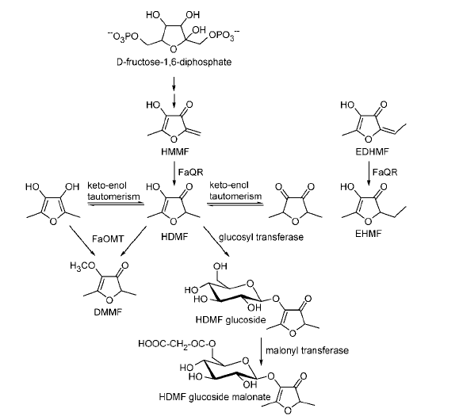
Figure 1. Transformation from HMMF to HDMF via the FaQR pathway.

Figure 2. Device: Fusion of a tetracycline repressible promotor, FaQR and GFP.

REFERENCES
Aharoni, A., A.P. Giri, F.W.A. Verstappen, C.M. Bertea, R. Sevenier, Z. Sun, M.A
Jongsma,W. Schwab, and H.J. Bouwmeester. Gain and Loss of Fruit Flavor
Compounds Produced by Wild and Cultivated Strawberry Species. The Plant
Cell 16: 3110-3131.

Elowitz, M.B. and S. Leibler. 2000. A Synthetic Oscillatory Network of
Transcriptional Regulators. Letters to Nature 403: 335-338.

Kiefer, E., W. Heller and D. Ernst. 2008. A Simple and Efficient Protocol for Isolation
of Functional RNA from Plant Tissues Rich in Secondary Metabolites. Plant
Molecular Biology Reporter 18(1): 33-39.

Klein, D., B. Fink, B. Arold, W. Eisenreich, and W. Schwab. 2007. Functional
Characterization of Enone Reductases from Strawberry and Tomato Fruit.
Journal of Agricultural and Food Chemistry 55: 6705-6711.

Mercado, J., I. el Mansouri, S. Jimenez-Bermudez, F. Pliego-Alfaro and M.A. Quesada.
1999. A Convenient Protocol for Extraction and Purification of DNA from
Fragaria. In Vitro Cellular Developmental Biology: Plant 35: 152-153.

Raab, R., J.A. Lopez-Raez, R. Klein, J.L. Caballero, E. Moyano, W. Schwab, and J.
Munoz-Blanco. FaQR, Required for the Biosynthesis of the Strawberry Flavor
Compound 4-Hydroxy-2,5-Dimethyl-3(2H)-Furanone, Encodes an Enone
Oxidoreductase. The Plant Cell 18:1023-1037.

