Introduction
Kinesin is a motor protein that is able to transport cargo through its processive stepping process on microtubules. They are essential to many cellular processes such as cell reproduction and axonal transport. A technique that has proven very valuable to studying kinesin’s physical properties is called a gliding motility assay. In this experiment, the kinesin’s tail is fixed to a slide with their motor domains sticking into the solution. Microtubules are then added to the solution. This allows the microtubules to basically crowd surf along the kinesin motor domains as seen in the illustration to the right. The microtubules are labeled with a fluorphore which allows them to be seen through fluorescence microscopy. This experiment allows the study of many kinesin kinetic properties such as velocity, microtubule polarity, and force induction in the kinetic process.
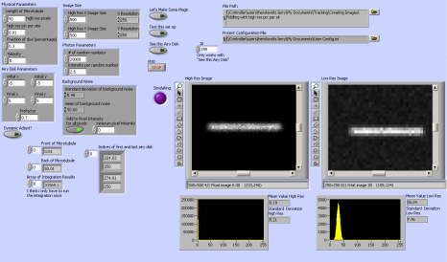
To extract information from these experiments, it is often imperative to track the moving microtubules through a series of images. However, manual tracking means going through hundreds of images and recording the position of the microtubule by hand. This can be an extremely slow and exhausting process. The data acquired is also prone to large experimenter error. Because of this tracking software has been written. To test the effectiveness of these tracking programs, many laboratories will track a stationary object. This however is not ideal since it does not match experimental conditions well. To see the noise from data acquired in the tracking algorithms, it is best to test the program on a moving object. It is impossible to know the exact positions of a real object. That is why simulating the images of a microtubule is necessary. For this purpose I have wrote a program that can imitate images that are captured from a gliding motility assay through a microscope.
This program was written in National Instruments Labview 7.1. The user interface can be seen in the accompanying figure. In this paper I will describe the algorithm used to produce the simulated images, the user controls, as well as how this information is saved.
Algorithm
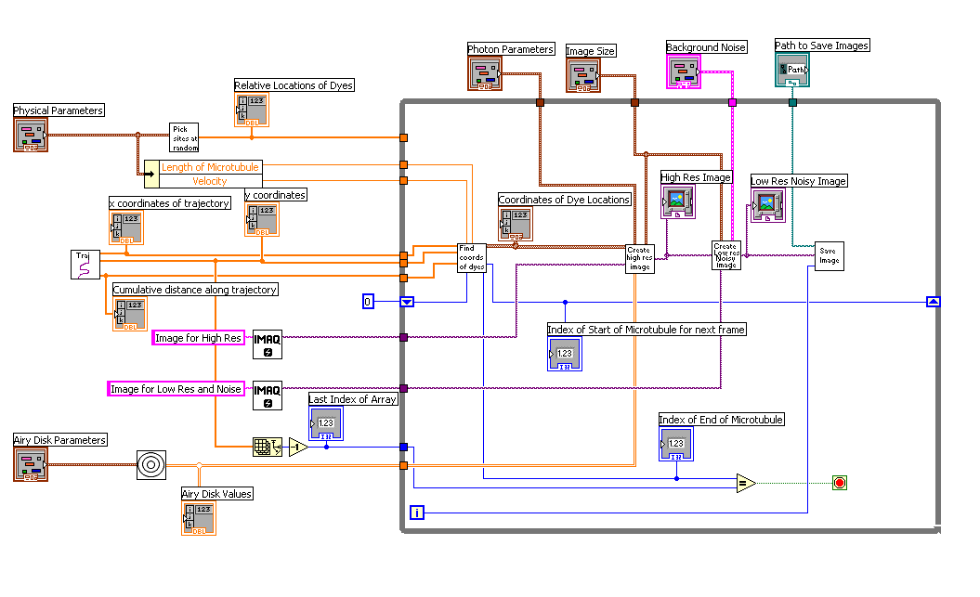
Seen here is a simplified diagram of this algorithm. This paper will go into detail of how this algorithm works. There is a main while loop seen in the diagram as the box on the right. In this while loop a frame is constructed and saved in each iteration. Before the while loop can be started, the software completes three tasks which is represented here as sub.vis. A sub.vi in Labview is similar to a function in C++. The user must create the trajectory the microtubule will follow throughout the images that will be created. This is done in the trajectory sub.vi. Using the user inputs in the “Physical Parameters” control the program can randomly select where the locations of the dyes will be placed along the microtubule length. The third task is to create a prototype Airy Disk from the “Airy Disk Parameters.” Each one of these sub.vis are completed only once for each set of images.
Inside of the while loop, the trajectory is loaded in the first sub.vi along with the index of the start of the microtubule, velocity, and length of the microtubule. This sub.vi has three outputs: “Coordinates of Dye Locations”, the “Index of Start of Microtubule for next frame,” and the “Index of End of Microtubule.” The dye location coordinates is what allows the microtubule image to be constructed. These are absolute coordinates in the image along the trajectory instead of the relative coordinates with respect to the microtubule length that the “Pick sites at random” sub.vi outputs. The second output goes into a shift register and replaces the previous iteration’s index for the start of the microtubule. The distance change which is calculated from the velocity is used inside of this sub.vi to calculate the next start index. The index of the end of the microtubule is calculated using the length of the microtubule value. When the end of the microtubule index has reached the end of the trajectory array, the while loop stops.
When this sub.vi finishes, the next one starts. “Create high res image” takes in the coordinates of the dye locations, a pointer to an image location and the user inputs “Photon Parameters” and “Image Size.” Inside this .vi are the probability distribution function and the Monte Carlo algorithm to randomly select the photon locations.
“Create low res noisy image” sub.vi takes in “Image Size,” “Background Noise” and the “High Res Image.” It then resamples the high resolution image to create a lower resolution image based on the user input. Then noise is added to the background. The output of this sub.vi is the final image.
This image is then saved in a directory the user has chosen, and named after the frame number which is the iteration number.
This paper will be broken up into four sections: Microtubule Construction, Resampling and Noise Addition, Trajectory, and Saving. In each of these sections the necessary user input is highlighted as well as a simplified version of the code used to construct each pertinent area.
Microtubule Construction
User Input:
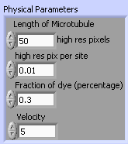
The user can set the microtubule length via the “Length of Microtubule” control. This control is in units of high resolution pixels. The high resolution and low resolution image will be explained in more detail in the Resampling and Noise Addition section below. The “high res pix per site” control dictates how many possibly fluorescent dyes are theoretically possible to be found in each pixel. For a microtubule, the dyes attach to BLAH (PROTOFILMANET I THINK), and there are x blahs/nm. This control will change depending on the users desired nm/pixel ratio.
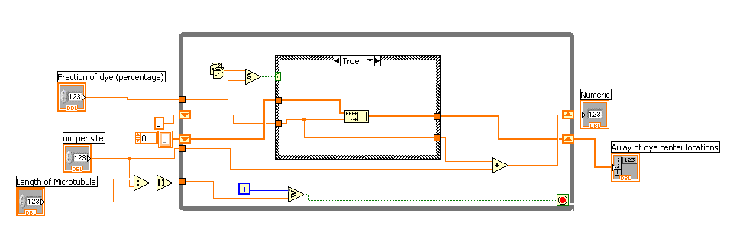
The program now has how long the microtubule is and the maximum number of dyes that can be possibly attached to the object. In the example above there can be a maximum of 5,000 dyes. For each possibly one of the possible 5,000 sites of fluorescent labeling, the program uses a Monte Carlo method to determine if that site will be labeled. This is dependent on the fraction of dye control. A random number is selected for each site. If that random number is lower than the fraction, the site is labeled. If not the site is left alone. This code can be seen in the figure to the right.
If the site is selected to be labeled, an airy disk is centered at that location. An airy disk represents the fluorescent dye since the dye emits light that is captured by the circular aperture of the objective. With this set up a point source, the dye, appears as an airy disk. Mathematically an airy disk is described with the following equation:
$$I\left(r\right)=I_{0}(\frac{2J_{1}\left(kr\right)}{kr})$$
where $I_{0}$ is the maximum intensity of the airy disk center, $J_{1}(kr)$ is the Bessel function of the first kind in circular coordinates, r is the radius, and k is what I call the prefactor. It is the wavenumber times the radius of the aperture. It is the connection between the resolution of the real life objective and the simulated resolution.
Each airy disk is kept track with how far from the end of the microtubule it is. So when the microtubule is in motion and the object is curving, the airy disk location remains in their relative locations. Since the microtubule is extremely narrow, the unlabeled microtubule can be represented as a one dimensional line. So only the length of the microtubule end is needed to record a unique location for each airy disk.
This method of labeling dyes randomly along their microtubule length coincides with current theory that supports Fluorescent Speckled Microscopy (FSM). A microtubule in a solution with a low concentration of fluorescent dyes looks speckled. Waterman-Storer studied this phenomenon and realized that this is caused by a non-uniform distribution of the fluorescent dyes along the microtubule proto-filament which is a purely stochastic process.
User Input:
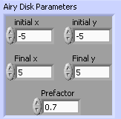
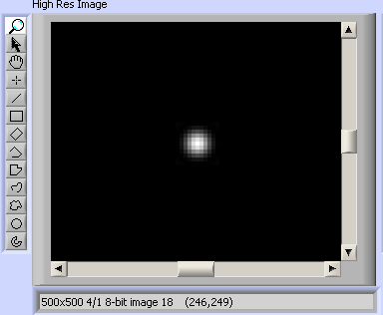
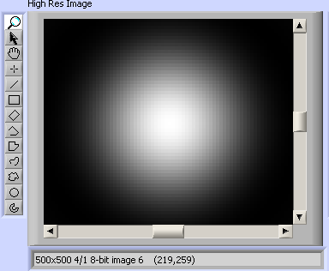
Since the airy disk intensity falls quickly, it is not necessary to calculate the airy disk over large values. The prefactor determines how quickly the airy disk reaches zero. A higher valued prefactor means fewer values need to be calculated to get an accurate representation than a lower valued prefactor. This is illustrated in the figure to the right. It is obvious that the airy disk with a prefactor of .7 does not need that many pixels to approximate the dye molecule. In the user input image above, a square of -5 to 5 for both x and y values was chosen. This means that a 10x10 box centered at the airy disk’s center was used for each airy disk in the simulation.
Figure 2-An Airy Disk with a prefactor of .7.
Figure 1-An Airy Disk with a prefactor of .1.
User Input:
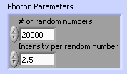
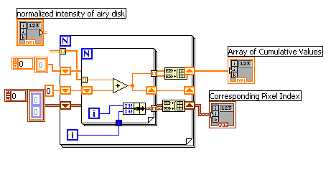
After all the airy disks have been placed along the microtubule length, the overlapping areas are then added together. Then this total function is normalized. This represents a probability density function for photon location. Each pixel coordinate now has a probability of a photon emitting from that location. Photon locations are randomly selected based on another Monte Carlo method. To minimize the number of random numbers that need to be used for each photon, all of the probabilities in the two dimensional figure are added together in a cumulative array. This means that the last element in the array is 1. Each element in the array represents a pixel coordinate. For each random number between 0 and 1 will fall between two elements in the array. The lower corresponding index is chosen. That index has a pixel coordinate corresponding to it. This means only 1 random number is needed for each photon. This code is seen in Figure G.
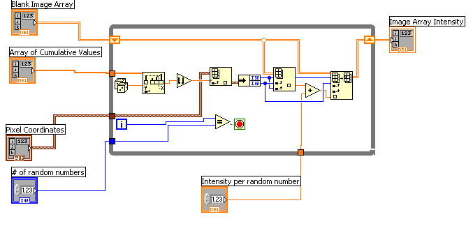
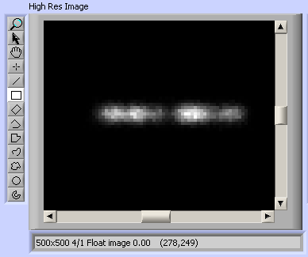
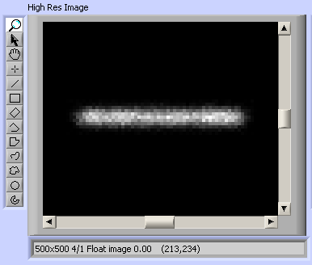
The user will input how many random numbers, photons, each image will collect. As well as how much of an intensity change each photon carries. Each photon that hits a pixel will increase the intensity of that pixel by a certain value that the user has input into “Intensity per random number.” The corresponding code is seen in the accompanying figure.
Figure X represents what an image from this step in the process looks like. The speckled nature of the microtubule is not obvious in this image since the “fraction of dye” input was too high. At a lower value .01, this speckled nature is evident. The image produced here is a float image. This image is cast into an 8 bit image. The float is used to show an unquenched image. However the casting will cause any pixel with a value equal to or above 255 to be set to 255 which is the maximum pixel intensity.
Resampling and Noise Addition
User Input:
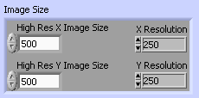
With the float image cast into an 8 bit image, the image is then resampled into a lower resolution image. The user will input the x and y resolution of the higher resolute image in “High Res X Image Size” and “High Res Y Image Size.” The user can then control how much the lower resolution image will be in “X Resolution” and “Y Resolution.” This resampling into a lower resolute image is done to allow for sub-pixel movement. This will be discussed more in the velocity section.
User Input:
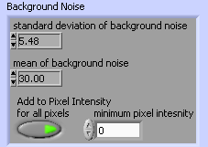
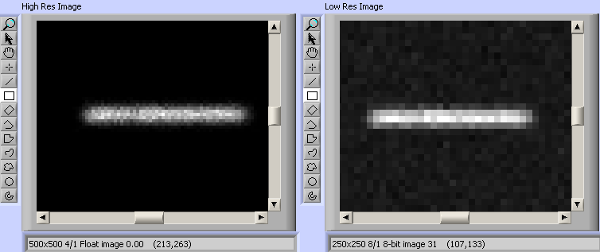
A background noise is then added to the image. The user can decide the mean value of the background noise as well as the standard deviation for that noise. Intensity is added to every pixel. If the pixel has intensity already from the process explained above, the user can choose to add the background noise intensity to that pixel or not. If he chooses not to then he has to set a “minimum pixel intensity” value. If the pixel has intensity higher than this value the algorithm will not add the background intensity to the pixel. Adding the noise to every pixel is more physically accurate than not. This is a relic from earlier software iterations, but this may serves a purpose for a future user so I have not removed it yet. Most likely this option will not be used.
The resulting image with its higher resolute counterpart can be seen in figure Y.
The speckled image becomes more obvious in this casted image. Figure Z shows this from the above example.
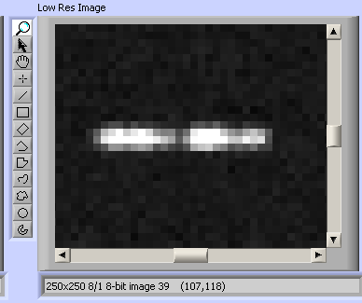
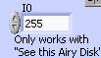
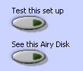
With all of these inputs to select from, it is useful to view a sample microtubule the user has chosen without creating a set of images. This option is available to the user with the ability to see what one airy disk also looks like from the parameters set. This allows the user to minimize the box surrounding the airy disk. These buttons are seen to the left. The images they produced are seen above. Pressing “Test this set up” produces a microtubule while “see this Airy Disk” shows what a single airy disk looks like. The maximum intensity of the airy disk can be controlled with “I0.” This only works with “See this Airy Disk” since all the airy disks when constructing the microtubule are normalized.
Trajectory
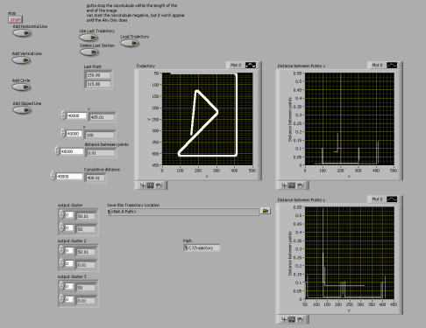
To give the microtubule movement from image to image, the user must specify a trajectory the object will follow. The user can construct this trajectory themselves from four different geometries, horizontal line, vertical line, sloped line, and circle. For the horizontal and vertical line, the user specifies the starting point x and y, and then the ending point (in x coordinates for horizontal and y for vertical). The user has to input the same values for a sloped line as well as the slope of the line. For a circle the user specifies the origin, radius and the angles to start and end the circle. The angles can vary from -2π to 2π. Using these geometries, a complicated trajectory could be produced like that in the figure seen here.
Velocity
User Input:
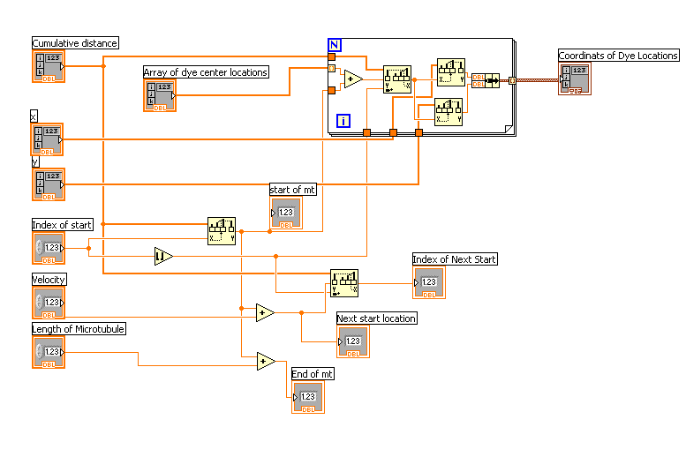
The user can input the velocity they desire the microtubule to follow in units of high res pixel/frame. In this case the user has input a velocity of 5 high res pixels/frame. Since they decided to resample the image to half its original size, the low res velocity will have a value of 2.5 low res pixels/frame. Since the algorithm resampled to a lower resolution, the user can be assured that this velocity though in sub-pixels in the lower resolution is accurate.
The software will move the microtubule along the trajectory a distance specified by the velocity. Since the airy disks are labeled by their distance from the start of the microtubule and not from a location on the image, their relative location remains unchanged despite curves along the trajectory. This code can be seen here.

To run the program select the “Let’s Make Some Magic” button. The program will run and save images until it reaches the end of the trajectory. Pressing the stop button will stop the entire program.
Saving
User Input:
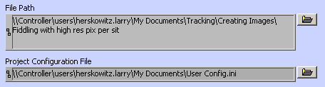
This software saves the images in a directory that is specified in “File Path.” The images are .pngs and are named after the frame number. The parameters used to create the microtubule as well as the trajectory are saved. The parameters are saved in a .ini file while the trajectory is saved as a .dat file. Old parameters can be loaded by right clicking the control and selecting the file.
This speed of this software creates an image depends on how the parameters the user has input. For example a higher random number will slow down the algorithm. A larger box around the center of the airy disk will slow down the program. With the settings shown in this paper, the software creates an image in 3 seconds.
Conclusion
This software can create a series of images of microtubule moving along a user specified trajectory. This can be used to test tracking software designed for microtubules. It is possible to adapt this software to create images of other proteins that follow the fluorescent speckled theory such as f-actin and some cytoskeletal proteins. However it is not equipped to handle these yet.
This is actually the second attempt to create images of microtubules. The first attempt followed more closely to the steps taken in the Cheezum paper¹¹. We found that this method is more physically correct. However the other process did work. It involved convoluting a line or rectangle with an airy disk. I then added in Poisson noise and background to better represent actual images. It is possible to reproduce this method by either using the Cheezum paper or looking at my Open Notebook at blah.

Goldstein L, Yang Z. Microtubule-based transport systems in neurons: the roles of kinesins and dyneins [Internet]. Annual review of neuroscience. 2000 ;23(1):39–71.Available from: http://arjournals.annualreviews.org/doi/abs/10.1146/annurev.neuro.23.1.39
Vale RD, Fletterick RJ. The design plan of kinesin motors. [Internet]. Annual review of cell and developmental biology. 1997 ;13745-77.Available from: http://www.ncbi.nlm.nih.gov/pubmed/9442886
Wittmann T, Hyman a, Desai a. The spindle: a dynamic assembly of microtubules and motors. [Internet]. Nature cell biology. 2001 ;3(1):E28-34.Available from: http://www.ncbi.nlm.nih.gov/pubmed/11146647
Clemmens J, Hess H, Lipscomb R, Hanein Y, Böhringer KF, Matzke CM, et al. Mechanisms of Microtubule Guiding on Microfabricated Kinesin-Coated Surfaces: Chemical and Topographic Surface Patterns [Internet]. Langmuir. 2003 ;19(26):10967-10974.Available from: http://pubs.acs.org/doi/abs/10.1021/la035519y
Dennis JR, Howard J, Vogel V. Molecular shuttles : directed motion of microtubules along nanoscale kinesin tracks. Nanotechnology. 1999 ;232
Hess H, Clemmens J, Matzke C, Bachand G, Bunker B, Vogel V. Ratchet patterns sort molecular shuttles [Internet]. Applied Physics A: Materials Science & Processing. 2002 ;75(2):309-313.Available from: http://www.springerlink.com/openurl.asp?genre=article&id=doi:10.1007/s003390201339
Hess H, Howard J, Vogel V. A Piconewton Forcemeter Assembled from Microtubules and Kinesins [Internet]. Nano Letters. 2002 ;2(10):1113-1115.Available from: http://pubs.acs.org/doi/abs/10.1021/nl025724i
ImageJ
Our paper soon
Chisena EN, Wall RA, Macosko JC, Holzwarth G. Speckled microtubules improve tracking in motor-protein gliding assays. [Internet]. Physical biology. 2007 ;4(1):10-5.Available from: http://www.ncbi.nlm.nih.gov/pubmed/17406081
Cheezum MK, Walker WF, Guilford WH. Quantitative comparison of algorithms for tracking single fluorescent particles. [Internet]. Biophysical journal. 2001 ;81(4):2378-88.Available from: http://www.ncbi.nlm.nih.gov/pubmed/11566807
NEED REFERENCE FOR DYES/NM THINGY
Wolf or something like that
Watermanstorer C. How Microtubules Get Fluorescent Speckles [Internet]. Biophysical Journal. 1998 ;75(4):2059-2069.Available from: http://linkinghub.elsevier.com/retrieve/pii/S0006349598776489
Voter A. Introduction to the kinetic Monte Carlo method [Internet]. In: Radiation Effects in Solids. Citeseer; 2007. p. 1568–2609.Available from: http://citeseerx.ist.psu.edu/viewdoc/download?doi=10.1.1.125.3560&rep=rep1&type=pdf
Danuser G, Waterman-Storer C. Quantitative fluorescent speckle microscopy: where it came from and where it is going [Internet]. Journal of Microscopy. 2003 ;211(October 2002):191–207.Available from: http://www3.interscience.wiley.com/journal/118870697/abstract
Vallotton P, Ponti A, Salmon ED, Waterman-storer CM, Danuser G. Recovery, visualization, and analysis of actin and tubulin polymer flow in live cells: a fluorescent speckle microscopy study. Biophys. J. 2003 ;851289-1306.

