2/9/2014 Lab 2: Identifying Algae and Protists
Objective- Our objectives for this lab were to analyze, study, and understand the characteristics of Protists and Algae and to understand how to use that dichotomus key. We also observed our hay infusion cultures and prepared serial dilutions. I believe that in the hay infusions we will find a lot of organisms that couldn’t be seen with the naked eye. This experiment will help us see if there are any organisms because the contents we collected in the jar act as a mini “ecosystem”. The serial dilutions will help us further examine the types of organisms in the jar.
Materials and Methods- 1) First, we observed known organisms under the microscope and tried characterizing them using the dichotomus key. We did this twice for practice. 2) Next, we carefully examined our hay infusions for any changes in the ecosystem. We took samples form the surface of the water (where plants were floating) and from the bottom of the jar because those are two different niches where organisms can live on. 3) Then, we drew and measured how the organisms looked like and tried characterizing them with the dichotomus key given. 4) Then, we prepared serial dilutions for next week’s lab by taking 4 test tubes and filling them with 10 mls of water, mixing the contents in the jar, piping out 100 microliters, and putting it into the first test tube which we labeled 2 for dilution 10^-2. Then we took 100 microliters from tube 2 and put it into tube 3 and labeled it 10^-3. This step was repeated two more times. 5) Lastly, we took 100 microliters from tube 2 and put it on a nutrient agar plate which we labeled 10^-3. This step was repeated three more times. One with tetracycline, one with test tube 4 and 6.
Observations and data- The top of our culture looks moldy and murky and it smells horrible. Most of the contents are at the bottom of the jar. There is also like a clear film thing on the surface that looks like the top of oatmeal after it cools off. Organisms at the bottom of the jar might not need more oxygen then the ones at the bottom. In the picture you see that the first three organisms were taken from the surface of the jar. The last three were taken from the bottom of the jar. The first organism under “Surface” was taken from the clear filmy substance.
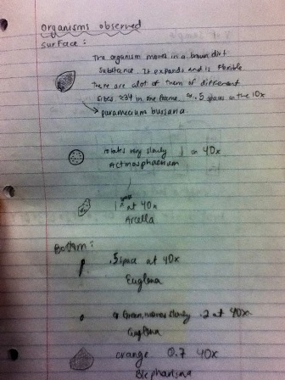

All of the organisms were mobile. Some more than others, for example the paramecium buraria was very mobile, but the actinosphaerium only rotated very slowly in the same place. The arcela moved more like a pseudopod and the bottom two were very mobile. The blepharisma moved slower. The paramecium bursaria meets all the need of life because the reproduce (asexually), and they have DNA, and they eat food to survive. If the hay infusion culture had been observed for another two months I think that the organisms would have died out because there wasn’t a lot of movement in the jar. Most of the dirt and plants were at the bottom. The selective pressures that may have affected our samples was the fact that the jar was clothes, this didn’t let enough oxygen get in.

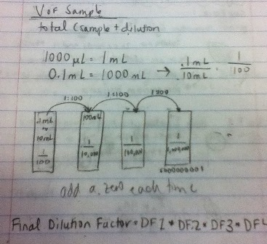
This is a picture of the serial dilutions we did Basically we took 100 microliters from one test tube and put it into the other ( we repeated this three more times). These dilutions helped us see organisms better; since it is hard to see what’s going on the water is too convoluted.

Conclusion- Ultimately, we saw that a lot of organisms were living in our culture. I think that we will get a better idea of what kind of organisms are in the jar when we observe the serial dilutions. I would like to have a better understanding of what selective pressures could kill or affect the life of the organisms.

2/15/2014 Lab 3: Microbiology and Identifying Bacteria with DNA
Objective- The objective for this week’s lab was to identify and discover the different bacteria. Three shapes classify bacteria: bacillus (rod shaped), coccus (circularly shaped), and spirillum (spiral shaped). There is also a stain that helps characterize bacteria. This is called the Gram stain. A bacterium is said to be gram-positive if the cell retains the violet dye and gram-negative if it stains pink. If the cell is gram-positive it means the bacteria has a thick peptidoglycan layer in the cell walls. If it is gram-negative it means it has less peptidoglycan in the cell walls. Another objective was to observe antibiotic resistance of tetracycline and to understand how DNA sequences are used to identify organism (the PCR reaction was used for this). I believe that the peptidoglycan wall has a lot to do with antibiotic resistance. I have heard that applying too much hand sanitizer is bad for you because it kills the good bacteria, but it will be very interesting to learn exactly why that is.
Materials and Methods- 1) The first thing we did when we entered lab was check on our hay infusions for any changes in the niches. 2) Then, we looked at the dilutions that we made last week and we counted how many colonies where on each agar plate (with and without tetracycline). We used a conversion factor to get the colonies per mL number. 3) Then, observed prokaryotes under the microscope. We observed prepared slides of bacteria and wet mound slides of gram stained bacteria from the nutrient agar and from the tetracycline. 3) In order to get a better understanding of what these cells look like we observed the prepared slides that showed spirillus, bacillus, and coccus shaped bacteria. 4) Then we took two very small colony samples from the nutrient agar plate and one small sample from the tetracycline plate. In total it was three colony samples. These are used for the PCR chain reaction to see how DNA sequences are used to classify bacteria. 5) Next, we took another sample of the colonies from the agar to observe under the microscope 6) Then, we gram stained the colony. It was a long process. First, we labeled the slides, and then we passed the slide three times under a flame. Then, we put a crystal violet dye on it and let it sit for one minute. After that we rinsed it and put the iodine mordant and let it sit for a minute. Then, we decolorized the slide by rinsing it with 95% alcohol for 20 seconds. Lastly, we observed the final product using a microscope. 7) The last thing we did in lab was set up the PCR reaction by putting one colony in 100 microliters of water in a test tube and incubating it to 100 degrees Celsius for 10 minutes. After this we put it in the centrifuge to separate the DNA.
Questions in red from the lab manual for procedure I-
- I think that Archaea could grow in the agar plates because they are a form of bacteria.
- The appearance or smell of the hay infusion might change week after week because the bacteria are breaking down the vegetation and more microbes are growing,

Observations and Data- This data helped us better visualize the colonies and see about how many there were and how they looked like.
Procedure I:
Table 1: 100-fold Serial Dilutions Results
Dilution (plate label) | Agar | Colonies Counted | Conversion Factor | Colonies/ml
10^-3 | Nutrient | 25,000 | X 10^3 | 2,500,000
10^-5 | Nutrient | 300 | X 10^5 | 30,000,000
10^-7 | Nutrient | 50 | X 10^7 | 500,000,000
10^-9 | Nutrient | 6 | X 10^9 | 6,000,000,000
10^-3 | Nutrient + tet | 2410 | X 10^3 | 241,000
10^-5 | Nutrient + tet | 300 | X 10^5 | 30,000,000
10^-7 | Nutrient + tet | 100 | X 10^7 | 1,000,000,000
Procedure III: Gram-stained Cell Morphology
Colony Label | Tet or Nutrient | Colony description: diameter, color shape, texture, etc. | # of colonies = bacteria per ml of culture | Cell description: Motility, shape, arrangement, etc. | Gram positive or gram negative
10^-3 | Nutrient | -Location: around the border and in the middle  -Shape and texture: mixture of flat and raises. Also undulate.  -The form is undulate  -Color: Yellow | 2,500,000 | Spirillum (spirochetes)  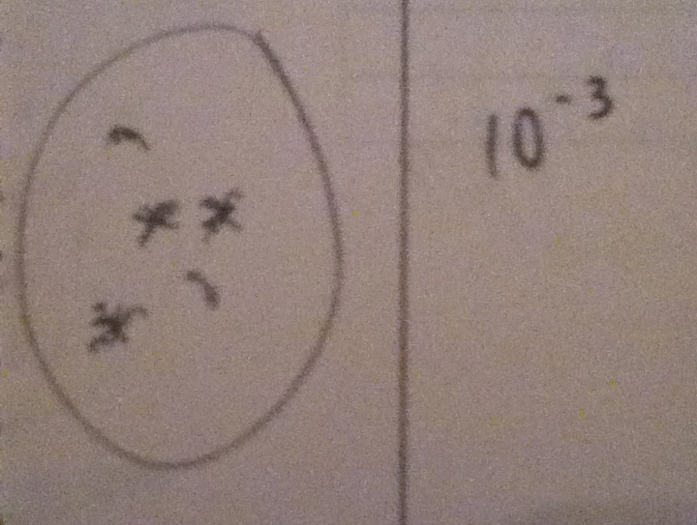Figure A  Magnification: 40x | Negative
10^-3 | Tetracycline | -Location: Middle  -Shape and mixture: flat and some are convexed, the edge is a mixture of entire and undulate  -The form is wrinkled and irregular  -Color: Yellow | 241,000 | Cocci  (stafphylococcus)  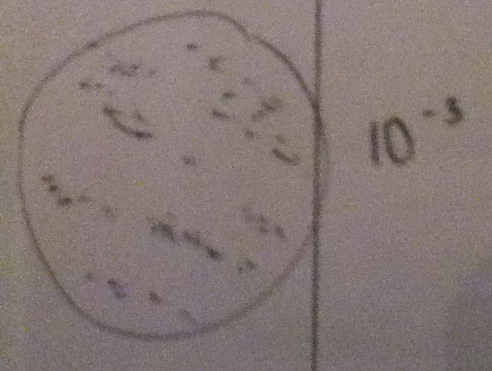  Figure B  Magnification:  40x | Positive
10^-5 | Tetracycline | -Location: scattered  -Shape and mixture: circular, entire, and pulvinate.  -Color: see through | 30,000,000 | Cocci (stafphylococcus)  Figure C  Magnification :40x | Positive
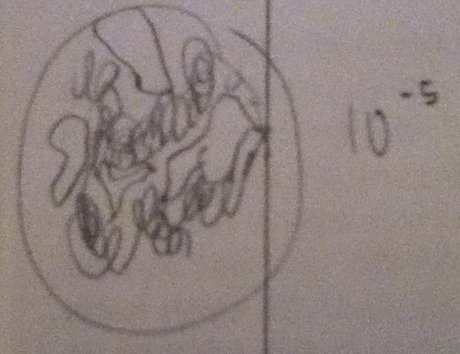
Red Questions- There is no bacterial growth on the tetracycline plates (the white fuzzy stuff is bacteria). This indicates that the bacteria aren’t immune to the tetracycline and the tetracycline is effective. The effect of tetracycline on the total number of bacteria is that it reduces the number of bacteria (our plates don’t have any fungi). Only one species of bacteria is unaffected by tetracycline. Tetracycline works by inhibiting protein synthesis. It changes the cytoplasm and causes nucleotides to come out of the cell. This doesn’t the kill the cell (http://www.chm.bris.ac.uk/motm/tetracycline/antimicr.htm
Cell Morphology-
Figure D (40x) Figure E (40x) Figure F (40x)
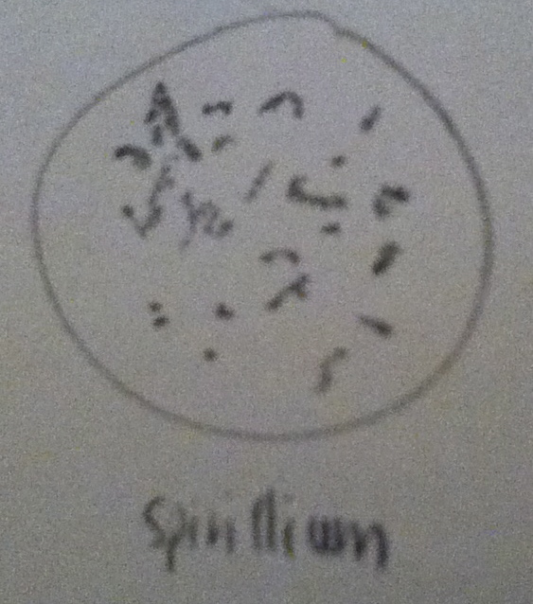
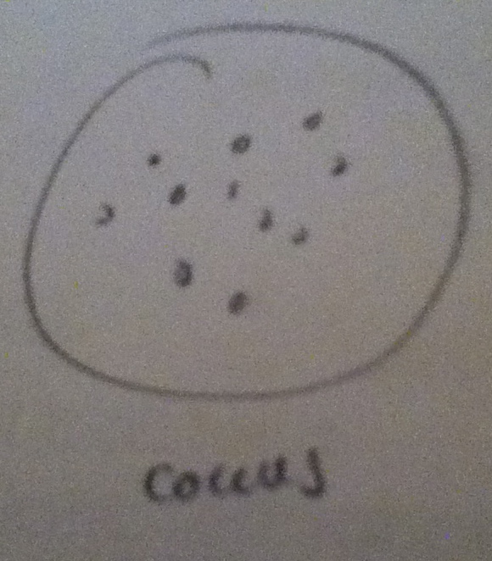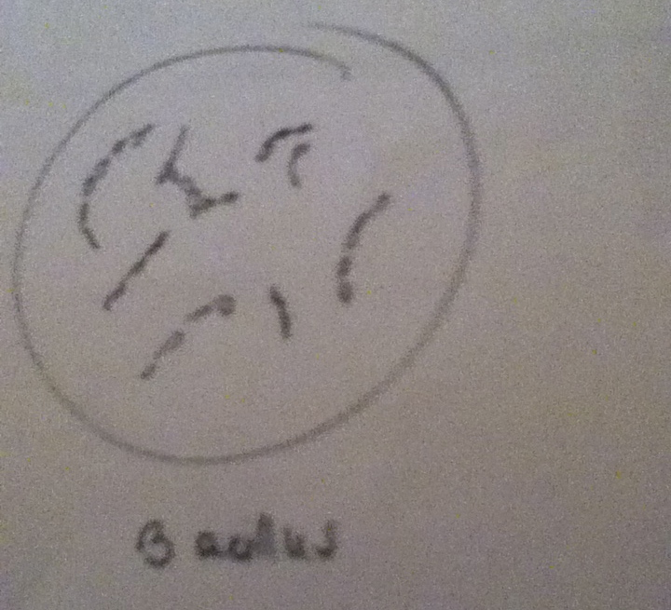
Conclusion- This lab was very helpful at teaching us cell morphology and the difference between nutrient agar and tetracycline growth. I understood that by using too much antibacterial soap you’re killing the bad bacteria, but then some bacteria are left behind that aren’t effected, their DNA changes so they become anti-biotic resistant.

