July. 1st
We conducted the third annealing according to the parameters below:
 | A (10mM MgCl₂) | B (20mM MgCl₂) | C (30mM MgCl₂)
20X DFB | 2.5 | 2.5 | 2.5
6 | 1 | 1 | 1
7 | 1 | 1 | 1
9 | 1 | 1 | 1
10 | 1 | 1 | 1
1 | 2 | 2 | 2
2 | 2 | 2 | 2
3 | 2 | 2 | 2
4 | 2 | 2 | 2
5 | 2 | 2 | 2
B8 | 1 | 1 | 1
 | 17.5 | 17.5 | 17.5
RNase free H₂O | 32.5 | 32.5 | 32.5
Total | 50.0 | 50.0 | 50.0
We arranged AFM imaging at City University of Hong Kong this week.
July. 2nd
A 2% agarose gel electrophoresis was conducted. Photo was captured, and the target bands were excised and undergone gel extraction according to the protocol (see methodology). After gel extraction, the concentration of DNA was determined by Nanodrop:
 | A | B | C
DNA Concentration | 4.6 ng/µL | 4.2 ng/µL | 4.6 ng/µL
260/280 | 4.10 | 1.18 | 2.34

Result of the gel electrophoresis:
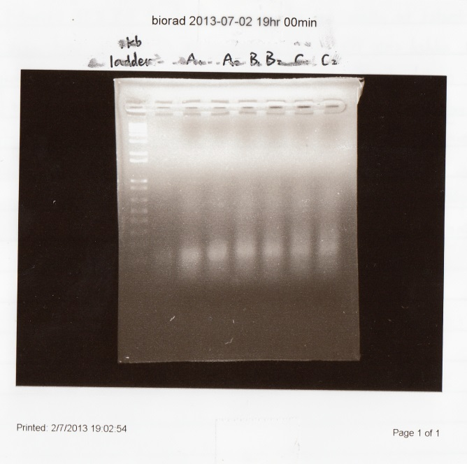
July. 3rd
We prepared for the AFM imaging tomorrow. A 10mL solution of 0.5X TBE buffer containing 10mM MgCl₂ was made. Instead of preparing the slides in advance, we will bring all samples suspended in solution to CityU tomorrow.

July. 4th
Results of AFM imaging:
CD Surface Control, Size scale: 1.0µm×1.0µm; Height scale: -6.0nm – 6.0nm.
DNA (1), Size scale: 10.0µm×10.0µm; Height scale: -6.0nm – 6.0nm.
DNA (2), Size scale: 10.0µm×10.0µm; Height scale: -6.0nm – 6.0nm.

DNA (3), Size scale: 5.0µm×5.0µm; Height scale: -6.0nm – 6.0nm.
DNA (4), Size scale: 1.7µm×1.7µm; Height scale: -6.0nm – 6.0nm.
DNA (5), Size scale: 10.0µm×10.0µm; Height scale: -6.0nm – 6.0nm.
DNA (6), Size scale: 1.0µm×1.0µm; Height scale: -6.0nm – 6.0nm.
The next AFM imaging was reserved next Wednesday (July. 10th.) According to the results, no clear evidence shows that the residue left on the CD surface was the DNA origami. Assuming the shapes represented the DNA, and then the relatively large size of the shapes (around 2-3 micrometers, much larger than the designed size) is presumably caused by the effects of aggregation which makes the DNA origami sticks together rather than disperse throughout the images. After discussion, several reasons were proposed:
- The DNA origami was not well diluted;
- The CD surface might not be an ideal surface for scanning DNA. We chose CD surface for AFM imaging because of its relative flatness, but CD surface is hydrophobic and hard for the immobilization for DNA;
- The way preparing sample slides (drying through natural evaporation) may be improper.
Though we decided to continue preparing AFM slides by CD surface, the TedPella mica sheets were ordered at once today. As soon as the TedPella mica is arrived, CD surface will be replaced.
We ran the fourth annealing today according to the parameters in June. 30th. According to the reference (Douglas 2012), the concentration of DNA origami needs to be diluted to around 2 to 10 nM. Therefore, after calculation, we made a 1:10 dilution to the sample made in June.28th.
Process of calculation:
MW_{DNA(6/30)} =114700.6 g/mol
C_{DNA (6/28)} =8.6 ng/μL=7.50×10⁻⁸M=75 nM

July. 5th
A 2% agarose gel electrophoresis was conducted. Photo was captured, and the target bands were excised and undergone gel extraction according to the protocol (see methodology). After gel extraction, the concentration of DNA was determined by Nanodrop:
DNA concentration | 8.6 ng/μL = 63.64 nM
260/280 ratio | 2.27
Result of gel electrophoresis:
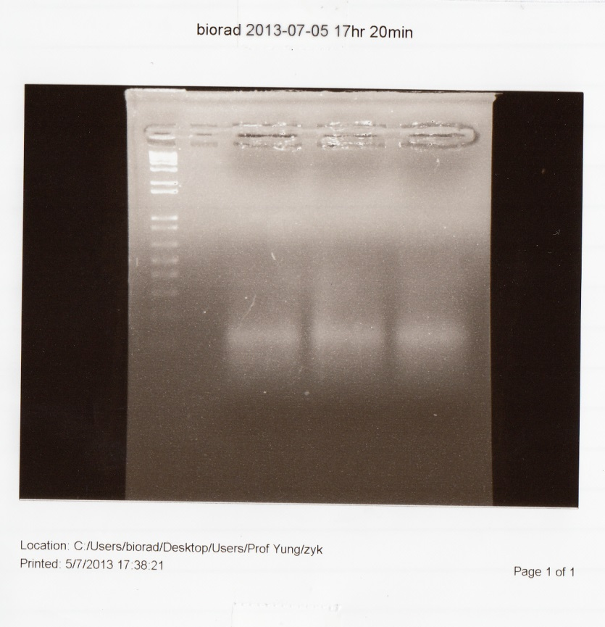

July. 8th
We conducted the fifth annealing today. The concentrations of scaffolds and staples were the same as those in June.27th, and the annealing time was 23 hours.
We prepared slides for AFM imaging today using two different methods (see methodology).

July. 9th
No bands were obtained from the fifth annealing, thus no photo was captured. We conducted the sixth annealing with the same parameter as the fifth one.

July. 10th
Results of AFM imaging:
2nM DNA, Size scale: 1.0µm×1.0µm; Height scale: -6.0nm – 6.0nm
6nM DNA, Size scale: 1.0µm×1.0µm; Height scale: -6.0nm – 6.0nm
Judging from the results, either many bands or dots were observed by the AFM studying, and we still could not determine whether the structure was correctly folded from the imaging. After discussion, we decided to keep preparing DNA samples and slides with CD surface for AFM studying. Next AFM imaging was reserved next Wednesday (July. 17th.)
A 2% agarose gel electrophoresis was conducted. Photo was captured, and the target bands were excised and undergone gel extraction according to the protocol (see methodology). After gel extraction, the concentration of DNA was determined by Nanodrop:
DNA concentration | 6.6 ng/μL
260/280 ratio | 2.24
Result of gel electrophoresis:
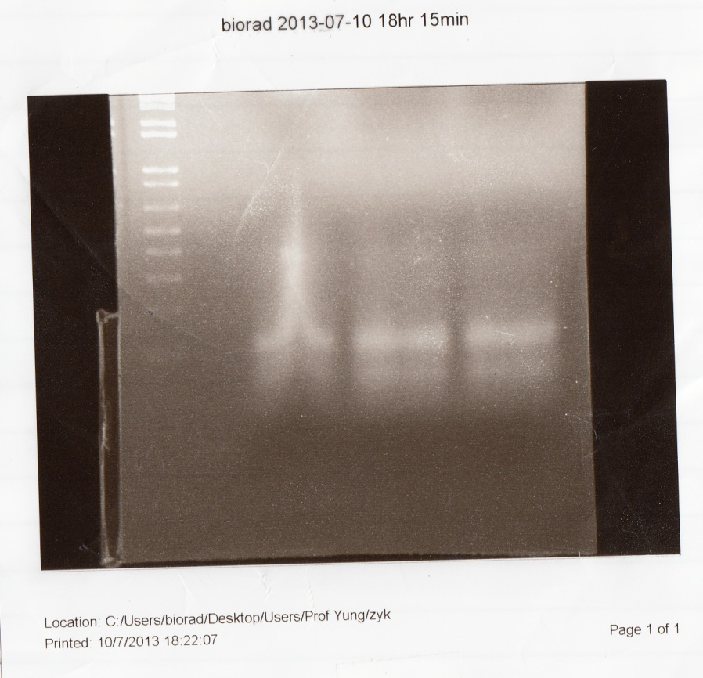
In the first well, the DNA band was retarded because the side of the first well was not flat. We will be more careful in making the agarose gel next time.

July. 11th
We prepared slides for AFM imaging today using two different methods (see methodology).

July. 13th
We discussed the precautions of the annealing process today. Several things shall be noted:
- MgCl₂ should be added after boiling the agarose gel;
- MgCl₂ should be added into the 1X TBE running buffer (around 0.95g in 500mL buffer);
- An ice box should be prepared to settle the electrophoresis box, so as to avoid the devastating effects of high temperature to the DNA origami.

July. 15th
We started the seventh annealing (23 hours) according to the parameters shown below:
 |  | Final concentration
Scaffolds | 6, 7, B8, 9, 10 | 200 nM
Staples | 1, 2, 3, 4, 5 | 1 µM

 |  | Volume (µL)
20X DFB |  | 2.5
Scaffolds | 6 | 1
Scaffolds | 7 | 1
Scaffolds | B8 | 1
Scaffolds | 9 | 1
Scaffolds | 10 | 1
Staples | 1 | 2
Staples | 2 | 2
Staples | 3 | 2
Staples | 4 | 2
Staples | 5 | 2
RNase free water |  | 32.5
Total |  | 50.0
We got some quantum dots (Invitrogen, Streptavidin-QD625, Lot# A0196) from Dr. Li Hung Wing. We planned to conduct the first trial of DNA-QD conjugation tomorrow.

July. 16th
A 2% agarose gel electrophoresis was conducted. Photo was captured, and the target bands were excised and undergone gel extraction according to the protocol (see methodology).
Results of gel electrophoresis:
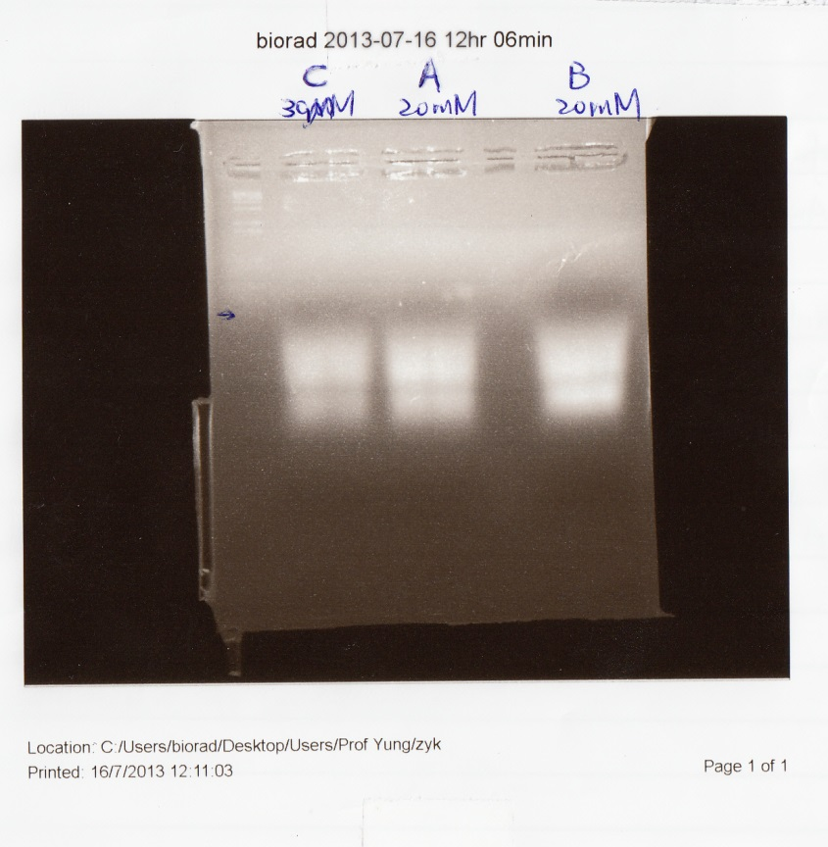
After gel extraction, we determined the concentration of DNA using Nanodrop, and we diluted the DNA sample to 2nM. After that, we conducted QD-DNA conjugation and incubated overnight, according to the parameters shown below:
 | 7/16 sample A | 7/16 sample B | 7/16 sample C
C_{DNA} | 2 nM | 2 nM | 2 nM
C_{QD} | 2 nM | 200 pM | 20 pM
Ratio | 1:1 | 1:1 | 1:1
Volume | 50μL | 50μL | 50μL

July. 17th
Results of AFM imaging:
Buffer Solution Control, Size scale: 1.0µm×1.0µm; Height scale: -6.0nm – 6.0nm
QD Control, Size scale: 1.0µm×1.0µm; Height scale: -6.0nm – 6.0nm
7/16 sample A, Size scale: 1.0µm×1.0µm; Height scale: -6.0nm – 6.0nm
7/16 sample B, Size scale: 1.0µm×1.0µm; Height scale: -6.0nm – 6.0nm
7/16 sample C, Size scale: 1.0µm×1.0µm; Height scale: -6.0nm – 6.0nm
Judging from the AFM studying, no strong conclusion can be made that the DNA or the DNA-QD conjugates has been obtained. After discussion, we believe several aspects can be improved in the annealing process and AFM imaging:
- CD surface might not be a good substrate for conducting AFM imaging for DNA origami, since the surface is hydrophobic, uncharged, which makes DNA hard to be immobilized; so, the alternative way is to use mica surface;
- During water evaporation, DNA origami (together with the buffer ions) have a large chance to be gathered into the smaller drop of water and finally be highly concentrated, rather than evenly distributed on the CD surface;
- Parameters during AFM scanning are not optimal, though we are trying to minimize it; Speed of gel electrophoresis is too slow, which does not separate the correctly folded structure from the misfolded and unfolded ones.
Moreover, we are curious of the tiny dots surrounded the large circles. Usually, the tiny white dots are recognized as signaling errors when the AFM cantilever is scanning; however, such "signaling error" has a certain pattern of distribution rather than exist randomly. To conclude, we are still confident to synthesize better samples in the next three months through improving the four aspects mentioned above.

