An attempt at creating some nice smelling and good looking E. coli.
Dustin Ebert
Sufia Munim
Sudeep Shakya
Abstract
Based on the biobrick component, Wintergreen, GFP, and a promoter, we tried to develop an E.coli which smells like wintergreen and turns green under UV light. After a number of attempts we were unable to isolate the parts, so we decided to work with RFP-Promoter reporter gene provided to us by Dr. Schwendiek to get some substantial results and end our experiment on a good note. Later we tried to repress the the promoter with different glucose and IPTG concentration which worked too.
Introduction
BioBrick standard biological parts are DNA sequences of defined structure and function. They share a common interface and are designed to be composed and incorporated into living cells such as E. coli to construct new biological systems. The physical registry of BioBrick parts which contain the actual DNA use plasmid vectors as carriers of these parts. The common usage intended for these is to cut the part out of its vector and insert it before or after another part or “device” (string of parts) in another vector. To facilitate easy digestion and ligation of parts across the registry, a standard set of restriction sites flank the part and are integral to the plasmids. These are called the prefix, containing EcoRI and XbaI, and the suffix, containing SpeI and PstI as shown below:
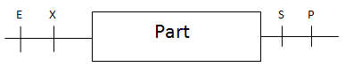
Figure 1: BioBrick prefix and suffix.
We had originally set out to construct a device consisting of three parts. The first codes for an enzyme called SAM benzoic acid/salicylic acid carboxyl methyltransferase I derived from BSMT1 from Petunia x hybrida. BSMT1 converts benzoic acid to methyl benzoate and salicylic acid to methyl salicylate (fig 1). Methyl benzoate has a floral smell and methyl salicylate has a wintergreen smell. We were going to be a little specific, though, and only invoke the wintergreen smell. Thus, we’ll refer to this part as the wintergreen gene or WG.
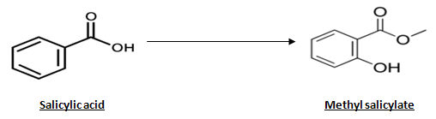
Figure 2: Conversion of salicylic acid to produce a wintergreen odor.
Within the registry, this part is present in the plasmid pSB1A3 which is ampicillin resistant. It is 2157bp long and has the standard BioBrick prefix and suffix. The WG part is 1074bp and when inserted into pSB1A3 is part of a 3231bp molecule.
Our second part codes for Green fluorescent protein (GFP) and is available in the BioBrick Registry as Part BBa_E0040. This biobrick part is derived from jellyfish Aequeora victoria wild-type GFP. It is 720 bp long. It was to be used in our project as a reporter gene to turn E. coli green indicating the expression of Wintergreen gene. The excitation and emission data for this part is 501nm and 511nm respectively. It has an initial plasmid pSB1A2 with Ampicillin resistance. Like pSB1A3, pSB1A2 is also a high copy number (100-300 per cell) plasmid. It is 2079 bp long and has pUC19-derived pMB1 as replication origin.
Our third Biobrick part, pBad is an E. coli promoter that is induced by L-arabinose and repressed by AraC. It is contained in a pSB2K3 vector which is a variable copy number plasmid carrying kanamycin resistance. The length of the promotor part is 1210 bp and the plasmid is 4425 bp long. Like most all BioBrick vectors, it has the standard prefix and suffix restriction sites flanking the part.
At this point, we should mention about RFP. During the first couple of weeks of our project we found out that GFP is not working. So Dr. Schwekendiek provides us with RFP liquid cultures. It is available in Biobrick Registry as Part: Bba E1010. It is a highly engineered mutant of red fluorescent protein from Discosoma striata (coral). It is 681 bp long. The sources of RFP were J61002 and J621003. J61006 is 2948 bp long and J62003 is 2298 bp long. The emission and excitation data for this part is 583 nm and 558 nm respectively.
Materials and Methods
BioBrick extraction
Each Biobrick library comes with its own respective protocol for the extraction of the parts or plasmid. For parts from the ’08 registry we punched out different BioBricks from the source paper binder. TE was added to the punched part in a separate tube so that it was completely soaked. This solution contained the DNA. For ‘09 we added TE buffer to the necessary wells to suspend the dried DNA inside. All the above protocols were used according to the registry protocols.
Cell Transformation
We used two types of cells: New England Biolabs (NEB) and Axel’s lab-prepared cells. They were transformed according to Dr. Jurgenson’s heat shock transformation protocol using two different concentrations of plasmid (2 uL, 10 uL). We then poured the transformants onto agar plates containing antibiotics (kanamycin or ampicillin).
Liquid Cultures
We picked up single colonies from streaked selected plates to inoculate in 5ml LB broth. We supplemented the broth with 8 ul of Kanamycin or 5ul of Ampicillin according to the plasmids drug resistance requirements and added 50 ul of thawed cells if the source was a glycerol stock. We then incubated them overnight at 37⁰C, continuous shaking at 225 rpm.
PCR of Wintergreen, Promoter and RFP
PCR reactions for WG, Promoter and RFP samples were set up using 2x PCR mix (Taq polymerase, Buffer and dNTPs), forward and reverse primers, DNA template, and H₂O. A positive control with pBluescript and a negative control with no template was included.
For some of the PCR reactions, BioBrick-generic VF and VR primers were used. We used primers modified with Biobrick prefixes and suffixes to run PCRs on our RFP and WG samples:
2nd WG F: 5’-GAATTCGCGGCCGCTTCTAGAGATGGAAGTTGTTGAAGT
2nd WG R: 5’-ACTGCAGCGGCCGCTACTAGTATTAATTTATTTTGGTCA
RFP F: 5’-GAATTCGCGGCCGCTTCTAGAGATGGCTTCCTCCGAAGA
RFP R: 5’-ACTGCAGCGGCCGCTACTAGTATTATTAAGCACCGGTGG
PCR purification
We used the given protocol (reference- Qiagen PCR purification kit) and then eluted the samples with 35ul of elution buffer.
Plasmid Isolation
It was done according to the given protocol (Reference- Fermentas Mini prep Protocol). We did various restriction digests (10x FastDigest buffer - in some instances TBE Buffer in place of 10x FastDigest buffer was used. Its implication is highlighted in results and discussion DNA, restriction enzyme, water). The incubation time was 15-30 minutes at 37⁰C.
Ligation
10x buffer, T4 ligase (5 Weiss/ul), insert vector and water. It was incubated for 30 min at 25⁰C.
Results
Growth of Bacteria in LB media
Table 1 lists each BioBrick part we used and the number of agar plates/liquid cultures we attempted to grow containing each part followed by how many actually did grow. For the Pro-RFP cultures, we are only counting growth by how many cultures were red regardless of other bacterial growth in the container. Most of the controls gave expected results, however our negative plates for both initially amplifying the BioBrick parts and plating our device ligation, all on ampicillin, grew a few colonies.

Part | # Plates Attempted | # Plates w/ Growth | # Liquid Cultures Attempted | # Liquid Cultures w/ Growth
GFP | 6 | 4 | 30 | 21
WG | 6 | 4 | 20 | 20
1st AraC Promoter (I0500) | 4 | 0 | - | -
2nd AraC Promoter (R0080) | - | - | 2 | 2
RFP | - | - | 4 | 4
Pro-RFP | 8 | 1 | 16 | 9
Onion Group Promoters | - | - | 16 | 16
Total | 24 | 9 | 88 | 72
Table 1: Growth of Bacteria in LB media
Restriction Digestion of Plasmid Inserts
Combinations of different restriction enzymes for the restriction sites of the BioBrick-standard prefix and suffix were used to cut out the part inserts. All four prefix/suffix restriction enzymes (EcoRI, XbaI, SpeI, and PstI) were able to cut out the inserts for the four different types of promoters we obtained from the Onion group (Figure 6). Our first attempted digestion of the arabinose-inducible promoter (R0080) with XbaI and SpeI was hampered by the use of the wrong buffer (TBE buffer) in the reaction instead of FastDigest buffer (Figure 3). Only EcoRI and PstI could successfully digest out the WG insert with XbaI and SpeI producing negative results (no insert released) (Figure 5). When RFP was initially digested from its plasmid, only EcoRI, XbaI, and PstI would appear to cut (Figure 7). Digestion of the final RFP PCR product with XbaI and PstI was assumed to have worked because of the success of the insert-vector ligation made apparent by the red E. coli colony that grew. However, this was not confirmed by gel electrophoresis nor, in our opinion, did it need to be confirmed.
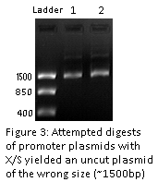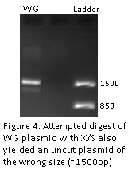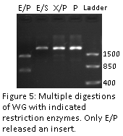
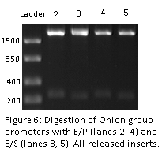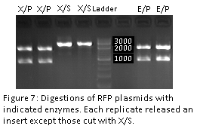
PCR of Wintergreen, RFP, and the Promoter
We ran two PCR reactions on our assumed WG template using different sets of primers to obtain fragments of different sizes. The first one used the BioBrick standard VF and VR primers intending to amplify the region of the WG gene that extended several hundred base pairs surrounding the start and stop codons and including the prefix and suffix. This produced a band 300-350bp in size. (Figure 9) The expected size was 1390bp so we decided that this was not the correct sequence. The second PCR on WG used two 39bp forward and reverse primers (listed in Methods) that included sections complementary to the first and last 17bp of the WG gene and adding alternate ends containing the BioBrick standard prefix and suffix. This was done intending to restore the possibly mutated XbaI and SpeI restriction sites that we have been unable to digest. The PCR products were only 100bp when we expected them to be 1100bp. (Figure 10) Therefore, this has led us to believe that our WG template is very different than what we suspected.
The RFP PCR reaction that was carried out was designed very similarly to the second WG PCR reaction. This used another set of 39bp primers with the prefix and suffix attached in the alternate end PCR fashion intending to restore the XbaI and SpeI sites that we needed to cut out the RFP gene and insert into our new vectors (Figure 8). The product’s expected size was confirmed by gel electrophoresis as 700bp. We now have a workable RFP gene fragment. (Figure 10)
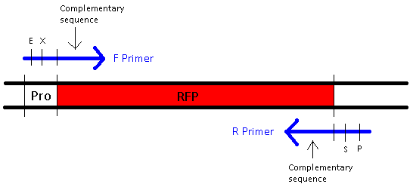
Figure 8: Alternate-end priming strategy for J61002 to amplify only the RFP gene fragment with the BioBrick prefix and suffix attached.
The reactions used to isolate a promoter also used the BioBrick VF and VR primers to amplify products for the two different promoter types: 387bp for the arabinose-induced promoter (R0080) and 438bp for the lac repressible promoter (R0010). This reaction failed to produce any product as no band was observed when assayed by gel electrophoresis (results not shown).
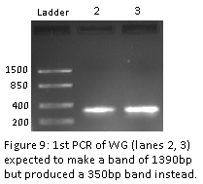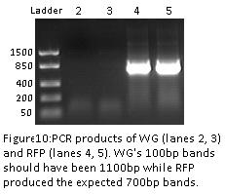
Final ligation of Pro-RFP device, transformation, and resulting plates
To ligate our device parts together, we digested the RFP PCR product (Figure 10) with XbaI and PstI and digested the lac repressible promoter plasmid with SpeI and PstI. We then removed the restriction enzymes with a PCR purification kit and ligated these together, crossing part samples to make multiple ligation reactions.
We attempted to grow Pro-RFP colonies on 8 plates with different concentrations of ligation solution transformed into the cells. We also did a positive (pBluescript-transformed) and a negative (nontransformed) control. Very few colonies grew in each Pro-RFP plate, most of them standard yellow in color. The positive control was almost completely covered in colonies while the negative control had few. Only one plate had a very small red-colored colony. We used this colony to streak a new plate which, after overnight incubation, produced a similar streak of bright pink E. coli colonies
Now that we have achieved a working Pro-RFP device of our own, we decided to experiment with inducing and repressing expression of this RFP gene by stimultating the lacI promoter that we used. Since this is the same promoter as the one that controls the regular E. coli lac operon, we assumed that it would respond to different nutritional conditions similarly. When a high level of glucose is present in E. coli, lactose-hydrolyzing enzymes of the lac operon are prevented from being expressed by repression of the lacI promoter. Inversely, presence of IPTG (Isopropyl β-D-1-thiogalactopyranoside) represses the lac repressor, acting as a sort of inducer. We experimented with different concentrations of both glucose and IPTG being added to liquid cultures grown from Pro-RFP plates. Only the culture with the most amount of glucose added (300ul) showed any decrease in red coloring compared to the other cultures:
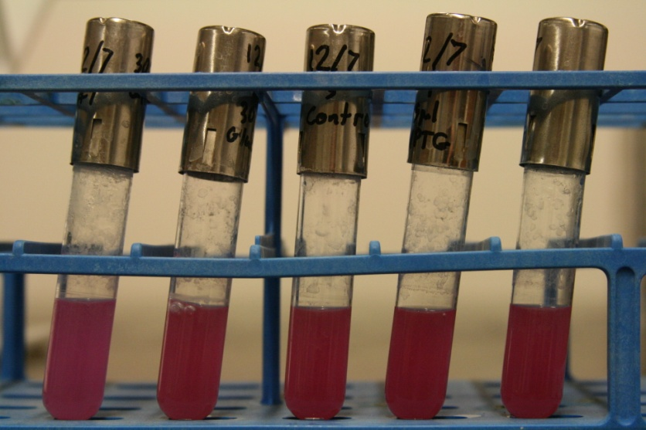
Figure 11: Liquid cultures with differing levels of glucose and IPTG added
Tube #1: 300ul glucose; #2: 30ul glucose; #3: control; #4: 5ul IPTG; #5: 50ul IPTG
Discussion
We initially had problems with some of the bacterial agar plates that contained our separate BioBrick parts transformed into E. coli. Only E. coli transformed with plasmids which contained the wintergreen or GFP gene grew. The very first promoter we attempted to harvest failed to produce colonies on any of the four plates we inoculated. One possible reason for the lack of growth is that the paper punches that we used to obtain the part from the physical 2008 registry might not have actually contained any DNA. The spot on the paper already had some holes punched out from last year so we were forced to punch out the edges. The main difference between these three parts (WG, GFP, and promoter) relevant to selectively growing bacteria is the different antibiotic resistance genes provided by the transforming vectors which contained these inserts. Every plasmid we worked with required ampicillin in the media except for the first arabinose-inducible promoter (I0500), which required kanamycin. If the bacteria that were plated on these antibiotics did not have this plasmid with the resistance gene transformed into them, it should have been impossible for them to grow. The negative control plate containing kanamycin with bacteria that was purposely not transformed with any plasmid didn’t have any colonies growing while one of the negative control plates that used ampicillin did have a few grow. This fact points to the potency of the kanamycin as another possible contributing factor. This problem quickly ceased to matter, however, after we obtained another promoter through the Spring 09 Onion group’s glycerol stocks since it and every other part we worked with used ampicillin.
Another problem that’s very confusing because of the antibiotic resistance issue is that we could never seem able to isolate any plasmid DNA from our GFP colonies. Four out of six GFP plates with “transformed” bacteria grew colonies with a few plates that had well over a hundred. Every plasmid isolation miniprep we attempted on liquid cultures grown from a large sampling (21 colonies) of these plates failed to yield any DNA. If these bacteria lacked the plasmid which contained ampicillin resistance, they should have been prevented from growing, much less thriving like they did. This again is possibly a matter involving the potency of the antibiotics. The specific stock of ampicillin we used could have been either bad or diluted allowing for unobstructed growth of non-transformed bacteria. This problem could have then been coupled with the lack of DNA from the paper punches/dry wells that we used from the registries to ensure that no colonies contained any plasmid.
Concerning these bacterial plate issues, I would lean more towards faulting the physical registry lacking the DNA rather than any antibiotics causing these problems. However, two things we could have done to improve chances of extraction from the paper punches is preheating the TE buffer used and centrifuging them down.
Another mistake we made was using the TBE buffer (usually intended for gel electrophoresis) in our first few restriction digests instead of the required Fermentas FastDigest buffer. TBE consists of a chemical composition unsuitable for restriction digestion and thus inhibits the reaction. Reviewing our experiments, however, this only affected the digestion of the arabinose-inducible promoter noted in the Results section and we were later able to correct this.
The largest source of frustration in the project was most likely the DNA that we obtained from our wintergreen colonies. Every plasmid isolation that yielded DNA was of the same size (~1500bp), but when digested with EcoRI and PstI would produce two fragments: a 1400bp fragment and a 700bp fragment (Figure 5). Furthermore, XbaI and SpeI sites appeared to be missing since these enzymes would cut other parts like the promoter and RFP of our resulting plasmid but could not cut WG. Regardless of this DNA’s apparent ability to morph sizes when digested, these sizes were nowhere near the sizes listed in the parts registry: 1074bp for the WG insert and 2157bp for the plasmid backbone making a 3231bp complete fragment. The only thing similar to this fragment was the rough insert: plasmid size ratio of 1:2. When we tried to restore the normal BioBrick prefix and suffix by using alternate-end PCR, we got a very faint band of ~100bp (Figure 10). Perhaps one of the primers was able to stay annealed to the template long enough each cycle for some DNA to be synthesized. It would have been nice to digest the remainder of this product with EcoRI or PstI to see which primer was possibly responsible for this. However, we ended up throwing the sample out immediately after getting these results.
When we eventually realized that we’d never be able to extract GFP DNA from the BioBricks registry we were in need of some kind of assay for recombination and to overall make our device a little more interesting. Dr. Schwekendiek luckily provided us with four liquid cultures containing plasmids with an RFP gene. After multiple digestions, we were running into almost the same problem we had with WG: the SpeI site appeared to be removed. We consulted the parts registry entry for RFP (J61002) and discovered that it was actually the regular RFP part (E1010) inserted into a vector device with a tetracycline-repressible promoter (R0040). The resulting device left a scar sequence over the SpeI site between the promoter and RFP and followed this order: EcoRI-XbaI-promoter-RFP-PstI (Figure 12). When we still intended to use WG in our device we required the RFP part to be digestible at the BioBrick standard restriction sites. We successfully used PCR to restore the prefix and suffix to RFP and used this to insert into another plasmid after an already included lac promoter (R0010). This produced a BioBrick-compatible device that always turned E. coli red when present.
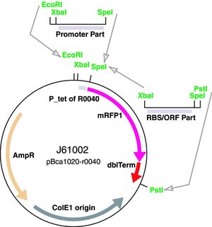
Figure 12: Plasmid map of J61002 containing a tetracycline-repressible promoter with RFP. This is the source of the RFP part in our ligated plasmid.

