Raw Data and calculations of mean and standard deviation 1
Determination of Voltage difference for known Time delay 3
Calculation of Voltage difference for set length difference 4
Calculation of Speed of Light from voltage/time relationship and 5
Calculation of minimum and maximum values using error in oscilloscope 6
Calculation of minimum and maximum values within 1 standard deviation of mean 7

Raw Data and calculations of mean and standard deviation
calibration_voltage=[1.84 2.24 2.36 2.20
.960 1.44 1.84 2.24
2.08 1.52 1.88 1.48
1.28 1.36 1.68 2.04
1.72 1.92 1.94 1.76
1.60 2.08 1.64 2.04
1.36 1.76 1.32 1.76
1.12 1.56 1.92 1.88
1.64 2.00 1.44 1.52
1.16 1.72 1.84 1.80
1.12 1.56 2.20 2.00
1.48 1.72 1.56 1.92
1.64 1.60 1.88 1.64
1.28 1.44 1.52 1.76
1.48 1.36 2.08 1.96
.960 1.72 2.16 1.88
.800 1.96 1.64 1.84
1.24 1.48 1.92 1.72
1.40 1.76 1.76 2.08
1.42 1.44 1.60 2.16];
calibration_average=mean(calibration_voltage)
calibration_deviation=std(calibration_voltage)

test_voltage=[.860 1.06 1.32 1.60 1.48
1.18 1.02 1.30 1.32 1.60
.940 1.12 1.00 1.02 1.60
1.08 1.60 1.68 1.52 1.28
.940 .780 1.32 1.12 1.52
1.04 1.34 1.22 1.30 1.92
.840 1.28 1.40 1.60 1.32
.820 1.14 1.56 1.48 1.46
.900 .920 1.44 1.56 1.24
1.10 1.08 1.40 1.30 2.06
1.36 1.42 1.48 1.36 1.28
.880 1.28 1.10 1.48 1.56
1.28 1.06 1.10 1.22 1.74
.920 1.32 1.60 1.50 1.38
.840 1.58 1.34 1.58 1.64
1.36 1.08 1.46 1.56 1.82
.760 .840 1.26 1.38 1.38
1.00 .860 1.40 1.66 1.34
1.22 1.14 1.50 1.62 1.58
1.24 1.34 1.22 .980 1.38];
test_average=mean(test_voltage)
test_deviation=std(test_voltage)

calibration_average =

1.3790 1.6820 1.8090 1.8840

calibration_deviation =

0.3192 0.2521 0.2663 0.2112

test_average =

1.0280 1.1630 1.3550 1.4080 1.5290

test_deviation =

0.1888 0.2301 0.1741 0.2020 0.2237

Determination of Voltage difference for known Time delay
t_delay=[0 .5 1 2];
calibration_fit=polyfit(t_delay,calibration_average,1)
t_cal_fit=linspace(0,2,100);
v_cal_fit=polyval(calibration_fit,t_cal_fit);
figure
plot(t_delay,calibration_average,'ro',t_cal_fit,v_cal_fit,'k');
xlabel('t(ns)'),ylabel('voltage'),title('Voltage vs. Time delay');

calibration_fit =

0.2323 1.4852

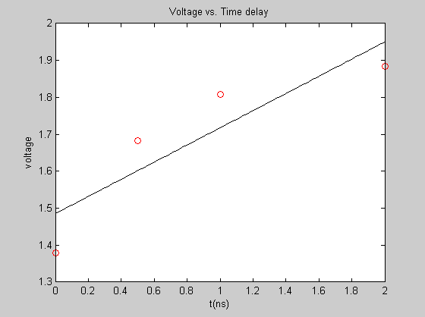

Calculation of Voltage difference for set length difference
x_difference=[0.00,.25,.50,.75,1.00];
length_fit=polyfit(x_difference,test_average,1)
x_fit=linspace(0,1,100);
v_test_fit=polyval(length_fit,x_fit);
figure
plot(x_difference,test_average,'ro',x_fit,v_test_fit,'k');
xlabel('x(m)'),ylabel('voltage'),title('Voltage vs. Difference in length');

length_fit =

0.4988 1.0472

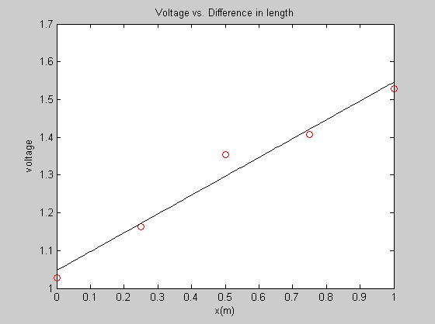

Calculation of Speed of Light from voltage/time relationship and
voltage/length relationship

c_mpns=calibration_fit(1)/length_fit(1) %the units of the calibration
%fit are volts/nanosecond, and those of the length fit are volts/meter
c=c_mpns*1e9

c_mpns =

0.4658

c =

4.6580e+008

Calculation of minimum and maximum values using error in oscilloscope
Margin of error in oscilloscope calculations = .02V Minimum slope would be found with maximum value(n+.02) for data less than median and minimum value (n-.02) for data greater than median minimum L/T = minimum -> L=minimum, T=maximum

t_scope_min(1:2)=calibration_average(1:2)+.02;
t_scope_min(3:4)=calibration_average(3:4)-.02;
V_t_min=polyfit(t_delay,t_scope_min,1)
L_scope_max(1:2)=test_average(1:2)-.02;
L_scope_max(3)=test_average(3);
L_scope_max(4:5)=test_average(4:5)+.02;
V_L_max=polyfit(x_difference,L_scope_max,1)
c_scope_min=abs(V_t_min(1)/V_L_max(1)*1e9)

% maximum
% L/T = maximum -> L=maximum, T=minimum
t_scope_max(1:2)=calibration_average(1:2)-.02;
t_scope_max(3:4)=calibration_average(3:4)+.02;
V_t_max=polyfit(t_delay,t_scope_max,1)
L_scope_min(1:2)=test_average(1:2)+.02;
L_scope_min(3)=test_average(3);
L_scope_min(4:5)=test_average(4:5)-.02;
V_L_min=polyfit(x_difference,L_scope_min,1)
c_scope_max=abs(V_t_max(1)/V_L_min(1)*1e9)

V_t_min =

0.2095 1.5052

V_L_max =

0.5468 1.0232

c_scope_min =

3.8311e+008

V_t_max =

0.2552 1.4652

V_L_min =

0.4508 1.0712

c_scope_max =

5.6610e+008

Calculation of minimum and maximum values within 1 standard deviation of mean
Margin of error = 1 standard deviation Minimum slope would be found with maximum value(n+sd) for data less than median and minimum value (n-sd) for data greater than median minimum L/T = minimum -> L=minimum, T=maximum

t_sd_min(1:2)=calibration_average(1:2)+calibration_deviation(1:2);
t_sd_min(3:4)=calibration_average(3:4)-calibration_deviation(3:4);
V_tsd_min=polyfit(t_delay,t_sd_min,1)
L_sd_max(1:2)=test_average(1:2)-test_deviation(1:2);
L_sd_max(3)=test_average(3);
L_sd_max(4:5)=test_average(4:5)+test_deviation(4:5);
V_Lsd_max=polyfit(x_difference,L_sd_max,1)
c_sd_min=abs(V_tsd_min(1)/V_Lsd_max(1)*1e9)

% maximum
% L/T = maximum -> L=maximum, T=minimum
t_sd_max(1:2)=calibration_average(1:2)-calibration_deviation(1:2);
t_sd_max(3:4)=calibration_average(3:4)+calibration_deviation(3:4);
V_tsd_max=polyfit(t_delay,t_sd_max,1)
L_sd_min(1:2)=test_average(1:2)+test_deviation(1:2);
L_sd_min(3)=test_average(3);
L_sd_min(4:5)=test_average(4:5)-test_deviation(4:5);
V_Lsd_min=polyfit(x_difference,L_sd_min,1)
c_sd_max=abs(V_tsd_max(1)/V_Lsd_min(1)*1e9)

V_tsd_min =

-0.0624 1.7665

V_Lsd_max =

1.0016 0.7972

c_sd_min =

6.2296e+007

V_tsd_max =

0.5271 1.2039

V_Lsd_min =

-0.0040 1.2972

c_sd_max =

1.3084e+011

