DNA EXTRACTION LAB

By George Wolfe, Academy of Science, Loudon Cty, VA

ACTIVITY AT A GLANCE

Goal:
To introduce students to DNA extraction techniques and to isolate genomic DNA from insects and Wolbachia, the endosymbiotic bacteria that live within the cells of over 20% of insect species.

Learning Objectives:
Upon completion of this activity, students will transition from field work and morphological classification (Lab 1) to molecular biology and biotechnology, learn about DNA as a diagnostic tool to discover unseen microbes, increase abilities in biotechnology, and understand the process of inquiry and discovery-based research. They will isolate total genomic DNA from morphospecies identified in the Insect Identification Lab.

Prerequisite Skills:
- Prior practice with micropipettors.

Teaching Time:
90 minutes (2 class periods - optional 45min stopping point on page 8)

National Science Education Standards Addressed:
Unifying Concepts and Processes in Science, Science as Inquiry, Science and Technology, Life Science, Science in Personal and Social Perspectives, History and Nature of Science
Timeline for Teaching Discover the Microbes Within: The Wolbachia Project
Thursday
3 days ahead
Monday
Tuesday
Wednesday
8 weeks ahead
Friday
Monday
Order insects or assign collection
At this point, all insects should be preserved in ethanol & stored in lab freezer
Activity 1: Insect Identifi-cation Lab
Order laboratory materials
Activity 2: DNA Extraction Lab
Activity 3: DNA Amplifi-cation Lab
Activity 4: Gel Electro-phoresis
Activity 5: Bioin-formatics
Activity 6: DNA Sequence Alignments & Phylogenetics
Reserve Computer Lab
Check out Insect Field Guides
OVERVIEW

In this activity, students will extract total genomic DNA from each of their three morphospecies using Qiagen’s DNeasy Tissue Culture Kit. Total genomic DNA includes DNA of the insect host as well as any symbiotic bacteria, if present. In addition to the 2 unknown morphospecies, students will also prepare positive and negative controls using Nasonia vitripennis wasps that are infected and uninfected with Wolbachia pipientis, respectively. The Nasonia controls may be obtained by contacting Michele Bahr at The Marine Biological Laboratory (mbahr@mbl.edu) at least two weeks prior to beginning the lab series.

The extraction of total genomic DNA involves three distinct steps:
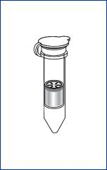
1. Cell Lysis: Students will begin by blotting the ethanol away from their insect specimens and then macerating them in a cell lysis solution (Buffer ATL). This basically breaks open cell and nuclear membranes. The dilemma here is that it also exposes DNA to proteins in the insect tissue. Therefore, the enzyme Proteinase K must be added to denature the proteins and keep the DNA intact. Finally, they will add ethanol to precipitate the DNA.

2. Elimination of Cellular Debris: Once students have destroyed the hydrolytic enzymes and precipitated DNA, they will begin the DNA purification process. In essence they will place the cellular components, including DNA, into a spin column and wash the spin column of all components except DNA. Upon centrifugation the material will pass through the filter, which attracts DNA and allows debris to pass through. This will be followed by two wash steps with two buffers (AW1 and AW2).
3. DNA Elution: Students will complete the activity by removing the DNA from the filter. This is done by adding the elution buffer (AE). Spinning the tube with the DNA embedded in the filter will pull the elution buffer through the matrix, thus pulling the DNA into the collection tube.

MATERIALS

- Incubator, heat block, or water bath set @ 70˚ C
- Vortex
- Centrifuge
- Student morphospecies
- + and – Nasonia controls
- Microtube Pestles (USA Scientific 1415-5390)
- Qiagen DNeasy Kit (#69504)
- P200 & P1000 pipets
- P200 & P1000 pipet tips
- Float racks for water bath
- Waste cups for tips, etc.
- Gloves
- Sharpies
- Tweezers
- Kimwipes
- Ethanol (95-100%)
- Tube Racks (USA Scientific 2396-5048)
- 1.5ml microcentrifuge tubes (USA Scientific 1415-9199)

TEACHER PREPARTION

This lab requires attention to detail, but it's worth it. Aliquot all of your reagents ahead of time into labeled sets of tubes so that YOU don’t get confused. Use the p1000 and p200 pipettes to aliquot the solutions into individual tubes for your students. Students will use pipettes to add the aliquoted solutions to their DNA extractions. If you do not have enough pipettes, have students share or use plastic transfer pipettes with pre-aliquoted volumes of each solution. The Qiagen DNeasy Kit contains spin columns, collection tubes, Proteinase K, and buffers ATL, AL, AW1, AW2, and AE. Note that some of these solutions require 95-100% Ethanol added to them prior to the start. You will also need to order the additional items in the list above. Set up each activity station with its own set of materials as reflected on the student sheet.

Note: The Qiagen DNeasy extraction yields high quality DNA but there are a number of different extraction protocols that can be used. See http://discover.mbl.edu/resources.htm for protocols that we have tested at MBL, including Promega Wizard SV, BioRad InstaGene, and Edward’s Buffer.

ACTIVITY PROCEDURE

Review the activity flow-chart (page 10) with your class and instruct them to revisit their hypothesis from the Insect Identification Lab Mini-Report. Students will work with their same partners from Lab 1 and follow the protocol outlined on the student sheet. They are encouraged to read through the procedure prior to beginning and activity in order to identify and understand the purpose of each reagent. Answers are shown below:

- Buffers ATL and AL: lysis solutions that break open tissue, cell, and nuclear membranes

- Proteinase K: an enzyme that catalyzes the breakdown of cellular proteins by splitting them into smaller peptides and amino acids

- Ethanol: used to precipitate DNA from the extracted material

- Buffer AW1 and AW2: wash solutions that wash the DNA attached in the column membrane of contaminants

- Buffer AE: a solution that elutes the DNA from the membrane and allows stable storage of DNA for years in the refrigerator or freezer

Student Activity Sheet Name:______________________

DNA Extraction Lab

Hypothesis: Based on the background information, formulate a hypothesis about the frequency of Wolbachia endosymbionts in your specimens.
__________________________________________________________________________________________________________________________________________________________________________________________________________________________________________

MATERIALS (per group of two students)
- 2 different morphospecies
- + and – Nasonia controls
- Gloves
- Sharpie
- Tweezers
- 1 box Kimwipes
- 1 box of P200 pipet tips
- 1 box of P1000 pipet tips
- P200 and P1000 pipets
- 1 waste cup for tips & tubes
- 4 Microtube pestles

- 1 tube of Proteinase K (100 µl)
- 1 tube of Buffer ATL (0.8 ml)
- 1 tube of Buffer AL (1 ml)
- 2 tubes of Buffer AW1 (1.2 ml each)
- 2 tubes of Buffer AW2 (1.2 ml each)
- 1 tube of Buffer AE (500 µl)
- 1 tube of ethanol (95-100% - 1 ml)
- 4 spin columns
- 8 empty 1.5 ml microcentrifuge tubes
- 1 tube rack
- Safety goggles

INTRODUCTION
In this activity, you will:
- Isolate total genomic DNA from morphospecies identified in the Insect Identification Lab
- Isolate DNA from infected (+) and uninfected (-) Nasonia controls.
- Learn about DNA as the molecular basis of heredity and the interactions of bacterial and animal organisms.
- Learn about cell structures and the nature of scientific knowledge

In this activity, you will extract total genomic DNA from each of their three morphospecies using Qiagen’s DNeasy Tissue Culture Kit. Total genomic DNA includes DNA of the insect host as well as any symbiotic bacteria Wolbachia, if present. In addition to the 2 unknown morphospecies, you will also prepare positive and negative controls using Nasonia vitripennis wasps that are infected and uninfected with Wolbachia, respectively. Review the activity flow-chart (page 10) and work with the same partners from Lab 1. Read through the procedure prior to beginning and activity in order to identify and understand the purpose of each reagent.

BEFORE YOU BEGIN
After the teacher reviews the entire procedure, note the purpose of each reagent:
- Buffers ATL and AL: ________________________________________________________________
- Ethanol:
_________________________________________________________________
- Buffer AW1: _________________________________________________________________
- Buffer AW2: _________________________________________________________________
- Buffer AE: _________________________________________________________________

The extraction of total genomic DNA involves three distinct steps:
1. Cell Lysis: You will begin by blotting the ethanol away from the insect specimens and then macerating them in a cell lysis solution (Buffer ATL). This basically breaks open cell and nuclear membranes that prevent you from extracting DNA from cells. The dilemma here is that it also exposes DNA to proteins in the insect tissue that could break up the DNA. Therefore, the enzyme Proteinase K must be added to denature the proteins and keep the DNA intact. Finally, you will add ethanol to precipitate the DNA.

2. Elimination of Cellular Debris: Once you have destroyed the hydrolytic enzymes and precipitated DNA, you will begin the DNA purification process. In essence they will place the cellular components, including DNA, into a spin column and wash the spin column of all components except DNA. Upon centrifugation the material will pass through the filter, which attracts DNA and allows debris to pass through. This will be followed by two wash steps with two buffers (AW1 and AW2).

3. DNA Elution: You will complete the activity by removing the DNA from the filter. This is done by adding the elution buffer (AE). Spinning the tube with the DNA embedded in the filter will pull the elution buffer through the matrix, thus pulling the DNA into the collection tube.

PROCEDURE
Preparation

1. In the chart below note the contents of what you will put in each tube.

Tube # | Contents (Voucher #)
1
2
3 | - Nasonia control
4 | + Nasonia control

- Collect five 1.5 ml microcentrifuge tubes. Using a Sharpie marker, number them 1-5 along with your initials.

Cell Lysis
IT IS IMPORTANT TO DO STEP 3 AS RAPIDLY AS POSSIBLE! MACERATED TISSUE RELEASES DNases WHICH LEAD TO A RAPID BREAKDOWN OF DNA.
- Place 180 microliters (µl) of buffer ATL into each tube to macerate the insects in.
- Place the small insect or abdomen of a larger insect into the buffer (no larger than 2 mm²) of Tube 1 with tweezers. If the insect is preserved in ethanol, blot it thoroughly dry on a Kimwipe. Blot the ethanol away of your + and – Nasonia controls as well.
- Take Tube 1 and macerate THOROUGHLY using a microtube pestle.
- IMMEDIATELY add 20 µl of Proteinase K (destroys DNases that break down DNA).
- Add 200 µl of buffer AL (lysis buffer to break open cells).
- Mix by vortexing for 10 sec or inverting 25 times.
(* Do not pre-mix Proteinase K and Buffer AL, they must be added separately)
- Repeat steps 2-6 with the other three samples. Be sure to use a different pestle and pipet tips for each tube.
- Incubate for at least 10 minutes at 70º C.
- Add 200 µl of Ethanol (95-100%) to each tube. This will precipitate DNA from the extracted material.
- Vortex.

*Optional stopping point. Store tubes at 4° C overnight.

Cellular Debris Removal

- Collect four DNeasy spin columns fitted in four 2.0 ml collection tubes and label the lids of the spin columns 1-4 with your initials.
- Pipet the liquid from tube 1 of the above steps (with or without exoskeleton) into the DNeasy Mini spin column #1. Using a new pipet tip for each transfer, repeat this process with the four other tubes. Make sure to keep tube numbers consistent.
- Centrifuge for 1 minute at 6000 g or 8,000 rpm. The DNA is now caught in the filter of the spin column. Discard the flow through waste into the 2.0 ml collection tubes in the waste bucket.
- Place the spin column containing the DNA from tube 1 in the same emptied 2.0 ml collection tube.
- Repeat for your other 3 tubes, remembering to label.
- To each, add 500 µl of Buffer AW1. This is a wash buffer that washes the DNA.
- Centrifuge for 1 minute at 6000 g or 8000 rpm.
- Again, discard the flow through waste in the 2.0 ml collection tubes in the waste bucket and place the DNeasy Mini spin column from tube 1 into the same emptied 2 ml collection tube labeled “1”; repeat for your other 3 tubes.
- Add 500 µl of Buffer AW2 (a second wash buffer) to each of your 4 tubes and centrifuge for 3 minutes at 20,000 g or 13,000 rpm (or max speed if your centrifuge doesn’t go that high)*. Discard flow-through and collection tubes. This step is also removing the ethanol.
10. Place your spin columns into 1.5 ml microcentrifuge tubess
Again, be sure to label the lids of each tube 1-4 and include your initials this time. These will contain your purified DNA samples. There will be 2 lids, one from the spin column and another from the collection tube.

*Note-if the centrifuge you are using cannot attain this speed, you can allow the tube to air dry for 5 minutes. This will evaporate the ethanol.

DNA Elution and Dilution

- Pipet 100 µl of Buffer AE directly onto the membrane. This is an elution buffer that rinses the DNA off the spin column filter and into the 1.5 ml tube.
- Incubate at room temperature for 1 minute.
- Centrifuge (6000g or 8,000 rpm) for 1 minute to elute.
- Discard the spin column and KEEP the labeled 1.5 ml tube.
- Store the eluted DNA frozen at –20º C until PCR.

DNA Isolation Flow Chart

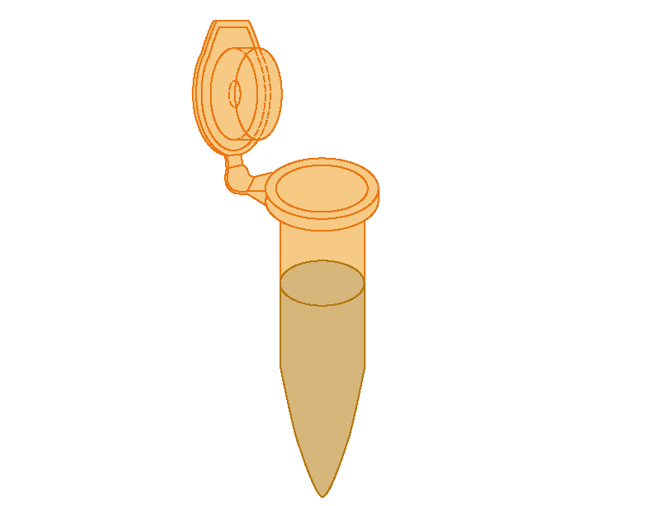
1 2 3 4

Add ATL and Macerate

Add Proteinase K and AL

Vortex and Incubate

Add Ethanol (Stopping point here and store in 4°C)

Spin through a filter and discard flow-through
Wash with Buffer AW1

Spin and discard flow through

Wash With Buffer AW2

Spin and discard flow through

Add Elution Buffer, spin, and keep flow through

Please answer the following questions:

1) Briefly outline the steps required to isolate DNA, taking the cellular structures into consideration.

2) What are the cellular structures and elements that serve as a barrier to getting your DNA out of the cell and intact?

3) After completion of DNA extraction, what did the DNA look like?

4) Research scientists who are trying to determine the identification of a new flu virus would perform a DNA extraction from human tissues. Will the method used to isolate DNA be similar or different from the method you used to isolate insect and Wolbachia DNA?

5) What is the purpose of isolating the DNA? What is your next step in determining the frequency of Wolbachia?

