Janelly Gonzalez
Lab Exercise IV Plantae & Fungi
2/12/16

Table 1: Characteristics of Plants Collected from Transects
Transect Sample Plants | Location and # in transect | Description (size and shape) | Vascularization | Specialized Structures | Mechanisms of Reproduction
1: Common Milkweed | One in the back of transect at the base of fern | long twig stemming out from the ground, smooth berry like | vascular bundles, monocot | berry bundles at top of twig like stem | seeds, stems, and roots
2: Eastern White Pine | One around ferns | Long branch from evergreen tree, smooth flat short needle leaves, | Parallel Spine monocot | pine and fern needle leaf | pine cone like small seeds at ends of branch
3: Dandelion Leaf | Scattered few on the floor front of transect | small leaf, rigid edges | Parallel Spine monocot | Flowers, leaf, seed head | Seeds via wind, taperoot grows
4: White clover leaf | One under tall oak tree | small pointed leaves | Net like veins, Dicot | Flowering head | Bumblebees pollinate flower
5: Walnut | One half between tall grass and lamppost | Half of round oval walnut rigid shell, | One cotyledon monocot | leaves, flowers, seed from walnut tree | original shells, flowers

Figure 1: Common Milk Weed Figure 2: Eastern White Pine
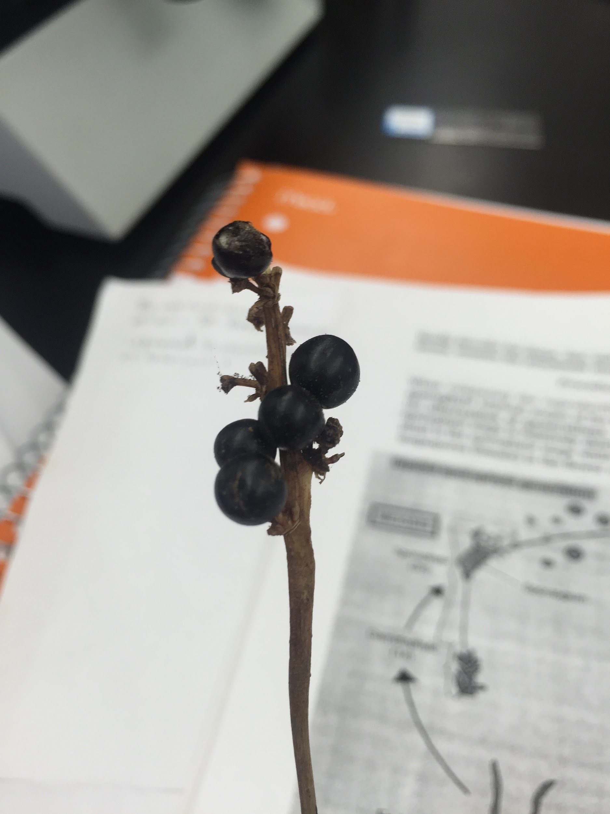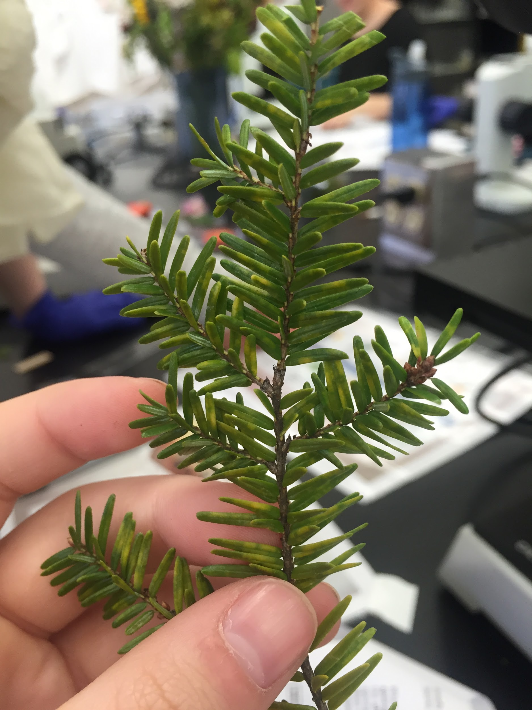

Figure 3: Dandelion Leaf Figure 4: White Clover Leaf
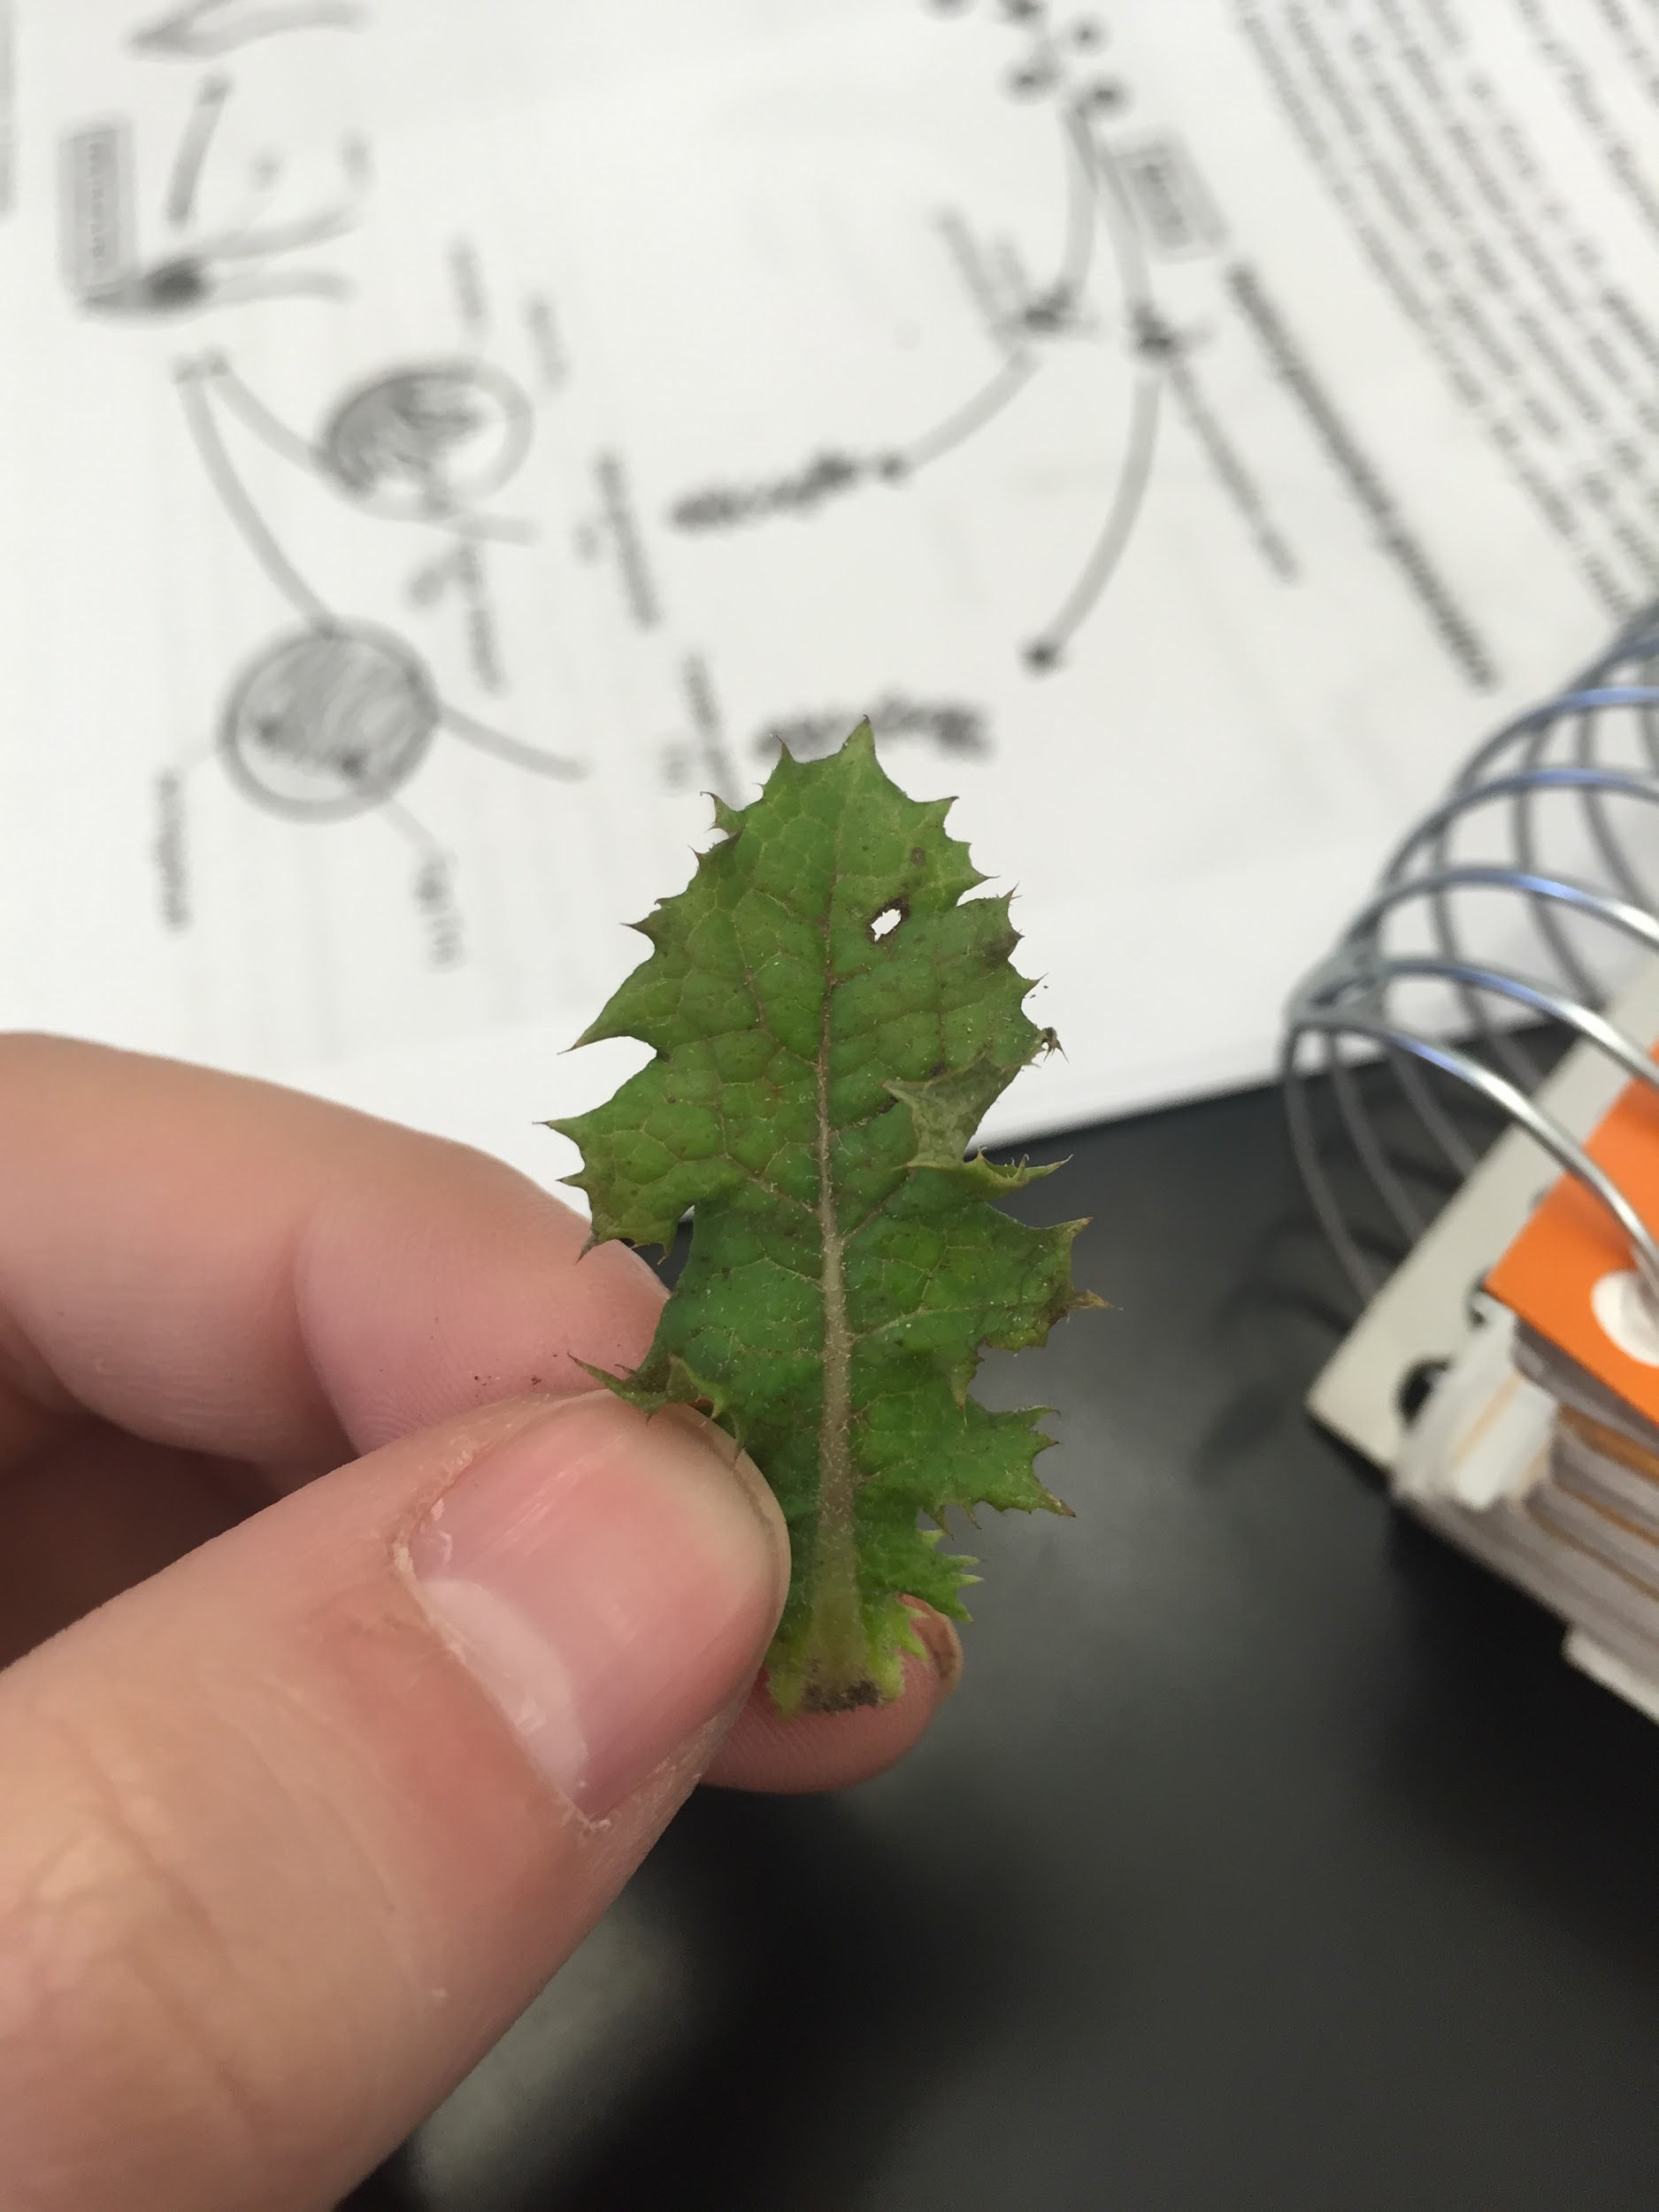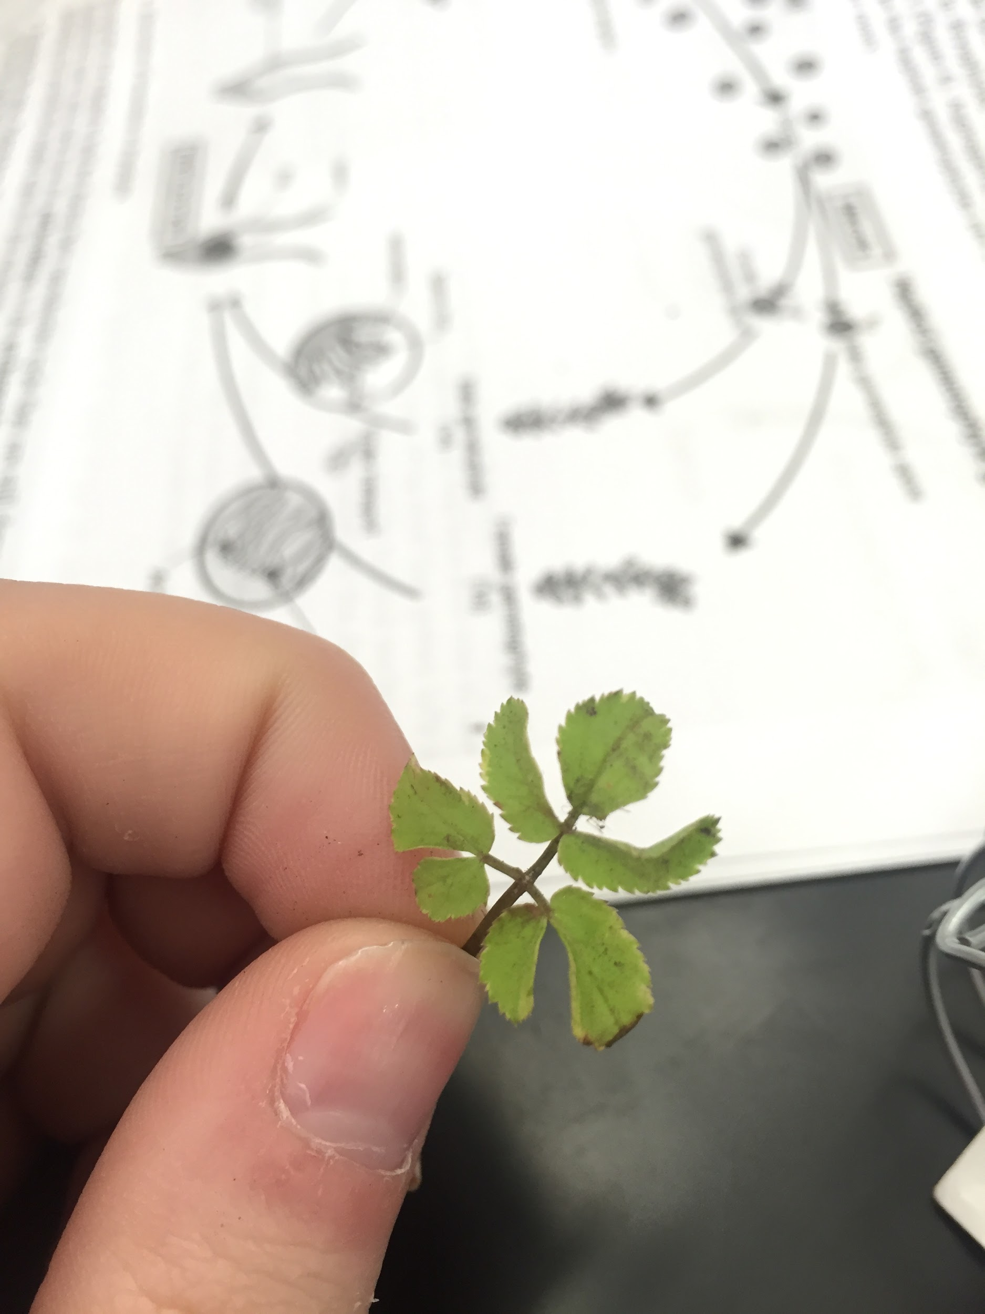

Figure 5: Outer Shell of Walnut Figure 6: Inner Shell of Walnut
