Gephi Upload Protocol
The following is a guide for how to upload files to Gephi from the excel adjacency matrices for our networks.

- Upload the desired excel file to GRNsight
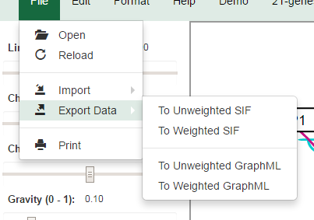
- Export the file to a weighted GraphML format using the file-> export data tab in GRNsight. Save the file in an easily accessibly location, such as the desktop

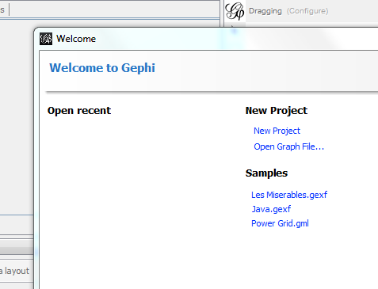
- Open Gephi and select “open graph file”
- Select your file, and the graph should appear on the main page

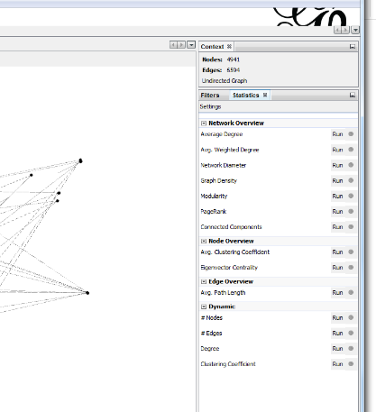
- On the right-hand column of the Gephi window, select the desired graph statistics you wish to run

- To view the output of these statistics, select the “Data laboratory” at the top of the screen

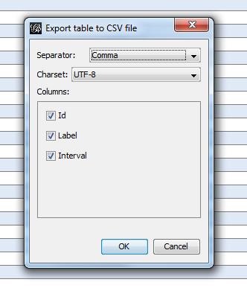
- To export the table, hit the “export table” button on the menu bar for the data laboratory 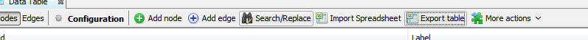
- Select the data columns you want to export, hit “Ok”, save the file and then view the data in excel

