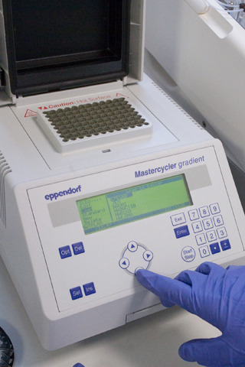
https://www.dur.ac.uk/biosciences/services/cts/gradient_pcr/

