PUID_____________________. This is a short, voluntary survey to assess the previous preparation of the class as a whole and in terms of populations in the class. You may choose not to answer if you wish.

We would like to use portions of data collected in this course for educational research that may result in publications on educational experiences at Purdue University. Publications will enable us to share best educational practices with other engineering institutes and programs. Publication of study results will be in a format that does not allow for data traceability to a specific individual. Please indicate if you are willing to have the responses you have provided in the initial and final online assessments and end of semester survey included in educational research publications. Election to not have your data included in the study will not impact your grade in class.
_____ Yes, please use my survey responses to evaluate the potential of discovery learning on improving student ability to design experiments and incorporate quantitative analysis into life science.
____ No, I prefer for my responses to not be included in this study

_______________________________ What is your major (Biology, Math, etc.)?
_______________________________ What is your class standing (Sophomore, etc.)?
_____ What gender are you? (1=female, 2=male)
_____ What is your approximate GPA currently? (1=>3.75, 2=3.25-3.75, 3=2.75-3.25, 4=2.25-2.75, 5=<2.25).
_____ How recently have you taken a biology course? (1=last sem., 2=last year, 3=2 years ago, 4=3 years, 5=>3 years).
_____ Have you ever taken a statistics course? (1=Yes, 2=No).
_____Have you previously been a participant in the Quantitative Physiology program?
_____If so, how many years?

In the left column, place the number from the right column describing a cellular function next to the matching cell component.
 | Cell component | Function in cell
 | Mitochondria | Generates ATP, 1
 | Ribosome | Phosphorylates proteins, 2
 | Endoplasmic reticulum | Makes and edits proteins, 3
 | Messenger RNA | Packages and transports proteins, 4
 | Protein kinase | Code for amino acid sequence, 5

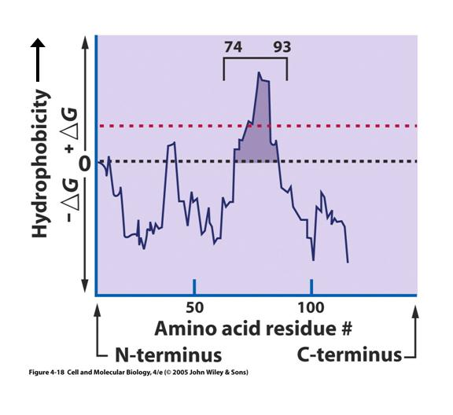
_____ In the hydropathy plot of amino acid residues (right), which amino acid residues would be most likely to be in contact with an aqueous solvent, such as water or the cytoplasm?
A) residues 1-73
B) residues 74-93
C) residues 93-120
D) A and C
E) B and C
_____ The amount of protein expressed and when a protein is expressed is determined by:
A) Amount and when transcription occurs
B) Amount and when translation occurs
C) Amount and when replication occurs
D) A and B
E) A, B, and C
_____ What can be said about the plot to the right:
A) The means of A and B are similar
B) The standard deviations of A and B are similar
C) The modes of A and B are similar
D) A and B
E) A, B, and C
_____ Which of the following comparisons between two sets of measurements are most likely to be statistically significantly different? Values given as number of measurements (N), mean ± standard deviation:
A) 50, 5 ± 1 30, 5 ± 5
B) 3, 6 ± 3.3 6, 3 ± 1.4
C) 1000, 5 ± 1 500, 5 ± 5
D) 1000, 5 ± 0.2 500, 4.7 ± 0.1
E) 1000, 10 ± 12 500, 8 ± 18

A group of 100 female students scored significantly higher than a group of 100 male students on a math achievement test. What conclusions, if any, can be drawn from this result? What additional information, if any, would strengthen the conclusions or allow conclusions to be drawn? (Please answer on the next page)

The graph on the right shows individual measurements of two variables. Describe the relationship, if any, between variable 1 and variable 2 and describe how you would deal with and interpret the point labeled A (Please answer below)

Please draw and label a cell and its components for a cell that you might find in your body (Please answer below).

