Macrophage Isolation Protocol
Materials:
C57BL/6, 8-10 weeks old (IACUC Protocol #2016-0066, covers males only)
Bring to mouse facility: Tweezers, scissors, 50 mL conical tube with medium to store bones
In biosafety hood: 10 mL syringe, 27-gauge needle, petri dish, 15 mL conical tube per bone to separate cells, 100 µm cell strainer, Lympholyte M solution (at room temperature)
Cell culture media
- IMDM, 20% FBS, 2mM L-glutamine, 0.4% Fungizone, 0.8% Pen strep, 0.2% FLT-3, 10ng/mL M-CSF
Methods:
- Sacrifice Animals with CO₂ asphyxiation and cervical dislocation.
- Clean animal with 70% ethanol.
- Remove skin by cutting around midsection and pulling down over the hind legs
- Isolate tibia and femurs within the first 30 minutes from death (This video can help demonstrate: https://www.youtube.com/watch?v=9FWsYQseg-U). Note: Placing bones in cell culture medium for 10 minutes at room temperature allows for easy removal of the muscle tissue.
  - Tibia – dislocate the ankle by moving back and forth until the joint moves freely. Push the knee joint opposite the normal range of motion and push the end of the tibia out the back of the leg. Peel away muscle and then separate bottom of bone from ankle. Scissors may be needed to cut the ligaments, but take caution not to break/cut the bone.
  - Femur – Grab ahold of the pelvis above the head of the hip. Pull on the bone while holding the pelvis to dislocate the hip. Using the thumbnail to apply pressure right above the hip can help. Once the bone is dislocated, carefully cut away remaining muscle.
  - Keep bones in cell culture medium until you isolate the bone marrow.
- Isolate the bone marrow. Do this in the biosafety hood.
  - Take bones and place on a sterile petri dish.
  - Cut across the top edges of the bone off.
  - Fill the syringe with 500uL of tissue culture medium.
  - Place the needle into one side of the bone and flush marrow from bone into cell strainer into a 15mL conical tube.
  - Spin cells at 800 xg for 10 minutes.
  - Aspirate supernatant, leaving a pellet at the bottom of the tube.
  - Resuspend cells in of IMDM cell culture 5 mL medium.
- Separate out macrophages using the Lympholyte M solution (see Figure).
  - Add 5 mL of Lympholyte M solution to the centrifuge tube so that it is below the cell suspension, see picture.
  - Spin at 1300 xg for 20 minutes.
  - Collect cells at interface using a 1 mL pipet (see Fig. D) and place in a new conical tube.
  - Spin at 800 xg for 10 minutes.
  - Resuspend in 10 mL complete IMDM medium.
  - Plate on T-75 flasks and place in incubator at 37ºC.
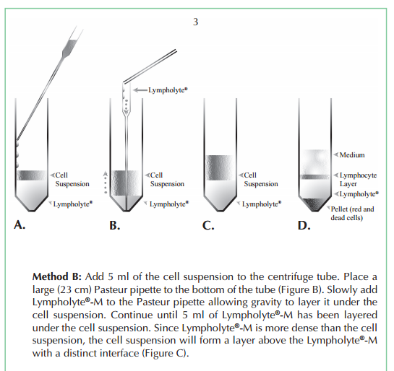
- Feed cells on day 5. You now have M0 macrophages!
  - Some cells are suspension, so take media from each flask and spin at 800 xg for 8 minutes.
  - Aspirate supernatant, leaving a pellet
  - Resuspend cells in new media and add back to the flask.
- To induce M1 and M2 phenotypes on day 7 add IFN-gamma @ 12 ng/mL and 5 ng/mL LPS for 24 hrs (M1) or IL-4 @10ng/mL for 48 hrs (see Becker, L et al, Plos One, 2012).
Note: Protocol adapted from: Jay SM, Skokos E, Laiwalla F, Krady MM, Kyriakides TR. Foreign body giant cell formation is preceded by lamellipodia formation and can be attenuated by inhibition of Rac1 activation. Am J Pathol 2007;171:632e40.

