Yeast Chromosomal Integrations

Cloning
Clone gene of interest into of one of the following plasmids (if you want something other than a TEF promoter and a Cyc1 terminator you have to do more cloning).

Plasmid Number | Selection Marker | Cloning Sites | Map Available?
pCS937 | G418 (Kan) | AvrII / XmaI | yes
pCS938 | HIS | AvrII / XmaI | Yes, but not annotated
pCS939 | URA | AvrII / XmaI | Yes, but not annotated
pCS940 | LEU | AvrII / XmaI | yes

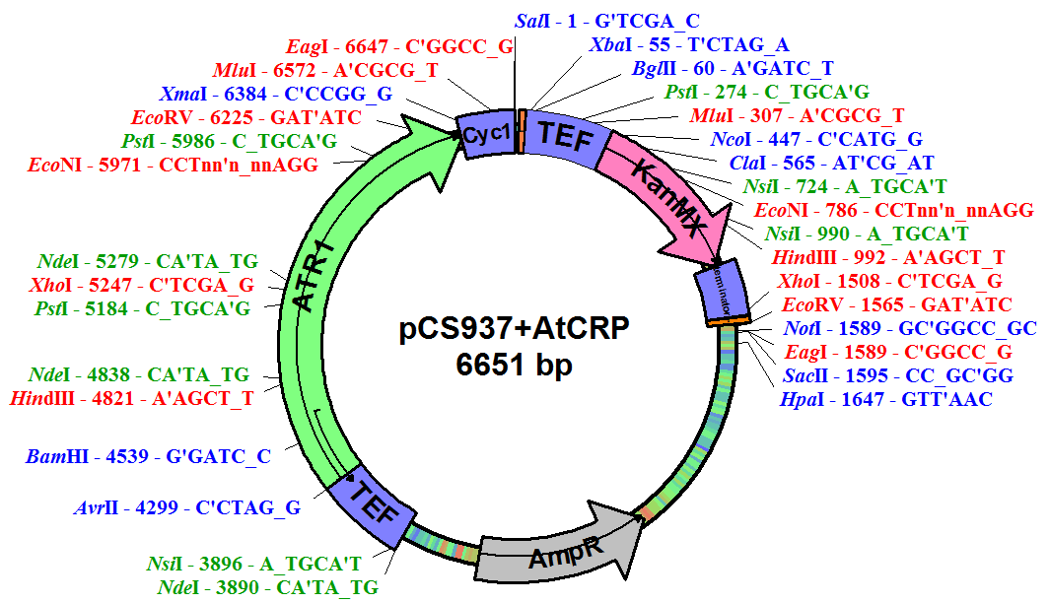
PCR Amplification
For each integration set up two 100µl reactions (target 8-12 µg of amplified DNA). Use Expand high fidelity polymerase (Roche cat no. 11 732 650 001).

PCR mix  78.5µl water  10µl 10x Expand buffer  2µl dNTPs  3µl forward primer  3µl reverse primer  2µl template (plasmid diluted to about 25ng/µl)  1.5µl Expand polymerase | PCR program  Saved as “Expand!!” in Isis’s folder.
   | Temperature | Time | Cycles
  Initial Denaturation | 94C | 2min | 1x
  Denaturation | 94C | 15s | 10x
  Annealing | 60C | 30s
  Elongation | 68C | 3min
  Denaturation | 94C | 15s | 20x
  Annealing | 60C | 30s
  Elongation | 68C | 3min + 5s each successive cycle
  Final Elongation | 68C | 7min | 1x
Primers
Locus | Confirmed to work?
URA3 | Not yet
HIS3 | Not yet
LEU2 | Yes, by Isis
TRP1 | Yes, by Isis
ADE2 | Yes, by Kate
All primers are built in the following way:
-----80bp homology to yeast chromosome----20bp to bind to plasmid----

Primers are already designed to integrate into the loci listed in the table to the right (sequences on last page).

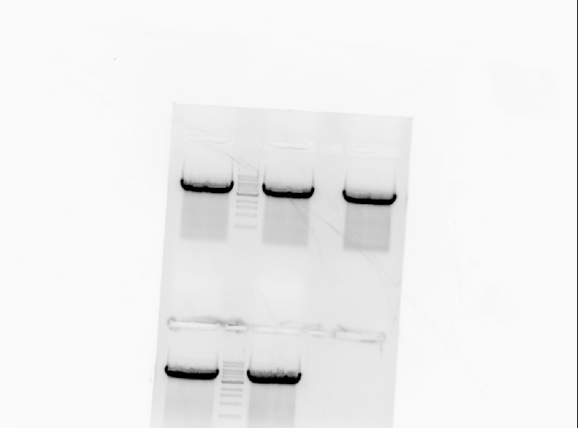
Typical PCR amplification result
If the amplification worked correctly, there should only one, very strong amplification product.

Transformation
DNA preparation
To prepare the PCR product for transformation, use the Qiagen PCR clean up kit on each PCR reaction separately, but elute (using water) into the same tube (giving at total volume of 60µl). It is also possible to directly transform the two PCR reactions (200µl total volume); however, the results can be more variable.

Transformation protocol
Follow the standard yeast transformation protocol, but consider the following notes and modifications:
1. Integrations are more sensitive to the growth state of the cells when the transformation is started so make sure the cells are in the 0.4-0.8 OD600 range. I also think being at the higher end of this range might be better.
2. Don’t use too many cells. If you plate too many cells then the selection doesn’t work as well. I control the number of cells at the step where you resuspend the cell pellet with 50µl for each transformation. I tend to resuspend in 50-100µl per transformation depending on the size of the pellet and then transfer 50µl to new tubes for each transformation, then add the DNA and SSD and PEG.
3. After the 42C bath, spin down the cells and resuspend them in 1mL YPD then let them rotate for 1 hour at 30C before plating.

Screening
If you get many uniformly sized colonies on your plates, then you probably have performed a successful integration! But you should probably screen to confirm.

Primer Choice
To screen, follow the normal yeast colony PCR protocol listed on the Smolke lab wiki. There are two ways you can set up the primers: the super thorough way or the fast way. I usually screen 12 colonies (because this is how many you can fit on a gel after you count the ladder and 2 controls).
1kb ladder
288 T/T
288 T/H
1 T/T
1 T/H
2 T/T
2 T/H
3 T/T
3 T/H
4 T/T
4 T/H
5 T/T
5 T/H

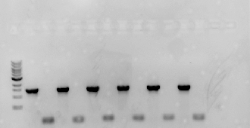
The super thorough way
In this method you screen each colony with two sets of primers: the first set is from locus to locus, meaning the forward primer is on the chromosome before where you integrated and the reverse is on the chromosome after the end of where you integrated. The second set has the forward primer on the chromosome and the reverse primer in the gene you integrated.
When you screen with these two sets, you will get a band for either the first set or the second set of primers, but not both. This way you will know for sure if you have an intact locus or if you have your gene of interest integrated into the locus.
T/T = TRP1.fwd / TRP1.rev; T/H = TRP1.fwd / hCRP.rev. All of these samples are negative for integration into the TRP1 locus.

The fast way
For this method you just screen with the locus forward primer and the gene reverse primer – you end up with a band/no band screen. It is very important to include controls with this method to confirm the PCR reaction is working (background strain with locus forward and reverse primers) and that the locus forward and gene reverse primers do not generate any non-specific amplification products (use them on the background strain).

Definite Confirmation of Integration
After I get what I think is a positive band on the initial screen, I perform another colony PCR starting from the restreaked colony (to confirm the results are reproducible). I do this PCR in 50µl so if the result is positive again, I send it in for sequencing. I use the same primers I used to amplify for sequencing (locus forward and gene reverse).

Primer Name | Sequence | Tm
IJT.HIS3-1.fwd | GCAAGATAAACGAAGGCAAAGATGACAGAGCAGAAAGCCCTAGTAAAGCGTATTACAAATGAAACCAAGATTCAGATTGCAGATTGTACTGAGAGTGCAC | 78.0, 100bp
IJT.HIS3-1.rev | CGTATGCTGCAGCTTTAAATAATCGGTGTCACTACATAAGAACACCTTTGGTGGAGGGAACATCGTTGGTACCATTGGGCCGACTCACTATAGGGAGACC | 78.3, 100bp
IJT.URA3-1.fwd | GGAAGAACGAAGGAAGGAGCACAGACTTAGATTGGTATATATACGCATATGTGGTGTTGAAGAAACATGAAATTGCCCAGAGATTGTACTGAGAGTGCAC | 77.7, 100bp
IJT.URA3-1.rev | CTCTTCCAACAATAATAATGTCAGATCCTGTAGAGACCACATCATCCACGGTTCTATACTGTTGACCCAATGCGTCTCCCCGACTCACTATAGGGAGACC | 77.6, 100bp
IJT.TRP1-4.fwd | GTATACGTGATTAAGCACACAAAGGCAGCTTGGAGTATGTCTGTTATTAATTTCACAGGTAGTTCTGGTCCATTGGTGAAAAGATTGTACTGAGAGTGCAC
IJT.TRP1-4.rev | TATGTTTAGATCTTTTATGCTTGCTTTTCAAAAGGCCTGCAGGCAAGTGCACAAACAATACTTAAATAAATACTACTCAGCGACTCACTATAGGGAGACC
IJT.LEU2-1.fwd | GACTAAATGCTTGCATCACAATACTTGAAGTTGACAATATTATTTAAGGACCTATTGTTTTTTCCAATAGGTGGTTAGCAGATTGTACTGAGAGTGCAC | 77.3, 99bp
IJT.LEU2-1.rev | GACAATTTCAACATCATTGCAGCAGACAAGATAGTGGCGATAGGGTTGACCTTATTCTTTGGCAAATCTGGAGCAGAACCCGACTCACTATAGGGAGACC | 78.3, 100bp
IJT.ADE2-1.fwd | CGGACAAAACAATCAAGTATGGATTCTAGAACAGTTGGTATATTAGGAGGGGGACAATTGGGACGTATGATTGTTGAGGCAGATTGTACTGAGAGTGCAC | 76.9, 100 bp
IJT.ADE2-1.rev | GCTTGGCGCTTATGATTCAAGTTATACAACGAAAATGGAACAGTTTTTATTAAAGCAAGAAGAAGAAGTTCTTGTCAAAGCGACTCACTATAGGGAGACC | 76.2, 100bp
Primers for Amplification
Primers for Screening
Primer Name | Sequence | Tm
HIS3intscreen.fwd | CTTGGCCTCCTCTAGTACACTC | 62.3, 22bp
HIS3intscreen.rev | TTCAGAATGACACGTATAGAATGATGC | 62.9, 27bp
URA3intscreen.fwd | GCGAGGCATATTTATGGTGAAGG | 62.8, 23bp
URA3intscreen.rev | CAATGCGTCCATCTTTACAGTCC | 62.8, 23bp
TRP1intscreen.fwd | AAACGGCAGCCCCGATCTAAAAGA
TRP1intscreen.rev | GAGATAAGTGTGATAAAGTTTTTACAGC
LEU2intscreen.fwd | GAATACTCAGGTATCGTAAGATGC | 60.3, 24bp
LEU2intscreen.rev | GTATTGACTTAAACTCCATCAAATGG | 60.6, 26bp
ADE2intscreen.fwd | CCTTTTGATGCGGAATTGACTTTTTC | 63.6, 26bp
ADE2intscreen.rev | GTTTTTGCTCCAGGTTTGATTCGTG | 64.7, 25bp

