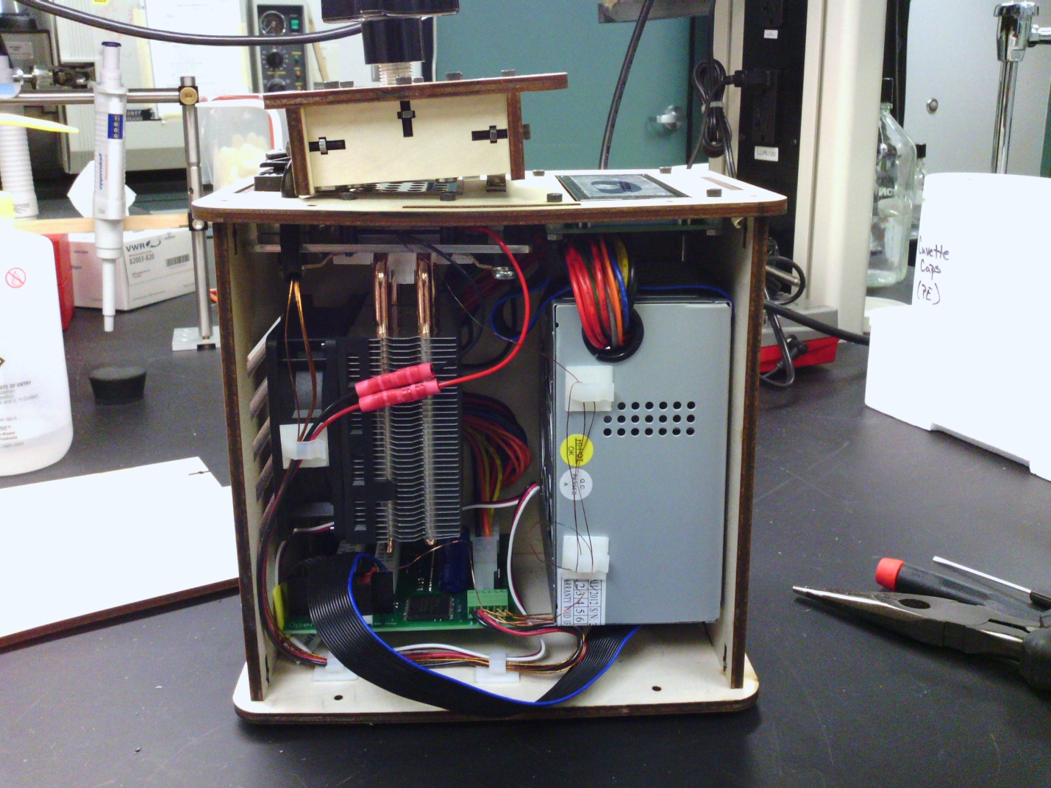
On/off switch+usb port
(Part 7)
Cooling Fan
(Part 5)
Circuit Boards
(Part 6)
Heating Lid (Part 1)
Heating Plate
(Part 2)
Power Supply
(Part 4)
LCD screen
(Part 3)

