Cameron Rehmani Seraji
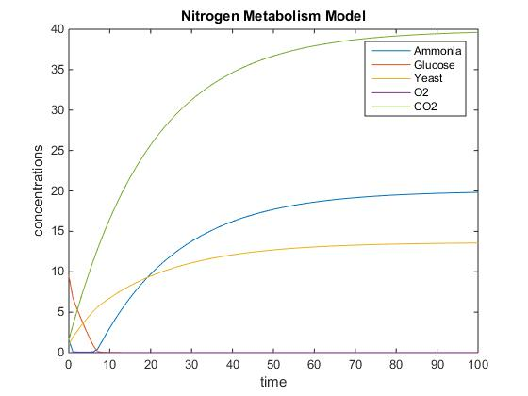
Initial Simulation of Nitrogen Metabolsim
Initial Ammonia = 1.5 g l^-1
Initial Glucose = 9.5 g l^-1
Initial CO2 = 0 mmol g^-1 h^-1
Initial O2 = 1.6 mmol g^-1 h^-1
D = 0.05 h^-1
U1 = 120 g l^-1
U2 = 100 g l^-1
U3 = 40 g l^-1
V = 110 t^-1
R = 15

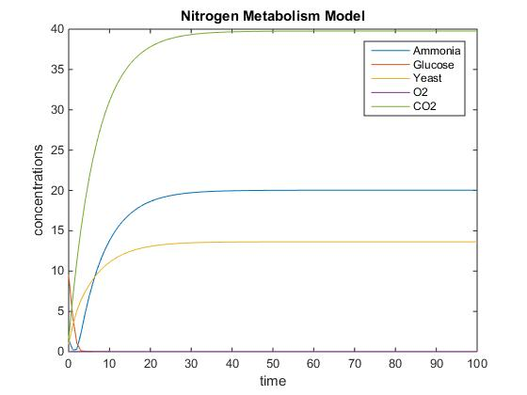
Increase in Dilution Rate Led to the System Reaching Equilibrium Faster
Initial Ammonia = 1.5 g l^-1
Initial Glucose = 9.5 g l^-1
Initial CO2 = 0 mmol g^-1 h^-1
Initial O2 = 1.6 mmol g^-1 h^-1
D = 0.15 h^-1
U1 = 120 g l^-1
U2 = 100 g l^-1
U3 = 40 g l^-1
V = 110 t^-1
R = 15

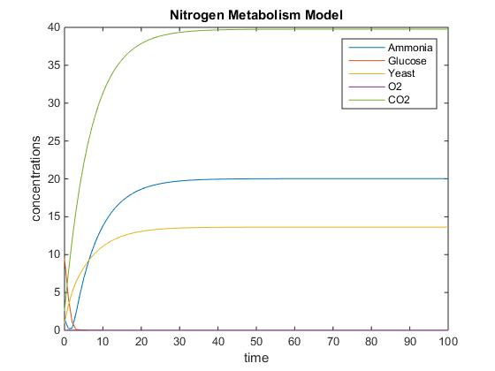
Increase in Initial Concentration of Oxygen Had no Effect on the System
Initial Ammonia = 1.5 g l^-1
Initial Glucose = 9.5 g l^-1
Initial CO2 = 0 mmol g^-1 h^-1
Initial O2 = 2.6 mmol g^-1 h^-1
D = 0.15 h^-1
U1 = 120 g l^-1
U2 = 100 g l^-1
U3 = 40 g l^-1
V = 110 t^-1
R = 15

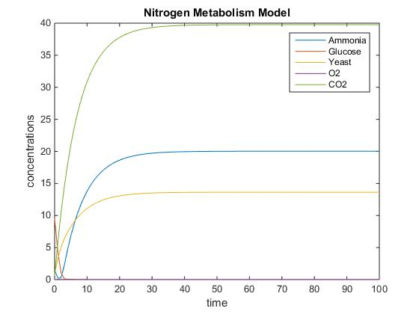
Decrease in Initial Concentration of Oxygen Had no Effect on the System
Initial Ammonia = 1.5 g l^-1
Initial Glucose = 9.5 g l^-1
Initial CO2 = 0 mmol g^-1 h^-1
Initial O2 = 0.6 mmol g^-1 h^-1
D = 0.15 h^-1
U1 = 120 g l^-1
U2 = 100 g l^-1
U3 = 40 g l^-1
V = 110 t^-1
R = 15

