Session 7

Glycerol Stocks & Sequencing Clones

Learning Objective:
In this lab you will prepare several of your clones for DNA sequencing and make glycerol stock cultures as a stable and uniform starting point for future experiments.

Introduction
In order to interpret the results of biological experiments it is necessary to know precisely with what you are working and have the ability to reproduce the biological aspects of an experiment. Molecular and microbiologists find it extremely useful to keep stocks of microbial strains cryogenically frozen, allowing experiments to be started from a consistent source. DNA sequencing is also an extremely useful tool for identifying the exact genetic composition of a strain and verifying successful constructs. Together, these two methods allow scientists to have confidence in controlling the biological basis for an experiment.

Background:

DNA Sequencing
In addition to being a useful tool for studies of biological evolution, phylogeny, microbial ecology, forensics, and healthcare, DNA sequencing provides a way to verify the identity of cloning products. There are numerous technologies still emerging in the field of DNA sequencing. New methods in DNA sequencing include increasing the throughput of existing methods (such as Emulsion PCR) or using “sequencing by synthesis” methods (such as Pyrosequencing and Reversible Terminator methods). However, chain-termination methods are still the most common and cheapest methods for sequencing.

Sanger sequencing is one of the earliest sequencing technologies and still the most frequently used. This method is a chain-termination method which closely resembles PCR; a template DNA strand binds a known primer and is amplified by a polymerase. However, unlike PCR, only one primer is used for sequencing (no reverse primer is needed) and none of the chains reach full length. Instead, before the polymerase can reach the end of the template sequence, a dideoxynucelotide triphosphate (ddNTP) is incorporated into the growing chain. ddNTPs are incorporated identically to their corresponding dNTP. Unlike a dNTP, a ddNTP prohibits additional chain elongation. Because the ddNTPs are incorporated randomly along with dNTPS, chains of various lengths are produced.

Only the final base (the ddNTP) is identified for each chain. This is achieved by separating all of the chains of different length using electrophoresis. The different bases (A, T, C, G) can be identified in the same reaction or in separate reactions. In the classical version of Sanger sequencing, each of the four ddNTP is added to an identical reaction of dNTPs. These products are run on separate lanes and thus each band fixed length and a known base. In a more recent adaptation, fluorescent markers of different colors on the ddNTPs give each band a distinct fluorescent color depending on the terminating base at each position. This allows the sequencing to be done in one reaction and one electrophoresis.

Glycerol Stocks: Preserving the Cloned Strain
An amazing feature of cells is the ability to remain viable after long periods of time at or below -70° C. At these low temperatures, all cellular activity essentially stops. As a result, cells which are defrosted from being cryogenically frozen are the same regardless of when they are defrosted. Biologists use this fact to store stocks of cell lines for long periods of time, growing new cultures from a few frozen cells whenever needed.

Cells cannot simply be cooled to very low temperature and be expected to survive. The water on the inside and outside of the cell expands upon freezing. If nothing is done to protect the cells, they can be crushed or burst by the ice that is formed. To avoid this problem, vitrification solutions are added to the samples to increase the viscosity and decrease the freezing temperature. The vitrified samples remain preserved because they are not damaged as a result of the freezing process. In microbiology, there are two commonly used compounds for vitrification, dimethyl sulfoxide (DMSO) and glycerol. The choice of solution depends on the type of cells being frozen. Glycerol solutions (about 10-20 vol%) are suitable for E. coli and are what we will use for making frozen stocks of our strains.

Session 7: Pre-Laboratory Exercises

Name: Date:

- What is a ddNTP and how does it differ from a dNTP?

- How are chains of different lengths produced in Sanger sequencing?

- How are chains of different lengths separated in Sanger sequencing?

- How is the base at each position in the DNA sequence identified in Sanger sequencing? (Hint: think about reporters)

- Why do biologists use frozen stocks of strains?

- Why is glycerol used for making frozen stocks of E. coli?

Laboratory Protocol

The exercise: You will pick monoclonal colonies from your transformations. You will be amplifying the DNA from these clones by rolling amplification to prepare it for Sanger DNA sequencing; this will be done directly from the colonies without isolating the plasmid DNA. You will also grow culture of these same colonies to be grown and cryogenically frozen for later use.

Materials: Monoclonal Colonies from Transformation
4 PCR Tubes
4 Falcon Culture Tubes
4 Cryo Tubes
Sterile Toothpicks
5 mL Disposable Serological Pipette
Templiphi Sample Buffer
Templiphi Reaction Buffer
Templiphi Polymerase Enzyme
Sterile LB Culture Media
Ampicillin
Sterile 20% Glycerol

Equipment: Heat block
-80° C freezer

Protocol:
- Observe the negative control plate. You should not see any colonies on the negative control plate! If you do, this means one of several things; you need to check stocks for contamination and improve sterile technique.

- Next, check the positive control plate. You should see numerous blue colonies. If you have no colonies at all this means something went wrong with your transformation. There was likely problem with how the cells were handled, the control vector added, or the actual technique for the heat shock transformation.

- Observe the remaining plates for colonies. Ideally, there will be plenty of colonies to choose from, but not so many that they start to touch each other. The colonies should be blue in color because they are expressing a Beta-galactosidase gene which catalyzes a reaction to produce a blue compound. It the colonies are not blue, they still may be the correct construct just expressing the enzyme at too low of a concentration for visible detection.

- Put 2.5 uL sample buffer into each of four PCR tubes. Label the tubes with numbers 1-4 and your initials.

- Put 3 mL LB into four falcon culture tubes. Add 3 uL ampicillin to each tube. Label the tubes with the name of the construct and your initials.

- Very carefully, pick a colony from each of the plates with a sterile tooth pick into one of the PCR tubes. Just touch the colony gently, do not break the surface of the agar. Then, move the tooth pick to the proper falcon culture tube. If you do not have four successful transformations, ask your instructor for an additional colony to sequence.

- Place the falcon culture tubes into the incubator at 37C

- Heat the PCR tubes to 95C for 3 minutes to break open cells and separate DNA.

- Add 2.5 uL of the reaction buffer and 0.1 uL of the enzyme (Hint: use a master mix) to each of the PCR tubes

- Incubate the PCR tubes at 30C overnight

- When the LB cultures are turbid (cloudy) pipette 0.7 mL of each culture into sterile cryo tubes.

- Add 0.7 mL sterile 20% glycerol to each cryo tube and freeze the tubes at -80C.

Session 7: Post-Laboratory Exercises

Name: Date:

- Cloning: Complete (Essentially…)
You have essentially completed the necessary steps for cloning a gene (you should remember, though, that verifying whether your product is correct, via sequencing or another method, is a crucial step in the cloning process). Referring back to the previous sessions, draw a schematic of the different steps in the cloning process and briefly describe what you did in lab for each of these steps. Include the names of all techniques, DNA parts, and enzymes you used for each step.

- DNA Sequencing

In this session, you prepared your cloning products for sequencing and in the next session you will be analyzing those results.

  - In the classical Sanger sequencing method, 4 separate reactions are run. Each reaction contains all of the dNTPs, DNA polymerase, the DNA to be sequenced, and a sequencing primer. What else is added to the 4 reactions?

  - Suppose we ran a sequencing reaction with only the nucleotides ddATP, dTTP, dCTP, and dGTP. Explain what would happen during the sequencing reaction and why this is not useful for sequencing.

  - Consider the following sequence. Suppose we use the primer 5’-TCAGT-3’ and run a classical Sanger sequencing reaction. We set up 4 reactions and then run a gel to separate the bands. Draw a gel and the locations of the bands from the sequencing run. Be sure to label the four lanes.

5’-TCAGTAGCGTAGCACCTAG-3’
3’-AGTCATCGCATCGTGGATC-5’

  - Current methods with different color fluorescently labeled nucleotides require only one reaction and use automated DNA sequencers. This is the method we will use in this class. Suppose we get the chromatogram as shown below. Write out the sequence this corresponds to. Green=A, Blue=C, Black=G, Red=T

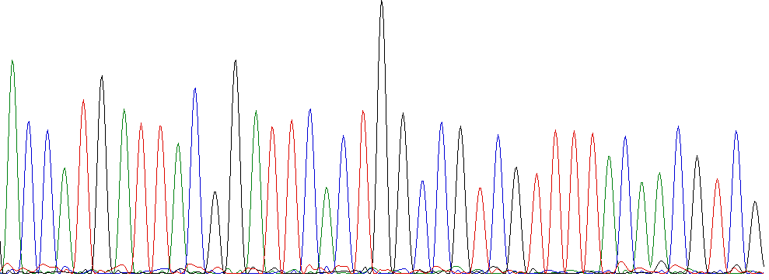

  - Using the previous DNA sequence, figure out what gene this sequence is likely from. To do this, you will use BLAST (http://www.ncbi.nlm.nih.gov/BLAST/). You can think of BLAST as a DNA sequence search engine. Click on nucleotide blast. Enter your sequence in the top box. Under database, choose “Others” and the “nucleotide collection (nr/nt)” and hit BLAST. Can you figure out what gene this sequence corresponds to?
(Hint: this is a very commonly used gene and so appears in many plasmids. Try to find the BLAST results that match a genome.)

References & Additional Reading

Wikipedia:
DNA Sequencing: http://en.wikipedia.org/wiki/DNA_sequencing

