Microteaching topics – solutions
Department of Biological Engineering TA Training

Here we include brief solution outlines, so you can focus your efforts on how best to teach the topic at hand, and not on wondering whether you have correctly solved the problem.

1. Free energy and ATP hydrolysis

The hydrolysis of ATP to ADP and inorganic phospate has a standard reaction free energy of about -30 kJ/mole at body temperature.

- If the reaction goes to equilibrium, what is the ratio of ADP:ATP at a 1 mM phosphate concentration? What does this result imply about hydrolysis in the body?

Get to $ΔG=-RT lnK$ and K = 1.14*10⁵.
K, equilibrium constant, is also $\frac{\left[ADP\right][Ppi]}{\left[ATP\right][H2O]}$.
The tricky part is that [H₂O] is taken as 1 M, leading to a ratio of 10⁸.
Hence, hydrolysis is highly favored.

- Often ATP hydrolysis is coupled to a needed cellular reaction (e.g., sugar processing) with a positive free energy change, making the overall paired reaction spontaneous. Physically, how might an enzyme work to couple two reactions, i.e., to ensure that they only proceed simultaneously?

The active site can bring components from disparate reactions together.

- If ATP hydrolysis is not coupled to a cellular process, what happens to the released free energy?

Lost as heat.

2. Protein-ligand binding parameters

A simple model for a ligand L binding to a protein can be written y = L/(L+K_{D}), where y is the fraction of the protein that is bound, and K_{D} is the dissociation constant of the reaction.

- Sketch the curve y vs. L. To do so, explicitly consider how the L:K_{D} ratio affects the magnitude of y.

Consider extrema (L>> or << KD) and equality (L=KD) to determine y values/equations as 1, linear, and 0.5 .

- The curve from part a) can represent the oxygen-binding protein myoglobin. Whereas myglobin has one site for binding oxygen, hemoglobin has four sites that are strongly positively cooperative. It also has a lower affinity for oxygen than does myoglobin. Draw both proteins’ binding curves on the same plot and discuss them.

Myoglobin should start at 0, increase linearly at first, then curve and plateau.
Hemoglobin should display a sigmoidal shape.

3. Conformational entropy

Discuss the Boltzmann formulation of entropy (S = k ln W), and apply it to a simple biological example. For example, you might talk about protein folding.

- If you model the native protein as having precisely one state, what is its entropy? How realistic is this model?

S = k ln(1) = 0! But there may be a few equivalent states, probably not realistic.

- What is the entropy of a protein with N amino acids and 2 available orientations per bond (bond angles), if it samples all possible conformations? Does sampling this many conformations seem physically feasible?

Multiplicity is at least 2^N (depending on assumptions about bonds). And N is at least on order of 100. So S = k ln (2^100) is not feasible to sample completely.

- Consider the protein as a system of interest. If its entropy decreases on folding, what must happen to the entropy of the surroundings, and by what processes might this change occur?

Entropy of surroundings should go up. Order of water decreases.

4. Metabolic network adaptation

Describe the role of Hif-1α in the mechanism by which metabolic networks adapt at the gene expression level to varying pO₂. Consider cells that are near a source of oxygen (e.g., a blood vessel; call this situation zone A) and cells that are remote from it (call this zone B).

As pO₂ decreases, Hif 1-alpha expression increases (hence Hypoxia-Inducible Factor). At high oxygen tension, Hif is marked for degradation. At low oxygen tension, Hif becomes active, and this transcription factor affects target genes related to angiogenesis and cell survival, among many others. Iron metabolism adaptations triggered by Hif regulation include upregulation of genes related to both transfer and oxidation. Glucose metabolism adaptations include a shift to oxygen-independent glycolysis and an increase in glucose uptake. Notably, overexpression of Hif-1alpha is present in some tumors.

5. Proton availability in a cell

How many free protons are there in a cell? A billion, a million, a hundred? We often take protons for granted because they are abundantly available to organic chemists, who are able to contrive reaction conditions to suit their purposes (see Figure). In a cell, however, the situation may be different. This problem involves calculation of the number of protons in an E. coli cell – that is, free protons available to participate in chemical reactions.

- Please calculate the volume of the cell, approximating it as a cylinder 1 micron wide and 2 microns long.

$V=πR^{2}h$ yields 1.571 * 10⁻¹² cm³ when units are correctly exponentiated

b) Given the volume of the cell, at pH 7 how many protons are contained within it?

By definition, pH 7 means [H+] is 1*10⁻⁷ mol/L.
Conversions to cm³ and molecules/mole yields ~95 protons.

c) A bacterial cell contains thousands of macromolecules such as proteins and nucleic acids that have ionizable groups. What does this calculation tell you about the role of the H+ and OH- in the chemistry of acid-base reactions in the cell?

It appears that protons are limiting.

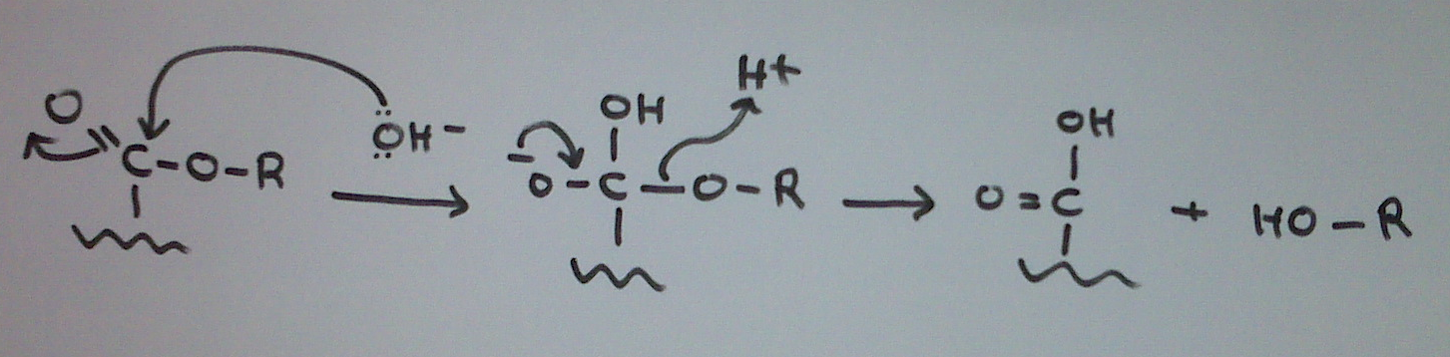

6. Protein mutant structure and thermodynamics

Consider a protein-protein interaction A+B <-> C, where C is the complex. The ΔΔG values for the binding reactions of three mutants of protein A are shown below. The wild-type protein A has Leu at position 100 and Ile at position 110.

Amino Acid Position |  | ΔΔG = ΔG_{mut} - ΔG_{wt} (kcal/mol)
100 | 110 | ΔΔG = ΔG_{mut} - ΔG_{wt} (kcal/mol)
Asp | Ile | 0.5
Leu | Lys | 0.4
Asp | Lys | -2.0

- Assume that the mutations have a negligible effect on the free energy of protein A. Compute the ΔΔG values for the following transitions, where (X,Y) indicates X at position 100 and Y at position 110:
(Leu,Lys) to (Asp,Lys)
(Asp,Ile) to (Asp,Lys)
We can write thermodynamic cycles:
(Leu, Lys) (Leu, Ile) (Asp, Lys) = -(0.4) + -2.0 = -2.4.
The first term is negative because now WT is the final and MUT the initial state.
Similarly, in the second case the answer is -2.5.

- The mutations occur in close proximity to the binding site of B on A. Propose an explanation for why the double mutant has a negative value ΔΔG and the single mutants have positive values. Your answer should make a prediction for the molecular properties of the surface of B in the vicinity of these mutations.
Leu and Ile are hydrophobic, while Asp and Lys are acidic and basic, respectively. Thus, the surface of B would appear to be sensitive to having a neutral charge and likely itself has both acidic and basic moeities.

7. Interplay between convection, reaction, and diffusion

- A perfectly adsorbing sensor is placed in an infinitely sized bath of molecules and the steady-state binding current is measured. Next, a stir bar is added to the system in order to create flow past the adsorber. Does the steady-state binding rate increase or remain the same? Explain why.

With a perfect adsorber, stirring will reduce the size of the depletion region, thereby
increasing the concentration gradient which results in an increase in binding rate.

- A perfectly adsorbing sensor is placed in the microchannels below under different flow conditions. The top sensor collects every molecule that flows into the channel; the bottom sensor does not. Channel/sensor dimensions are identical for each case. Explain which sensor has the greater binding rate, or if they have equal binding rates, or if there is not enough information to tell.

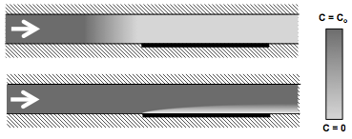

Since the depletion in region in the bottom channel is smaller, the flux is larger.
Given that the geometry is the same, the flow rate is expected to be larger in the
bottom channel. For a perfect adsorber (i.e. no reaction), increasing the flow rate
will always increase the binding rate.

8. Three short answer, independent questions about fluid dynamics

Answers only below; see other handout for problem statement.

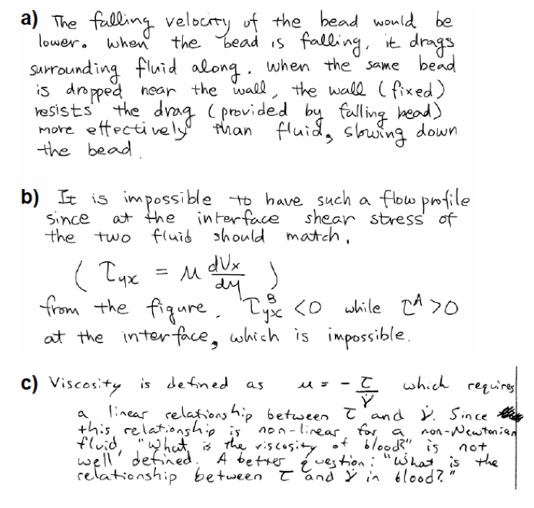
9. Short answer biomechanics questions, 1

- The cellular tensegrity model is often described as “action‐at‐a‐distance effect,” such that force application or mechanical deformation at one end of the cell can result in cytoskeletal or nuclear displacements in the center of the cell or the other end of the cell more than 10–20 micrometers away. Under what circumstances would you expect this model to hold true? Describe both general model assumptions and a specific biological example.

For tensegrity to act at a distance, the length scales for the “rigid” rods and elastic filaments would have to be on the order of magnitude of the cell (as is the case if we consider them to be actin stress fibers or microtubules).

- How does this “action at a distance” compare to the deformation behavior we would expect from scaling analysis (force or energy) for a homogeneous elastic linear isotropic (HILE) continuum mechanics model of a cell?

Energy dissipation would predict that deformations drop off quickly (over a distance characterized by the size of the probe used to apply force) away from the site of force application or applied strain in the continuum models.

10. Short answer biomechanics questions, 2

- In the biopolymer model for cell mechanics and filament networks, why does the bulk elastic modulus depend both on the polymer/filament density (i.e. solid volume fraction) and the cross‐link density (as reflected in the distance between cross‐links or entanglements)?

Cross‐linker density determines if individual filaments are physically connected and what the effective lengths between force application points is (labeled Le in our analysis). In other words, at low cross‐linker densities, the load is carried by fewer fibers (even at the same fiber concentration), while at high‐cross linker densities, the mesh size is comparable to the effective length Le.

- How would you expect the hydraulic permeability of a material (e.g., collagen gel) to change as the solid fraction increases? Why?

Permeability would fall because of increased drag on the fibers.

- Although we only spoke in class of isotropic poroelastic materials, i.e., those having the same permeability for flow in every direction, many biological materials are anisotropic. Give one example of a tissue that you expect would have anisotropic permeability, and explain why.

Cornea, due to the highly aligned collagen filaments. The same is true for ligaments and tendons, muscle, and several other tissues.

