Session 4

Plasmid Mini-Preparation & Restriction Digestion

Learning Objective:
The goal of this exercise is to become familiar with the procedure for isolating plasmid DNA from bacteria and running a restriction endonuclease digestion.

Introduction
Our ability to engineer biology depends on our ability to move DNA into and out of cells; today we will focus on out. Isolating small DNA (plasmids) from cells is a frequent procedure in molecular biology. Vector sources are maintained in strains for ease of mass production through culturing. Vectors maintained in strains and isolated for use need to be prepared to accept insert DNA. This is done by restriction digestion. Restriction digestion will cut a circular plasmid to make it linear; leaving ends which are compatible with other pieces of DNA cut with the same endonucleases. We will use this principle to prepare both our vector and PCR amplified product.

Background

Isolating DNA from a Cell
Removing DNA from a cell is a relatively simple process, especially when it comes to small plasmid DNA. The first step in this process is to break open the cells in a process called lysis. In this step, the cell membrane is disrupted with the use of a detergent and base and sometimes the use or physical means like sonication or pressing. Insoluble cell debris is then removed from the solution containing the soluble DNA. The next step involves purifying the DNA to remove unwanted proteins and salt. This is done by using isopropanol and ethanol to precipitate the DNA to an insoluble form and by selectively binding the DNA to silica beads. With the DNA firmly tied up, it can be washed to remove impurities. The final step is to elute the DNA from silica beads and re-dissolve it in water or the desired buffer solution. While the exact steps of this procedure vary depending on the location and size of the DNA and the type of cells being used, the basic steps are the same: break open the cells, purify the DNA, and re-suspend the DNA.

Restriction Endonucleases
An enzyme is a protein which catalyzes a chemical reaction. A restriction endonuclease is an enzyme which cleaves DNA in a specific location which is referred to as a recognition sequence. Recognition sequences can vary in length but are typically around six basepairs. Recognition sequences are typically inverted repeat palindromes, this means that the sequence reads the same regardless of the DNA strand on which it is located. For example the sequence: 5’-TCTAGA-3’
will have a complementary sequence of: 3’-AGATCT-5’
When the complementary sequence is read in the proper 5’ to 3’ orientation (right to left in this case) it is identical to the original sequence (read left to right). Different enzymes can share the same recognition sequence, these are called isoschizomers if they cut the DNA in the same location, and neoschizomers if they cut the DNA in different locations.

Depending on how and where the enzyme cuts the DNA, the result will be different. For instance the sequence 5’-GGGCCC-3’ can be cut in the middle on both stands by one enzyme (SmaI) to produce two new fragments, 5’-GGG-3’ and 5’-CCC-3’. Alternatively, the same sequence can be cut by a different enzyme (XmaI) to produce different ends, 5’-G-3’ and 5’-GGCCC-3’. Because the cut location is in the same relative location of the sequence on both strands, the results of the two cuts are very different:
Original: 5’-GGGCCC-3’
3’-CCCGGG-5’

SmaI: 5’-GGG-3’ + 5’-CCC-3’ XmaI: 5’-G-3’ + 5’-GGCCC-3’
5’-CCC-5’ 3’-GGG-3’ 3’-CCCGG-5’ 5’-G-3’

The cut produced by SmaI is referred to as a blunt-end, while the cut from XmaI produces an overhang sequence on one of the DNA strands which is referred to as a sticky-end or cohesive-end. The overhangs are called “sticky” because, despite no long being covalently bonded, the two strands “prefer” to remain paired because of favorable thermodynamic energetics, meaning they spend a great amount of time paired than unpaired.

It is possible for overhangs produced from different enzymes cutting different recognition sequences to produce ends with compatible sticky ends. As an example:

XbaI: 5’-TCTAGA-3’ Cuts to 5’-T-3’ + 5’-CTAGA-3’
3’-AGATCT-5’ 5’-AGATC-5’ 3’-T-3’

SpeI: 5’-ACTAGT-3’ Cuts to 5’-A-3’ + 5’-CTAGT-3’
3’-TGATCA-5’ 5’-TGATC-5’ 3’-A-3’

Notice that the overhang regions by both cuts are the same (5’-GATC-3’). Therefore, these overhangs are complementary and can pair just as well as those from just one cut. However, if the two sequences are joined permanently, neither restriction enzyme is capable of cutting the product. This scar, shown below, is the result of changing the six-base sequence so that it is no longer a palindrome and therefore not recognized by either enzyme.

XbaI + SpeI: 5’-T-3’ + 5’-CTAGT-3’ = 5’-TCTAGT-3’
3’-AGATC-5’ 3’-T-3’ 3’-AGATCA-5’

SpeI + XbaI: 5’-A-3’ + 5’-CTAGA-3’ = 5’-ACTAGA-3’
3’-TGATC-5’ 3’-T-3’ 3’-TGATCT-5’

Session 4: Pre-Laboratory Exercises

Name: Date:

- How is DNA isolated from cells?

- What is an enzyme?

- What does a restriction endonuclease do?

- What are “sticky-ends” and why might they be better to use for cloning than “blunt-ends”?

Laboratory Protocol

The exercise: In this lab you will extract pSB4A5 plasmid DNA from Escherichia coli using a plasmid mini-prep protocol. You will then digest this vector with EcoRI and PstI while you digest your PCR product from last week using XbaI and PstI.

Materials: Pellet bacterial cells containing pSB4A5
QIAprep buffers P1, P2, N3, PB, PE
Deionized, sterile H2O
PCR Product from Session 3 (to be digested)
Restriction enzymes (EcoR I, Xba I and Pst I)
NEB buffer 2
BSA (bovine serum albumin)
Deionized, sterile H2O
Pipette Tips
Microcentrifuge tubes

Equipment: Microcentrifuge
Vortexer
37° C incubator

Protocol: Part I – Plasmid Mini-Prep

- Completely re-suspend pelleted bacterial cells by vortexing in 250 μl Buffer P1 and transfer to a microcentrifuge tube. No cell clumps should be visible after resuspension of the pellet. The bacteria should be resuspended completely by vortexing or pipetting up and down until no cell clumps remain.

- Add 250 μl Buffer P2 and mix thoroughly by gently inverting the tube 4–6 times, do not vortex. The cell suspension will turn blue. Do not allow the lysis reaction to proceed for more than 5 min.

- Add 350 μl Buffer N3 and mix immediately and thoroughly by inverting the tube 4–6 times. The solution should become cloudy and all trace of blue should vanish leaving the suspension colorless.

- Centrifuge for 10 min at 13,000 rpm (~17,900 x g) in a table-top microcentrifuge. A compact white pellet will form.

- Apply the supernatants from step 4 to the QIAprep spin column by decanting or pipetting.

- Centrifuge for 30–60 s. Discard the flow-through.

- Wash the QIAprep spin column by adding 0.5 ml Buffer PB and centrifuging for 30–60 s. Discard the flow-through.

- Wash QIAprep spin column by adding 0.75 ml Buffer PE and centrifuging for 30–60 s. Discard the flow-through.

- Centrifuge for an additional 1 min to remove residual wash buffer.

- Place the QIAprep column in a clean microcentrifuge tube. To elute DNA, add 50 μl water to the center of each QIAprep spin column, let stand for 1 min, and centrifuge for 1 min.

Part II: Restriction Digestion of Plasmid and PCR Product

Use the amounts listed below for each of the two digestions:

5 μL NEB2 buffer
42.5 μL DNA (mini-prepped pSB4A5 DNA or PCR product).
0.5 μL 100X BSA
1 μL PstI
1 μL Second restriction enzyme(EcoRI or XbaI)

- To two different microcentrifuge tubes, add the appropriate amount of pSB4A5 Plasmid and PCR product DNA.

- Add restriction enzyme buffer to each tube.

- Add BSA to each tube. Vortex BSA before pipetting to ensure that it is well-mixed.

- Add 1 μL of PstI enzyme to each reaction. IMPORTANT: enzymes are extremely temperature-sensitive and should be kept on ice at ALL times when not in use! Also, the enzyme is in glycerol which tends to stick to the sides of your tip. To ensure you add only 1 μL, just touch your tip to the surface of the liquid when pipetting.

- Add 1 μL of EcoRI to the pSB4A5 digestion and 1 μL of XbaI to the PCR product digestion.

- Mix and vortex the reaction mixtures one final time.

- Quickly spin reaction mixtures (5 s) to collect all liquid in the bottom

- Place in incubator at 37°C. Your instructors will remove the digests and inactivate the enzyme for you later.

Session 4: Post-Laboratory Exercises

Name: Date:

- Laboratory Project Overview
Here, again, is our lab schematic (adapted from MIT’s 20.109 DNA Engineering Module: http://openwetware.org/wiki/20.109(F08):Module_1). Please answer the questions that follow.

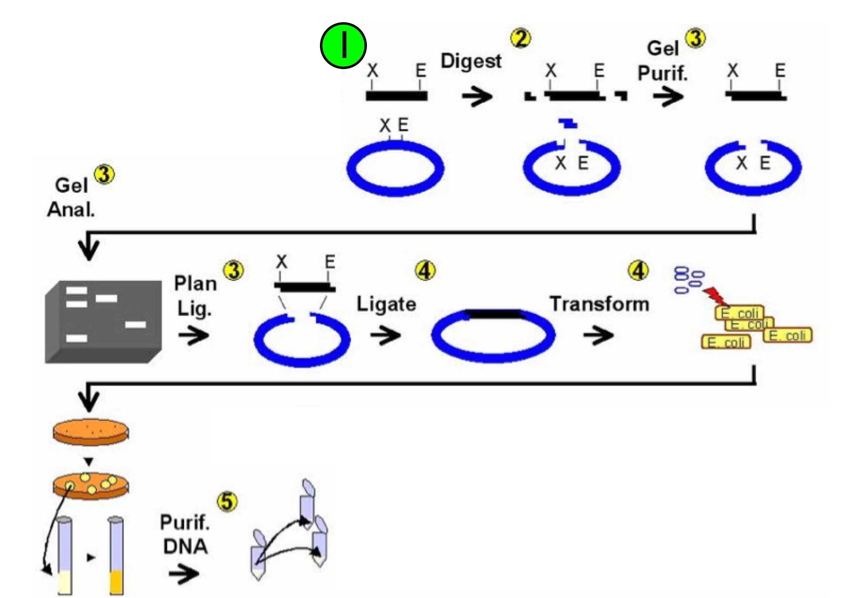

- Which steps in the process did you perform in Session 4? Refer to the step name(s) that appear(s) above the arrow (e.g. “Digest”, “Ligate”, etc.) rather than the number(s). Give a brief summary of the step(s).

- One of the major things that you did in Session 4 is not on the schematic. What is it? Give a two sentence description of this step.

- Go to the New England Biolabs (NEB) website (http://www.neb.com). From the homepage, click on “Products” and then “Restriction Endonucleases.” Find the four enzymes that we are going to use in this class (EcoRI, PstI, SpeI, and XbaI).

  - For each enzyme: list the recognition sequence, describe (draw) the DNA after the cut has been made (overhang), and describe the inactivation conditions.

  - How is a unit of restriction endonuclease activity defined?

- Use the information at the end of the homework (NEB pages) to answer the following questions about the sequence below:

5’ – ATTAGTCTAGAAATTCGCGACTAGTCAGCA - 3’
3’ – TAATCAGATCTTTAAGCGCTGATCAGTCGT - 5’

  - Draw the products of XbaI digestion of this sequence.

  - Draw the products of SpeI digestion of this sequence.

  - Can any of these products (from the XbaI and SpeI digestions) be ligated to form a new product? Draw them. Do not include potential products from blunt-end ligations.

  - Can this resulting fragment be cut by XbaI or SpeI? Why?

- Describe the location of DNA for each step in Part I of today’s protocol.

- Plasmid digestion problem

References & Additional Reading

Wikipedia
Enzyme: http://en.wikipedia.org/wiki/Enzyme
Restriction Endonuclease: http://en.wikipedia.org/wiki/Restriction_endonuclease

