Tissue Engineered Artificial
Pancreas

Chem Eng 590B
R01 Grant

The pancreas is a vital organ that is affected by several diseases that interfere with the pancreas’s functions, such as pancreatitis and pancreatic cancer. Pancreatic cancer is hard to detect and as a result it is known as one of the most fatal cancers with only a 7% survival rate after 5 years. Due to the fatality rate, several institutions are searching for solutions, but currently there is no replacement for pancreatic tissue while complete removal of the pancreas is deadly. As a result, our research group is aiming to engineer a total pancreas replacement.
The engineered pancreas must be able to perform a wide variety of functions; specifically, it must be able to perform the functions of the two main structures in the pancreas, the islets and the acini. The islets are spherical clusters of cells that produce hormones such as insulin, which regulates sugar metabolism. These hormones are all regulated through specific paracrine interactions from islet cell structures. The acini structures are smaller clusters of cells that are connected by small tubular structures to the main pancreatic duct, which is connected to the duodenum. These structures release digestive enzymes and bicarbonate ions for pH regulation into the small intestine. The acini structures are involved in exocrine functions and are regulated by hormones that come from the stomach and intestine. In order to achieve these structures in our engineered pancreas we will electrospin nanofibrous and microfibrous scaffolds that will be shaped into the islet and acini structures.
Electrospun nano/micro fibers are an inexpensive way to produce scaffolds for cell seeding. The fibers produced can be manufactured to regulate the microscopic mechanics of the scaffold, which translates to efficient cell adhesion and proliferation. A one-step fabrication that integrates living cells into the scaffold as it is spun could be used to reduce the time needed for manufacturing. Core-shell electrospun microfibers can also be used; these will create hollow fibers for acini structure capillaries. The scaffolds created by this process will be used along with magnetic nanoparticles to allow for 3D cell seeding.
Magnetic nanoparticles (MNP) provide a multitude of applications towards tissue engineering. One of the useful applications that we will be taking advantage of is cell seeding through magnetically labeled cells. MNPs provide an efficient way to seed cells into a 3D scaffold at a fast and relatively low cost. Cell density and distribution is controlled by the use of magnetic fields. Not only will this method improve cell distribution, but it will also increase the total number of cells adhered to the scaffold. The success of the engineered tissue is dependent on the distribution of cells throughout the scaffold, so this method should provide the optimal conditions for biofabrication.
Aim 1: Utilize a combination of collagen and polyethylene glycol (PEG) to electrospin nanofibrous and microfibrous scaffolds that will be shaped into acini and islet structures.
Hypothesis: An electrospun layer of collagen on top of the polyethylene glycol (PEG) will be able to produce a scaffold to which adult pancreatic stem cells will effectively bind and maintain its structural integrity as it is shaped into the desired structures.
Method: This will be tested by creating a cell adhesion profile based on defined fiber thicknesses as well as a modulus profile based on stress strain measurements. These profiles will be used to determine the best balance between adhesion and material resilience.
Aim 2: Use synthetic expanded Polytetrafluoroethylene (ePTFE) from existing vascular graft technology used by Gore® to form the main pancreatic duct. The duct will connect with capillaries to acini structures that are formed by core-shell electrospun Poly-lactic acid (PLA)/Chitosan (CS) microfibers.
Hypothesis: Main pancreatic duct made from ePTFE with capillary branches will link microfiber capillary connections to support acini structures for release of digestive enzymes and bicarbonate ions.
Methods: Structural integrity of the joints connecting biodegradable core-shell electrospun PLA/CS microfiber capillaries to the main synthetic ePTFE pancreatic duct will be assessed through structural analysis of mechanical moduli and elasticity of the tubing.
Aim 3: Seed 3-D islet and acini scaffolds with adult pancreatic stem cells labeled by magnetic nanoparticles via an electromagnetic device (magnetic tweezers) to achieve proper cell distribution throughout the scaffold.
Hypothesis: Magnetic driven cell seeding provides proper cell distribution while also increasing the amount of adhesion and proliferation of cells into the 3D scaffold.
Method: Cells will be labeled with iron oxide magnetic nanoparticles through endocytosis while incubating the cells in culture medium. With the aid of tweezer electromagnets to control the magnetic field, cell seeding will infiltrate the 3D scaffold to the desired locations and densities. Cell densities and distribution will be observed through fluorescent cell detection.
Significance

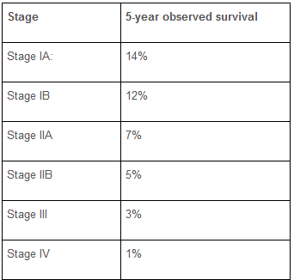
The pancreas is a very important organ, which is located behind the stomach. This organ creates, stores, and releases essential digestive enzymes and hormones that aid in digestion. Pancreatitis is an inflammation of the pancreas, and is caused when digestive enzymes are not released properly and start breaking down pancreatic tissues. Cystic fibrosis is another disease that can lead to improper release of digestive enzymes, leading to pancreatitis. A replacement pancreas would reduce symptoms of cystic fibrosis, but not completely cure it. Pancreatic cancer is the fourth most common cause of cancer death and one of the deadliest with nearly all patients dying within 5 years of diagnosis. If caught before metastasis, the cancer can be removed with the pancreas and replaced by a tissue engineered artificial pancreas.

Figure 1. 5-year observed survival rate for pancreatic cancer diagnosed at various stages. [4]

Pancreatic cancer is one of the most fatal of cancers, with a mean 7% survival rate 5 years after diagnosis [4]. This cancer is hard to detect, and there is currently no replacement for pancreatic tissues. Removal of the pancreas is deadly, so if a replacement could be made, these problems would be resolved. The tissue needed to replace the pancreas can be created from differentiated stem cells. The source of these stem cells would come from adult tissue specific stem cells. The existence of tissue specific pancreatic stem cells (PSC) has only recently been verified. Such stem cells would need to come from actual pancreatic tissue and would need to be cultured with specific scaffolding to produce the correct structures. Hormones may need to be introduced to the growing tissue so that the differentiating cells have the ability to produce the necessary enzymes for its various functions [1].

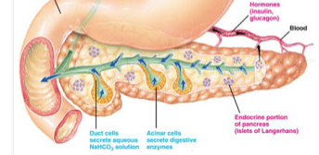
The engineered tissue needed to replace the pancreas must be able to able to perform a wide variety of functions. There are two main structures that provide the necessary functions in the pancreas, the islets and the acini. The islets are spherical clusters of cells that produce hormones such as insulin, glucagon, somatostatin and ghrelin in response to blood glucose, which regulates sugar metabolism. These hormones are all regulated through specific paracrine interactions from the α and β cells that make up the islet structures.
Figure 2. Pancreas showing endocrine (islets) structures and exocrine (acini) structures and their dual functions.

The acini structures are smaller clusters of cells that are connected by small tubular capillaries to the main pancreatic duct. This duct is connected to the duodenum and releases digestive enzymes into the small intestine. The acini structures are involved in exocrine function and are regulated by hormones that come from both the stomach and intestine. The digestive enzymes released are used to break down lipids and proteins. Bicarbonate ions are also released from acini capillaries with these secretions to raise the pH of the contents coming from the stomach. The engineered pancreatic tissue must contain all of these structures and be able to produce the wide range of hormones and enzymes needed for digestive function. The tissue must also have the ability to properly regulate the amount of hormones and enzymes it produces.

Innovation

A: Engineering Acini and Islet Structures by Electrospinning.

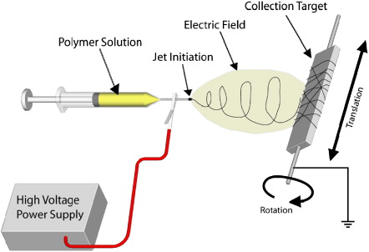
Electrospinning is a relatively inexpensive way to produce nanofibers for a wide range of applications. Polymer solution is drawn into a syringe pump and charged with large electric potentials. The polymer solution is then injected through the electric field using a spinneret. Once a critical level is reached the polymer is ejected onto a fixed target and as solvent evaporates fibers are created. The fibers are then collected on a mandrel, the nanofiber diameters can range from 50 nm to 10 µm and density and orientation can be manipulated by mandrel RPM or solvent concentrations. In essence electrospinning will be utilized to electrospin dual layered sheets of PEG and collagen to produce a scaffold; the scaffolds are spun with collagen to assimilate the extracellular matrix to allow for cell adhesion. These scaffolds will be subjected to folding to make innovative 3D structures, such as the acini and islet structures seen in the pancreas that will be seeded with pancreatic stem cells. Co-axial electrospinning will be utilized to form acini structure capillaries using PLA/CS. These biodegradable capillaries will be replaced by pancreatic cells, which will connect to the synthetic, non-biodegradable pancreatic duct made from ePTFE. The synthetic duct will form a backbone through the scaffold as it is seeded and will maintain the structural integrity of the scaffold.

B: Cell Seeding Islet and Acini Scaffolds via Magnetic Nanoparticles.

The islets and acini structures are both innovative 3D constructions. In order to create and mimic their functions, we must be able to create replicas in a similar 3D manner; this requires cell seeding of a 3D scaffold. Magnetic driven cell seeding is beneficial since there are few techniques that are able to properly distribute cells into a porous 3D scaffold. It is easy to seed cells onto a surface; however, it is a lot more difficult to achieve a desired distribution of cells throughout the 3D scaffold. Since the magnetic force is essentially just electricity, this method is relatively cheap, simple and fast. For our research the pancreatic stem cells will be magnetically labeled with nanoparticles until they are seeded within the cells. Once the cells are seeded, we will use the magnetic forces and apply it to the engineered 3D scaffold and the labeled pancreatic cells, achieving our goal of adhering the cells throughout the 3D structures. Most importantly, this method will increase the total number of adhered cells and consequently increase the success of these engineered tissue 3D scaffolds.

Approach

Aim 1: Utilize a combination of collagen and polyethylene glycol (PEG) to electrospin nanofibrous and microfibrous scaffolds that will be shaped into acini and islet structures.

Hypothesis: An electrospun layer of collagen on top of the polyethylene glycol (PEG) will be able to produce a scaffold to which adult pancreatic stem cells will effectively bind and maintain its structural integrity as it is shaped into the desired structures. To test this hypothesis, we will:

1A: Quantify mechanical properties of scaffold
We seek to find a scaffold that displays a high degree of cell adhesion which is also structurally robust. Scaffolding will initially be spun into dual layered sheets of polyethylene glycol (PEG) and collagen. Mechanical properties and morphology of the scaffold can be modified with different spun fiber thicknesses. Those properties are controlled by the following parameters:

- Polymer solution flow rate
- Concentration of polymer solution
- Needle voltage
- Distance between needle and spinning plate

Our ideal scaffold will be a sheet that is composed of uniform fibers with no beads [3]. It must also be able to withstand the stresses of being folded into the required shapes of acini and islet structures. Fiber uniformity will be observed. We will be measuring the Young’s modulus and flexural modulus of scaffold sheets spun with fiber diameters below 1µm. Soft organ tissue has a moduli typically in the 1-5 kPa range but the scaffold will likely need to have a modulus that exceeds that range.
1B: Create cell adhesion profile
On top of the PEG sheet we will be adding a layer of collagen in order to enhance cell binding on the scaffold. Collagen is a natural polymer that is structurally stable and is the most prevalent component in the extra-cellular matrix [6]. For these reasons, electro spinning collagen-PEG scaffold should result in a scaffold that can bind more cells. We will be spinning two different type of collagen: type I and type IV. Once the scaffolds are completed, adult pancreatic stem cells will be seeded via magnetic force driven cell seeding which will be detailed later on. We will also compare cell adhesion profiles between scaffolds that feature a collagen layer and scaffolds that are solely composed of PEG.

Aim 2: Use synthetic expanded Polytetrafluoroethylene (ePTFE) from existing vascular graft technology used by Gore® to form the main pancreatic duct. The duct will connect with capillaries to acini structures that are formed by core-shell electrospun Poly-lactic acid (PLA)/Chitosan (CS) microfibers.

Hypothesis: Main pancreatic duct made from ePTFE with capillary branches will link microfiber capillary connections to support acini structures for release of digestive enzymes and bicarbonate ions. To test this hypothesis we will first construct the main pancreatic duct:

2A: Synthetic Fabrication of Main Pancreatic Duct Structure
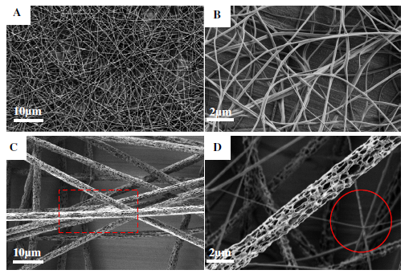Figure 4: The surface morphologies for electro spinning fibers
(A) SEM image for PLA/CS (1:3) Core/shell fibers,
(B) SEM image for PLA/CS (1:3) Core/shell fibers produced with higher magnification,
(C) SEM image for fibers with PLA/CS (1:1), as sign in the red square the fibers agglomerate obviously
(D) SEM image for PLA/CS
1:1, the fibers with higher magnification, as show in the red circle, the diameters of fibers were not uniform. (Wang et al., 2013)

The main pancreatic duct will be made from synthetic ePTFE, similar to existing vascular grafting technology produced by the company Gore. ePTFE can be constructed into a tubular structure that will mimic the function of the main pancreatic duct. The ePTFE duct can be made with varying degrees of elasticity producing a wide range of stretching properties. The tube can also be tapered to more closely resemble the pancreatic duct and allow for proper functioning. Small openings for connections to the core-shell electrospun microfiber capillaries connecting to acini structures can be placed along the tapered synthetic ePTFE main duct.

2B: Bio-fabrication of Acini Capillaries and Attachment to Main Duct

Micro-fiber capillaries will be produced by co-axially electrospinning poly-lactic acid (PLA) and Chitosan (CS). PLA will form the core of the capillary and will be dissolved to produce the microfiber CS capillary tubes. These CS microfibers will have surface crosslinking structures, enabled through the addition of genipin. Genipin has the ability to cross-link CS and the collagen that will replace the CS scaffold once the stem cells have proliferated, helping to form natural ECM [7]. PLA has been approved by the FDA for use in various tissue engineering applications. PLA sutures can be used to connect the core-shell electrospun microfiber capillaries to the main duct. Wang et al. have studied surface morphology of electrospun PLA/CS nano-fibers and optimized the core-shell morphology of surface CS crosslinking. Wang et al. have shown that PLA/CS core-shell fibers have better mechanical strength compared to pure PLA fibers, they found an elastic modulus as high as 117.18 MPa with a PLA/CS ratio of 1:3 [7]. PLA will use dichloromethane as solvent and CS will be spun with acetic acid aqueous solution. Scaled up PLA/CS microfibers will be spun using co-axial electrospinning technology and it will be determined if microfibers can be produced with the appropriate diameters. Mechanical properties of synthetic ePTFE main duct and acini capillaries will be determined using an instron and elastic modulus will be analyzed. Connection points will also be tested for mechanical strength and elasticity.
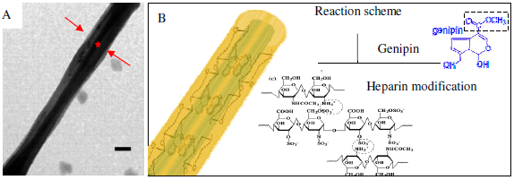Figure 5:
(A) TEM image of CS-PLA coaxial fibers. Core and shell part are indicated by asterisk and arrows, respectively (Scale bar is 100 nm),
(B) Surface reaction scheme for the core structure. (Wang et al., 2013)

Aim 3: Seed 3-D islet and acini scaffolds with adult pancreatic stem cells labeled by magnetic nanoparticles via an electromagnetic device (magnetic tweezers) to achieve proper cell distribution throughout the scaffold.

Hypothesis: Magnetic driven cell seeding provides proper cell distribution while also increasing the amount of adhesion and proliferation of cells into the 3D scaffold. To test this hypothesis, we will:
- Label cells with iron oxide magnetic nanoparticles through endocytosis and incubation in culture medium
- Seed cells via tweezer electromagnets in order to achieve 3D distribution
- Track cell infiltration and density by fluorescent cell detection

These experiments will A) determine the efficiency of labeling cells with magnetic nanoparticles in culture medium, B) estimate the force required to distribute the magnetically labeled cells, and C) show the distribution and infiltration of cells throughout a 3D scaffold

3A: Magnetic cell labeling

Cells will be labeled in accordance with Robert’s method. These nanoparticles will be made up of the same particles, anionic magnetic iron oxide [2]. In order to label pancreatic stem cells, they will be incubated in RPMI (Sigma) serum free culture medium with the nanoparticles. An approximate iron concentration of 5 millimolar will be used along with an incubation time of 30 minutes. To guarantee the nanoparticles are seeded within the cells, they are incubated at 37 C for an additional hour in iron-free culture medium. Finally, these cells can be detached with the help of trypsin and are now ready to undergo magnetic seeding [2].

3B: Cell seeding via electromagnetic tweezers

In order to control the magnetically labeled cells, electromagnetic tweezers will be used. These create a variable magnetic force which is based off of electric current. When applied to the opposite side of the scaffold (unseeded side), it will cause the magnetic cells to start infiltrating the 3D scaffold as seen in Figure 6. Before the experimental seeding, the strength of the magnetic field will be estimated. This is done by tracking small magnetic nano beads through a fluid; a high speed camera will be utilized to track their velocities. With this known, an estimated magnetic field can be determined for seeding the scaffold. In addition to this there will also be fluorescent imaging to confirm appropriate distribution of the pancreatic stem cells [2].
A.
B.
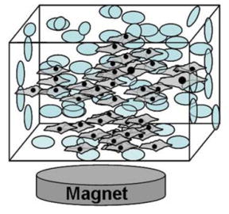
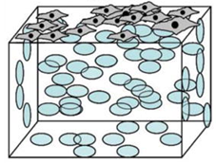

Figure 6: A. Cells seeded onto 3D scaffold before magnetic force. B. Cell distribution as a result of magnetic force [5]

3C: Fluorescent cell tracking
In order to track the infiltration of the cells, fluorescent imaging will be used. A cell tracer dye used by Thevenot, known as CFDA-SE (Invitrogen), will be used in this experiment [5]. With the help of Image J and a particle counter, the number of cells per section can be determined. This will allow for the calculation of cell density and distribution throughout the scaffold. Once the appropriate cell distribution is found out, these specifications can be used for the final product [5].

References

[1] Jiang, Fang-Xu, and Grant Morahan. "Pancreatic Stem Cells: Unresolved Business." Center for Diabetes Research, Western Australia (n.d.): n. pag. Print.
[2] Robert, Damien; Fayol, Delphine; Le Visage, Catherine; Frasca, Guillaume; Brule, Severine; Menager, Christine; Gazeau, Florence; Letourneur, Didier; Willhelm, Claire. Magnetic micro-manipulations to prove the local physical properties of porous scaffolds and to confine stem stem cells. Biomaterials, 31, 7, 1586-1595. Science Direct. [Online] http://www.sciencedirect.com/science/article/pii/S0142961209012265

[3] Sonntag, Karl. Electrospun Scaffolds for Directed Pancreatic Differentiation of Human IPS Cells. Thesis. University of Arkansas, 2010. N.p.: n.p., n.d. Print.
[4] Survival Rates for Pancreatic Cancer. American Cancer Society. [Online] http://www.cancer.org/cancer/pancreaticcancer/overviewguide/pancreatic-cancer-overview-survival-rates

[5] Thevenot, Paul; Sohaebuddin, Syed; Poudyal, Narayan; Ping Lui, J.; Tang, Liping. Magnetic Nanoparticles to Enhance Cell Seeding and Distribution in Tissue Engineering Scaffolds. US National Library of Medicine National Institutes of Health. [Online] http://www.ncbi.nlm.nih.gov/pmc/articles/PMC3279920/

[6] Tsing, Pamela. ELECTROSPINNING NATURAL POLYMERS FOR TISSUE ENGINEERING APPLICATIONS. Thesis. University of Pennsylvania, n.d. N.p.: n.p., n.d. Print.

[7] Wang, Ting, Xuyuan Ji, Lin Jin, Zhang-Qi Feng, JingHang Wu, Jie Zheng, Hongjin Wang, Zhewu Xu, Lingling Guo, and Nongyue He. "Fabrication and Characterization of Heparin Grafted Poly-L-lactic Acid-Chitosan Core-shell Nanofibers Scaffold for Vascular Gasket." American Chemical Society Appl. Mater. Interfaces (2013): n. pag. Web.
[8] Zhang, CY; Parton, LE; Ye, CP; Krauss, S; Shen, R; Lin, CT; Porco Jr, JA; Lowell, BB (2006). "Genipin inhibits UCP2-mediated proton leak and acutely reverses obesity- and high glucose-induced beta cell dysfunction in isolated pancreatic islets". Cell metabolism 3 (6): 417–27. doi:10.1016/j.cmet.2006.04.010. PMID 16753577.

