Transect 1 | Location | Description | Vascularization | Leaves and special characteristics | Seeds, evidence of flowers or other reproductive parts
Cattail  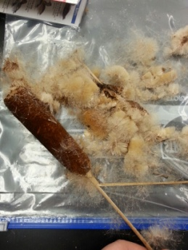 | 1 | Tall plant that resembles a hot-dog on a stick.  Brown part is soft and almost fluffy. | Vascular | No leaves | Many seeds on the inside.  Structure resembles Dandelions with a lot of seeds that float around.
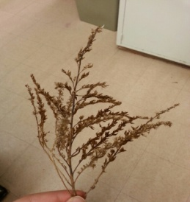  Tall grass | 2 | Tall plant that reminds me of wheat. Grows close to Cattails and are the same in height. | Vascular | Very tiny leaves | Very, very small flowering buds with white petals.
Red Shrub  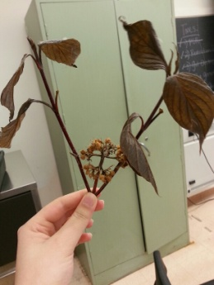 | 3 | Bush? A distinctive red pigment on the stem and the leaves look like they belong to that of flowering plants | Vascular | Broad leaves with net-like veins. This is most likely a dicot. | Round and medium-sized flower buds and seeds.
Green ground plant  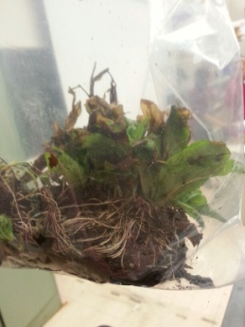 | 4 | Small plant that has a complex fibrous root system. Pulling out of the ground was actually pretty easy.  Looks like mini-spinach? Lettuce? | Vascular | Broad leaves with net-like veins. Plant is a dicot. | No signs of seeds or flowers
Grass | 5 | Simple plant | vascular | Long and narrow leaf with parallel veins going through.  This is a monocot. | No signs of seeds or flowers.

