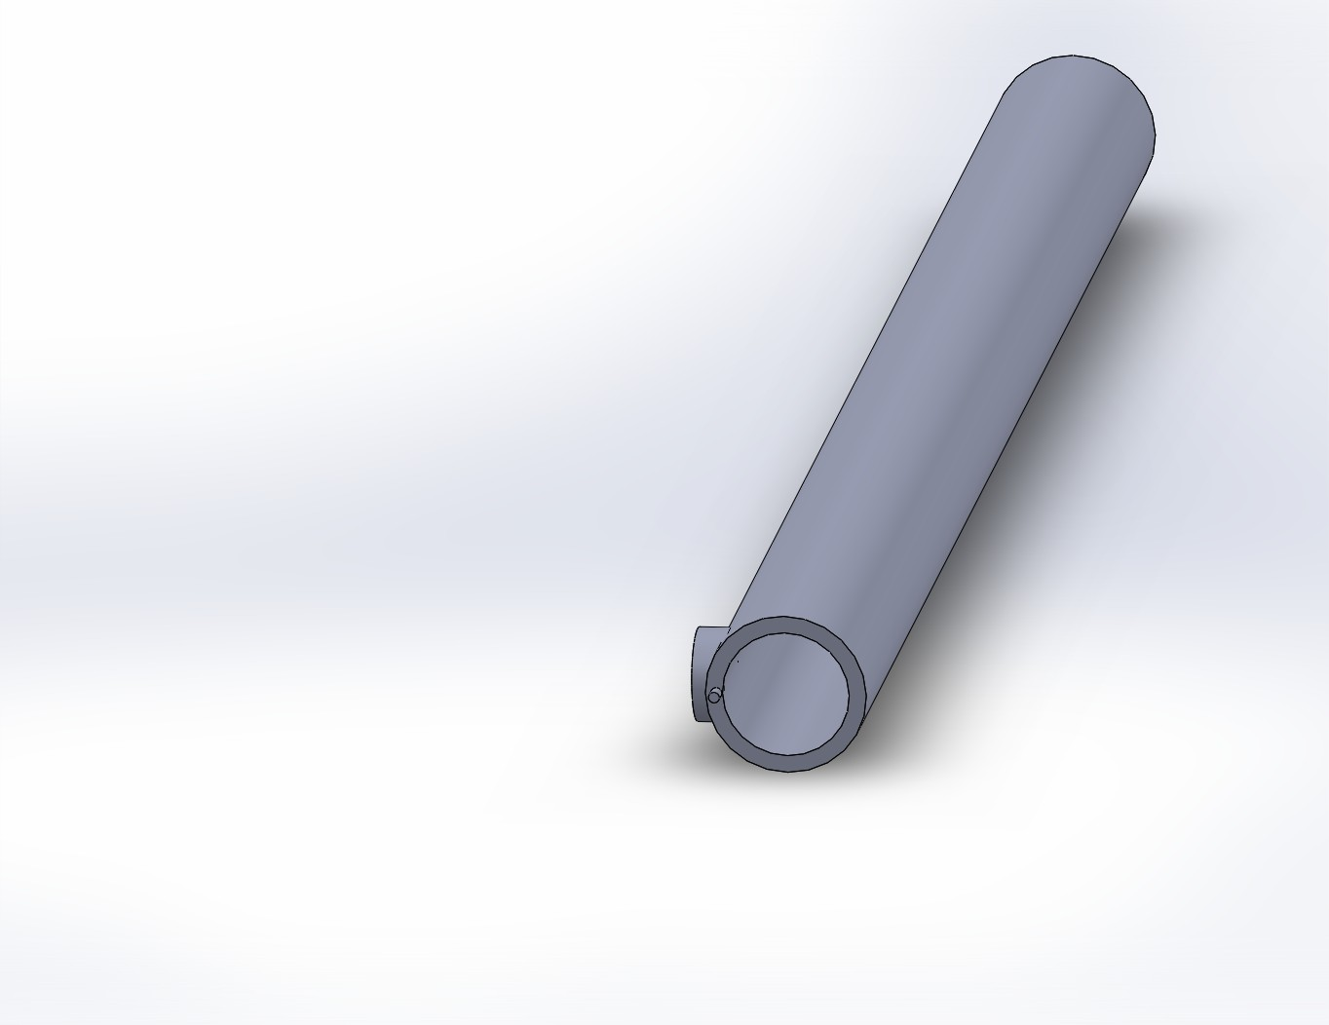
Blood Flow Monitor
Silicon Sleeve
LED light

