1.
$$0=\frac{dx}{dt}=-qx+V\frac{y}{K+y}\frac{z}{M+z}x$$
$$qx=V\frac{y}{K+y}\frac{z}{M+z}x$$
$$q=V\frac{y}{K+y}\frac{z}{M+z}$$

$$0=\frac{dy}{dt}=qu-qy-\frac{1}{ε}V\frac{y}{K+y}\frac{z}{M+z}x$$
$$0=qu-qy-\frac{1}{ε}qx$$
$$\frac{1}{ε}qx=qu-qy$$
$$qx=εq\left(u-y\right)$$

$$0=\frac{dz}{dt}=qv-qz-\frac{1}{δ}V\frac{y}{K+y}\frac{z}{M+z}x$$
$$0=qv-qz-\frac{1}{δ}qx$$
$$\frac{1}{δ}qx=qv-qz$$
$$qx=δq\left(v-z\right)$$

$$ε\left(qu-qy\right)= δ\left(qv-qz\right)$$
$$εq\left(u-y\right)= δq\left(v-z\right)$$
$$ε\left(u-y\right)= δ\left(v-z\right)$$
$$\frac{ε}{δ}\left(u-y\right)= v-z$$
$$z=v-\frac{ε}{δ}\left(u-y\right)$$
$$z=\frac{ε}{δ}y+v-\frac{ε}{δ}u$$
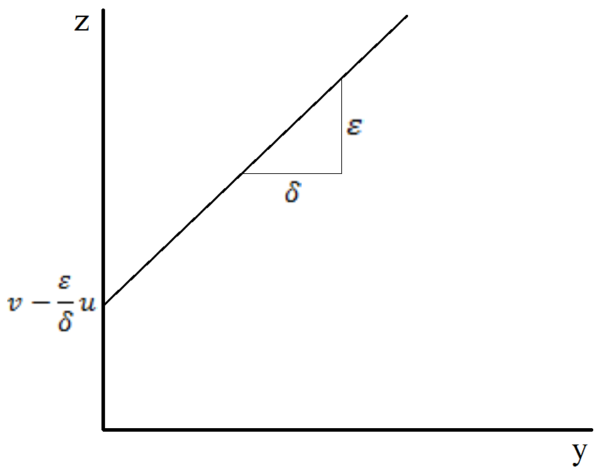
2.
$$0=\frac{dx}{dt}=-qx+V_{max}\left(min\left\{\frac{y}{K+y},\frac{z}{M+z}\right\}\right)x$$
$$qx=V_{max}\left(min\left\{\frac{y}{K+y},\frac{z}{M+z}\right\}\right)$$
$$\frac{q}{V_{max}}=min\left\{\frac{y}{K+y},\frac{z}{M+z}\right\}$$

$$\frac{y}{K+y}=\frac{z}{M+z}$$
$$y\left(M+z\right)=z\left(K+y\right)$$
$$yM+yz=zK+yz$$
$$yM=zK$$
$$z=\frac{M}{K}y$$

3.
$$\frac{q}{V_{max}}=\left\{\begin{matrix}\frac{y}{K+y} when z≥ \frac{M}{K}y \\ \frac{z}{M+z} when z≤ \frac{M}{K}y \end{matrix}\right.$$
$$z=\frac{ε}{δ}y+v-\frac{ε}{δ}u$$
$$\frac{M}{K}y=\frac{ε}{δ}y+v-\frac{ε}{δ}u$$
$$\frac{M}{K}y-\frac{ε}{δ}y=v-\frac{ε}{δ}u$$
$$y\left(\frac{M}{K}-\frac{ε}{δ}\right)=v-\frac{ε}{δ}u$$
$$y=\frac{v-\frac{ε}{δ}u}{\frac{M}{K}-\frac{ε}{δ}}$$
$$y=\frac{\frac{δv-εu}{δ}}{\frac{δM-εK}{δK}}$$
$$y=\frac{K(δv-εu)}{δM-εK}$$

$$z=\frac{ε}{δ}y+v-\frac{ε}{δ}u$$
$$z=\frac{ε}{δ}\frac{K}{M}z+v-\frac{ε}{δ}u$$
$$\frac{ε}{δ}\frac{K}{M}z-z= v-\frac{ε}{δ}u$$
$$z\left(\frac{ε}{δ}\frac{K}{M}-1\right)= v-\frac{ε}{δ}u$$
$$z=\frac{v-\frac{ε}{δ}u}{\frac{ε}{δ}\frac{K}{M}-1}$$
$$z=\frac{\frac{δv-εu}{δ}}{\frac{εK-δM}{δM}}$$
$$z=\frac{M(δv-εu)}{εK-δM}$$

4.
$$z=\frac{ε}{δ}y+v-\frac{ε}{δ}u$$
$$y=\frac{δ}{ε}(z-v+\frac{ε}{δ}u)$$
$$y=\frac{δ}{ε}\left(\frac{M\left(δv-εu\right)}{εK-δM}-v+\frac{ε}{δ}u\right)$$
$$qx=εq\left(u-y\right)$$
$$x=ε\left(u-y\right)$$
$$x=ε\left[u-\frac{δ}{ε}\left(\frac{M\left(δv-εu\right)}{εK-δM}-v+\frac{ε}{δ}u\right)\right]$$
$$x=εu-δ\left(\frac{M\left(δv-εu\right)}{εK-δM}-v+\frac{ε}{δ}u\right)$$
$$x=\frac{δM\left(δv-εu\right)}{εK-δM}-δv$$
5.
