Table 1: Transect Plants (#1-5)
Transect Sample Plants | Location and # in Transect | Description (size and shape) | Vascularization | Specialized Structures | Reproduction
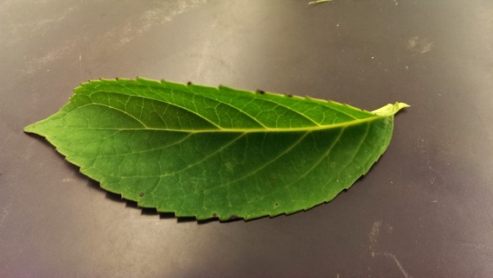  Vinca minor (Periwinkle) | #1: Midway through transect, low to ground | Plant overall is about 18 in. in height, with dark green serrated and crenellated leaves, waxy in surface. Plant also has purple flowers with 5 petals | Roots/Stem | Flowers | Dicot flowers/pollination
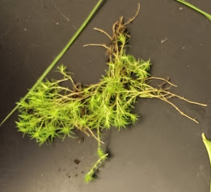  Moss | #2: Edge of transect, along path | Plant is low to the ground, elevation about 2 inches, with lateral spread of about 12 in. Leaves are needle-like | Rhizoids/Diffusion | Plant has rhizoids on leaves and stems, aiding in creeping structure close to ground | gametophytes
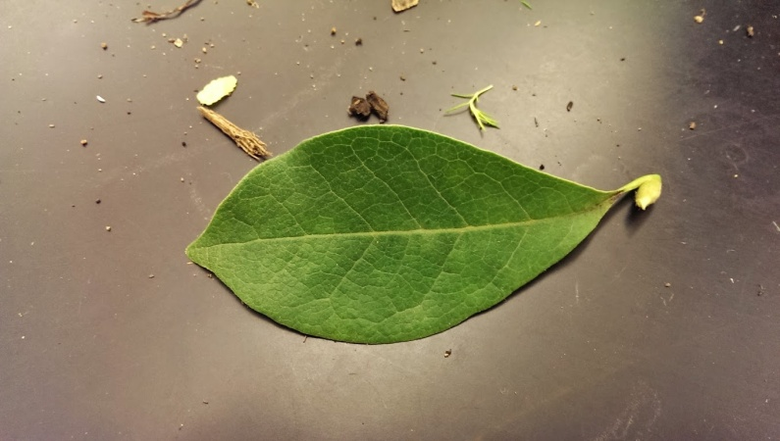  Lagerstroemia (Crepe Myrtle) | #3: near edge of transect | Large tree, about 8 ft in height with mottled but smooth bark. Leaves are clustered, dark green with entire, crenellated edges | Roots/Stem | Specialized structure includes large woody stems and stout trunk | Pollination/dicot flowers
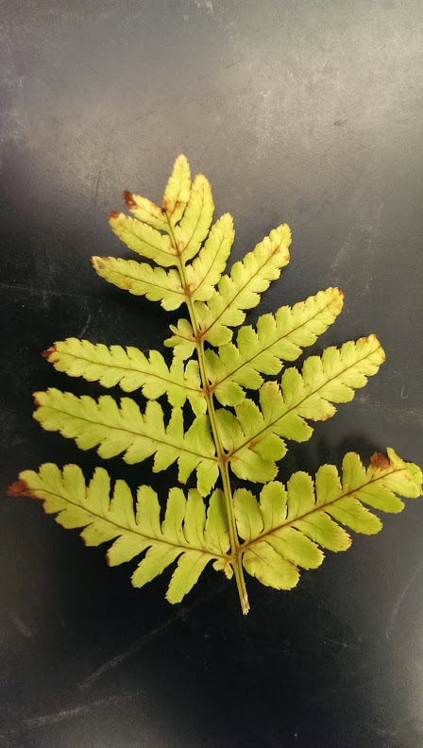  Fern | #4: middle of transect, toward center | Plant is ~8 in. in height with fronds consisting of lobed, serrated leaves increasing in size closer to the stem | Roots/Stem | Structure decreases in size toward plant’s extremities, spores on back sides of fronds | Spores
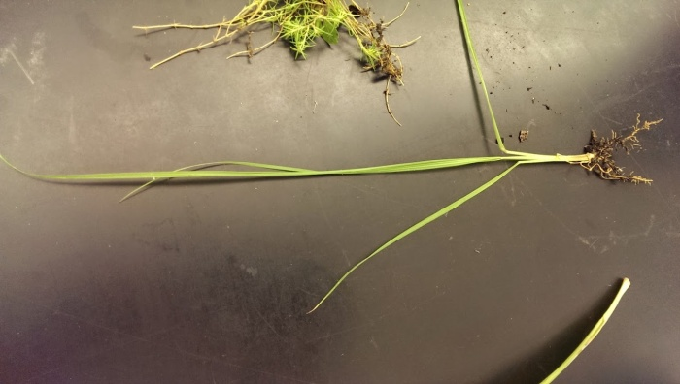  Grass | #5, near periphery of transect, ground level | Smooth, long, dark green leaves with entire edges, about 6 in. high | Roots/Stem | Plant roots are rhizoid, spreading under the surface of the soil | Monocot spread

