Lab 2: “Prototype Design: Part 1”
- Learn how to use SolidWorks.
  - Leverage “Help” in SolidWorks and Custom video on Blackboard.
- Design a prototype to address the chosen health issue.
- Draw prototype in SolidWorks.
- Determine the technical feasibility.
- Determine the clinical feasibility.

Assignment:
- Design and draw your prototype in SolidWorks. Upload as an image and provide a brief description (including how addresses health issue) on Open Wet Ware.
- Determine the technical feasibility of your design. Include answers to the following questions:
  - What are the technologies needed? The materials needed for the diabetic neuropathy sock are a flexible microfluidic sensors, gel with which to protect and encase the sensors, microwires, wool sock, and a heating device. The flexible microfluidic sensors have already been made in a lab, however they detect sweat. Our group’s device will detect plasma released from blisters and blood. The gel is simple to create for this device, and the microwires are very cheap and are abundantly on the market. The sock is basic wool sock that can be made for under two dollars USD, and the heating device is also rather inexpensive and easy to make.
  - What are the challenges? The challenges involved in making this device are simply making it cheap and effective. The microfluidic sensors also must be changed to detect plasma instead of detecting sweat. Also, creating a way to detect plasma even when the sensor has been broken by an outside object will be a challenge. The gel must be breathable allowing sweat and blood to pass through; if the gel is not breathable, cuts are more susceptible to infection due to the moist conditions. Placing the sensors strategically is a challenge, because the sensors must detect a cut anywhere on the foot. The heating sock must be made thin and a good size so the sock fits comfortably inside any type of shoe. This device must be comfortable, however the patients lacking feeling in their feet helps us out in this aspect a bit.

  - What could go wrong? The sensors could lose connection with the phone when broken and become dysfunctional, instead of alerting the user that the gel has been cut. Also, the heating pads could mess with the microfluidic sensors and make them dysfunctional. It is also possible the blood could leak out of the breathable material before it is ever scanned by the sensor.
- Determine the clinical feasibility.
  - Given the technical feasibility will it work in the clinic?
The technical feasibility is pretty high. The technology already out there leads us right to the product that we are trying to build. If we put the time and effort into making sure the product is highly reliable and effective, then we should have no problem with clinical trials. The product should work just fine, and if there are some failures in material it should not be very hard to make corrections until perfected.
  - What are the clinical risks?
There is a risk of electrocution, however the research labs developing the sensors reported no issues with breaks. Also, the charge running through the sensors is very minimal and is not the least bit worrisome. The only other risk possible, is an influx in heat that is too much for the body to handle. However, while designing this product we will pay special attention to keeping heat to a minimum will also making it effective.
  - Have similar products been in a clinical trial? How long was the trial?
No similar products have gone through a clinical trial. Our products most similar product is the sweat sensing microfluidic sensor patch. However, this product has only been done in a research lab and has only undergone initial clinical trials. There is one product that is a microfluidic device rather than a sensor that has gone under a clinical trial, but the use for this device is very different. This device studies the development of embryos in what is known as a Smart System. The clinical trial lasted one year.
- Using the fundability worksheet chart, determine the scores (0-3) for technical feasibility and clinical feasibility and provide support for scores.
Technical feasibility- The technology needed to make this device is already out there, we just need to make specifications to what the sensors detect. Also, we need to put all of the components of this device into a single item which should not be hard to do. This device is not simple like a pump, but it is not far away from becoming reality which is why it is given a 2 in technical feasibility.
Clinical Feasibility- Clinical success is very likely, and the list of possible failures is not very long. The design process before clinical trials will set us up for likely success; all of the possible holes in our design should be fixed during research. The path is not absolutely perfect, but definitely probable giving us a 2 in clinical feasibility.
Resources:
- Video on the basics of SolidWorks
- Video on how to search for clinical trial information.
  - See “Improving Searches with Boolean Operators” Video to learn about ClinicalTrials.gov

Lab 2: “Prototype Design: Part 2”
· Determine the market size.
· Determine overall fundability.
Assignment:
1. What value does your prototype create for the customer?
The prototype has a very large value to the customer, and can prevent many complications. The payoff for this product is huge, and is definitely a product that improves the quality of life (every biomedical engineer’s dream). This product prevents the need for antibiotics due to infections, and eliminates the option of amputation. This is a huge benefit to the lives of diabetic neuropathy patients; also, this product improves circulation through the application of heat, and limits the likelihood of infections even further by improved circulation. The gel is also tough to break through, so the sock provides as a protective material from outside objects.

2. Determine the cost to create your design. Justify.
The self heating sock is already on the market, and costs 9 dollars for a pair that covers the ankles. The microwires in the sock that detect the breakage are going to be made cheaply using a conductive film. This film is going to be in small symmetrical lines on the bottom of the foot, which virtually covers the whole foot. The cost of the roll of conductive film is 195 dollars per 64,800 square inches. The film cost per sock is calculated by the film price divided by the average foot size which is 31.5 square inches. This price comes out to 10 cents per sock, or 20 cents for the pair. As far as the sensor and gel go, the product has not hit the market. However, the creator of the flexible microfluidic device hopes to hit the market with four dollar sensors. To cover the foot effectively our device will have 7 sensors on the bottom of the foot. If we buy in bulk directly from the seller we can cut the cost of all of these single items by at least 10 percent. This places the cost of our device hover around 58 dollars.

3. What would be the anticipated average sale price (ASP)? Justify.
To put a price on the device that both optimizes the amount of buyers, and the greatest profit by the creator of this product, the price should be five times the cost of production. That price settles at around 275 dollars. Obviously that price seems ridiculously high. However, with the correct medical insurance codes, the price could become very affordable.

4. Using initial market size analysis in Lab 1, determine the market size in dollars per year. Assume 5% penetrance of the market (Sales price X 0.05 X total market size).
Market Size = (275 X 0.05 X 30 million) = 412,000,000

5. Using the fundability worksheet, determine if your prototype should be funded. Justify why or why not.
Using the fundability worksheet, the product does not seem to be appealing. Because of this, the product probably should not be funded. However, the payoff for this product is beyond astronomical, especially in the near future. Diabetes is on the rise, and the price of these sensors will become increasingly cheaper. The market size will increase dramatically, and the price will fall making the likelihood of buyers purchasing multiple pairs increase. The future of this product should be taken under consideration, and funded a great amount.

Score | Criteria | 0 | 1 | 2 | 3
1 | 1. Customer validation  (Lab 1) | No customer excitement to purchase | Hesitant interest to purchase  or  Not enough customer feedback to-date | Masses have expressed interest to purchase | Significant customers have agreed to purchase and/or are willing to invest
2 | 2. Market size (US only)  (Lab 2) | Less than 80M | 80M - 200M | 200M - 500M | Over 500M
3 | 3. Competition  (Lab 1) | Single dominant competitor  or  Value proposition insufficient to compete | Crowded market space  Differentiation will be difficult | Competitors exist but clinical improvements are still being sought | Value proposition will easily displace any competition
2 | 4. IP Position  (Lab 1) | No patentability  or  Freedom to operate | No or weak patent applications  or  Provisionals only | Non-provisional(s) filed and pending  or  Issued patents, but weak | Strong, issued patents
2 | 5. Technical Feasibility  (Lab 2) | Physics would have to be bent | Will require large investments/research,  Development will be cost prohibitive | Some challenges but will be overcome with time and within a reasonable cost | Simple and straight forward design with known materials and methods
1 | 6. Regulatory Pathway | Unclear regulatory pathway | PMA | 510k - clinical data needed  or  De Novo | 510k - no clinical data needed  Exempt
2 | 7. Clinical feasibility  (Lab 2) | Clinical success unlikely  Others have tried and failed | Clinical success is unclear. Large patient volumes or long time-frame trials required | Clinical success is likely but will require special expertise and/or research | Clear path to clinical success  Others have been clearly successful
1 | 8. Reimbursement | Reimbursement unlikely  no cash paying incentives | New application to CMS necessary prior to any payments being issued | Reimbursement could fall under an existing code but a new code will eventually need to be filed | Reimbursement readily accepted or patients are very incentivized to pay cash
48 | TOTAL (product)

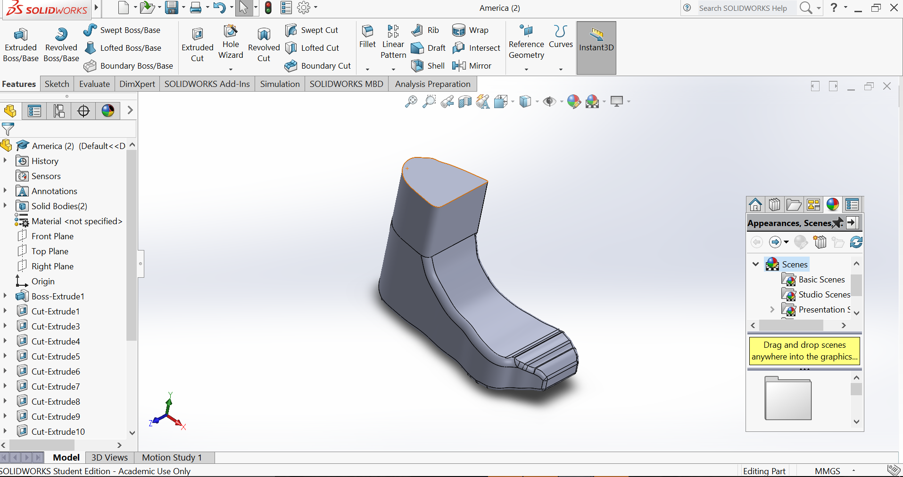

Works Cited

- “In Vitro Human Embryo Culture System.” A service of the U.S. National Institutes of Health. ClinicalTrials.gov, 8 Sep. 2010. Web. 19 Sep. 2017.
https://clinicaltrials.gov/ct2/show/NCT00985218
2. Erika Vázquez. “The Latest Wearable Tech: Flexible Microfluidic Devices.” MC10 Pulse. Mc10, 26
Jan 2017. Web. 19 Sep. 2017.
https://www.mc10inc.com/mc10-pulse/latest-wearable-tech-flexible-microfluidic-devices
3. Desiree Stimpert. “Men's U.S. Shoe Sizes in Inches.” LiveAbout. LiveAbout, 10 Sep 2017. Web. 19
Sep 2017.
https://www.liveabout.com/mens-us-shoe-sizes-in-inches-2987804
4. “Power Ionics 1pair(2pcs) F.I.R Self Heat Magnetic Fiber Therapy Arthritis Thick
Socks, HL024.” Amazon. Amazon, 2017. Web. 19 Sep 2017.
https://www.amazon.com/Power-Ionics-Magnetic-Therapy-Arthritis/dp/B00IJEY1CW/ref=sr_1_8_a_it?ie=UTF8&qid=1505865486&sr=8-8&keywords=heating+socks
5. “Conductive 4mil Black Polyethylene Film Roll, 36" x 150' Long.” All-Spec. All-Spec, 2017. Web. 19
Sep 2017.
http://www.all-spec.com/Catalog/Static-Control/Static-Control-Film-Tubing/Static-Control-Film/854-36150?utm_source=bing&utm_medium=cpc&utm_campaign=Product%20Listing%20Ads%20-%20Shopping&utm_term=1100404856849&utm_content=PLA
7. “Rogers Research Group.” Rogers Research Group. Rogers Research Group, 2016. Web. 19 Sep 2017.
http://rogersgroup.northwestern.edu/

