Questions for investigation of the behavior of one gene
- Production vs degradation rate – how do these combine?
- ANOVA p-values for within strain
  - Magnitude (large dynamics?)
  - Variance?
  - Combination of the two?
- Fit vs. parameter stability
  - Good fit with stable parameter values?
  - Bad fit with unstable parameter values?
  - Good fit with unstable parameter values?
  - Bad fit with stable parameter values?

FHL1 – modeled well
- Production vs degradation rate – how do these combine?
  - Across all strain comparisons, production rate remains relatively constant at around 0.05
    - Production rate (wt): 0.055153
    - Degradation rate: 0.017329
    - For a gene with no inputs, expect x=P/(2*d) = 1.5, log2(x)= 0.58 at steady state
      - Anything greater than one is an increase in expression. This is observed in the dynamic output graphs
- ANOVA p-values for within strain
  - dHAP4:
    - B&H p value = 0.923
    - Uncorrected p value = 0.8812
  - Wt
    - B&H = 0.4454
    - Uncorrected = 0.2982
  - No significant change – this is as expected for a gene that is just a regulator.
- Fit vs. parameter stability: FHL1 has stable estimated parameters (b’s and p’s)
  - Good fit with stable parameter values?
    - Good fit across all strain outputs. Good fit + stable means that FHL1 is probably modeled well

SWI6 – missing input
- Production vs degradation rate – how do these combine?
  - Across all strain comparisons, production rate remains relatively constant at around 0.07
    - Production rate (all strains): 0.0750
    - Degradation rate: 0.0408
    - Combined effect: x=0.92 , log2(x)= -0.12 at steady state
      - Slight decrease in expression expected. This is observed in the various dynamic outputs, except dCIN5, where the dynamics increase slightly.
- ANOVA p-values for within strain
  - dHAP4:
    - B&H p value = 0.644
    - Uncorrected p value = 0.511
  - Wt
    - B&H = 0.118
    - Uncorrected = 0.0439
  - Overall, ANOVA shows that SWI6 does not have any significant dynamics. The one significant p-value, uncorrected for wt, is reflective of the greater dynamics of the wt data. This is reflected in the outputs of the code, where the estimated production rate using wt data alone is smaller than the other estimated production rates. This, according to x=P/(2d), would yield a smaller x (i.e. a more negative dynamic)
  - Magnitude (large dynamics?) – some dynamics
  - Variance? – some, but relatively tight for wt data
  - Combination of the two? – the most likely cause of wt significance
- Fit vs. parameter stability
  - dCIN5 is trying to give SWI6 positive dynamics… They should be more closely connected in the network… SWI6 should maybe have an input that is connected to CIN5 in some way
  - Bad fit with stable parameter values?
    - I think this is the most likely case. We are definitely missing a connection between CIN5 and SWI6 (CIN5 represses SWI6, either directly or indirectly, so when CIN5 is deleted SWI6 is over-expressed compared to the wt).

SKO1 – missing input
- Production vs degradation rate – how do these combine?
  - Across all strain comparisons, production rate remains relatively constant at around 0.12
    - Production rate (all strains): 0.1255
    - Degradation rate: 0.0385
    - Combined effect: x=1.63, log2(x)= 0.7 at steady state
      - Visible increase in expression expected. This is observed in the various dynamic outputs.
- ANOVA p-values for within strain
  - dHAP4:
    - B&H p value = 0.0152
    - Uncorrected p value = 0.00223
      - SKO1 is clearly affected by the deletion of HAP4 in some way… this is not accounted for in our current network
  - Wt
    - B&H = 0.133
    - Uncorrected = 0.0516
  - Magnitude (large dynamics?) – because of high variance, SKO1’s almost significance is probably due to actual dynamics
  - Variance? – high variance across the wt data
- Fit vs. parameter stability
  - Good fit with stable parameter values?
    - Yes…. It looks like a pretty good fit across all the strain runs. The only concerning thing here is that it looks like there is significant upward dynamics in all runs, which is not accounted for in our network. SKO1 needs an input (note: it doesn’t seems to be affected directly by any of the deletion strains run through the model, but it does seem to be highly affected by the deletion of dHAP4 – it has B&H significance with the dHAP4 strain).
    - Upward dynamics probably just due to production/degradation effect
    - Looks like HAP4 represses SKO1

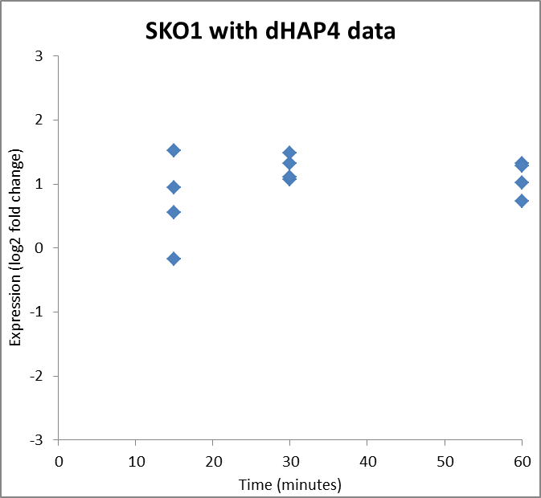

Genes with no outputs

HOT1 – modeling noise?
Two inputs: CIN5 and SKN7. With wt alone, inputs are both significantly negative. With all strains, inputs are both significantly positive
Negative b-values correlate with higher production rates
Positive b-values correlate with lower production rates

- Production vs degradation rate – how do these combine?
- ANOVA p-values for within strain
  - dHAP4:
    - B&H p value = 0.974
    - Uncorrected p value = 0.960
  - Wt
    - B&H = 0.639
    - Uncorrected = 0.509
  - Variance is very high for wt data… it could be covering up some actual dynamics
  - From these p-values, it looks as if we are modeling noise. For a gene with two inputs you would expect dynamics (especially given that the model is assigning the same signs to both inputs)
- Fit vs. parameter stability
  - The dynamics for the different strains are all over the place.
    - Wt data has a lot of variance, this might be throwing the fit off
    - dCIN5 plot shows negative dynamics, although the fit doesn’t seem to be very good for t15. The data suggests that CIN5 activates HOT1, although it is really difficult to tell because of the variance in the wt data. For the wt and dCIN5 run, the lines are pretty much overlapping, which should not be the case if CIN5 is directly connected to HOT1
    - The data is either too noisy, or CIN5 is not connected to HOT1
  - Bad fit with unstable parameter values?
    - Most outputs are fit poorly. This could be because of large variances in the data. Because parameter values are fit poorly too, we could just be modeling noise.
  - CIN5 should activate HOT1 given the negative dynamics of HOT1 when CIN5 is deleted.
  - Ex) Output network for all strains shows double activation…. But output graph of model for HOT1 does not really show any upward dynamics. Either something is wrong with SKN7, or we are missing things

Questions:
- We see that important, different trendlines are not being added to some output graphs with multiple strains (eg wt, dCIN5, and wt+dCIN5). Does this error affect estimated parameter outputs?
  - Is this overlaying of graphs somehow connected to the calculations? How? Is it trying to take into account all data?
  - Model deems groups significantly different enough to draw a different line…. Can we change this cutoff?
- We have observed that the dynamics are modeled better in the first 30 minutes than the last thirty minutes (probably because we don’t have a 45 minute time point…. But it really should be better – e.g. SKN7 of dGLN3)
  - It seems like the t15 time point has the most sway
- It seems that for most genes the initial production/degradation is setting the trend for the dynamics across the whole timespan…. Is there any way to account for this? They might be masking the effects of gene inputs

