Purpose
To examine the amplified bacteria that was found in the Hay Infusion Culture as well as determining the cell morphology of the cells found through the use of gram staining.
Material and Methods
The experiment called for the agar plates that were created last week to be examined under a microscope to examine the colonies that had formed. After that primary examination, they were then observed on a wet mount to determine the shape of the bacteria. Then the samples underwent gram staining with crystal violet, Grams's iodine mordant, 95% alcohol, and finally safranin to allow for examination of the cell wall.
Data and Observation
Prior to beginning the examination of the growth on the agar plates, the Hay Infusion Cultures were observed. It was darker and had less water. It smelled more like water than mold. It was concluded that there was no more growth because there were no more nutrient left in the environment for them to grow.
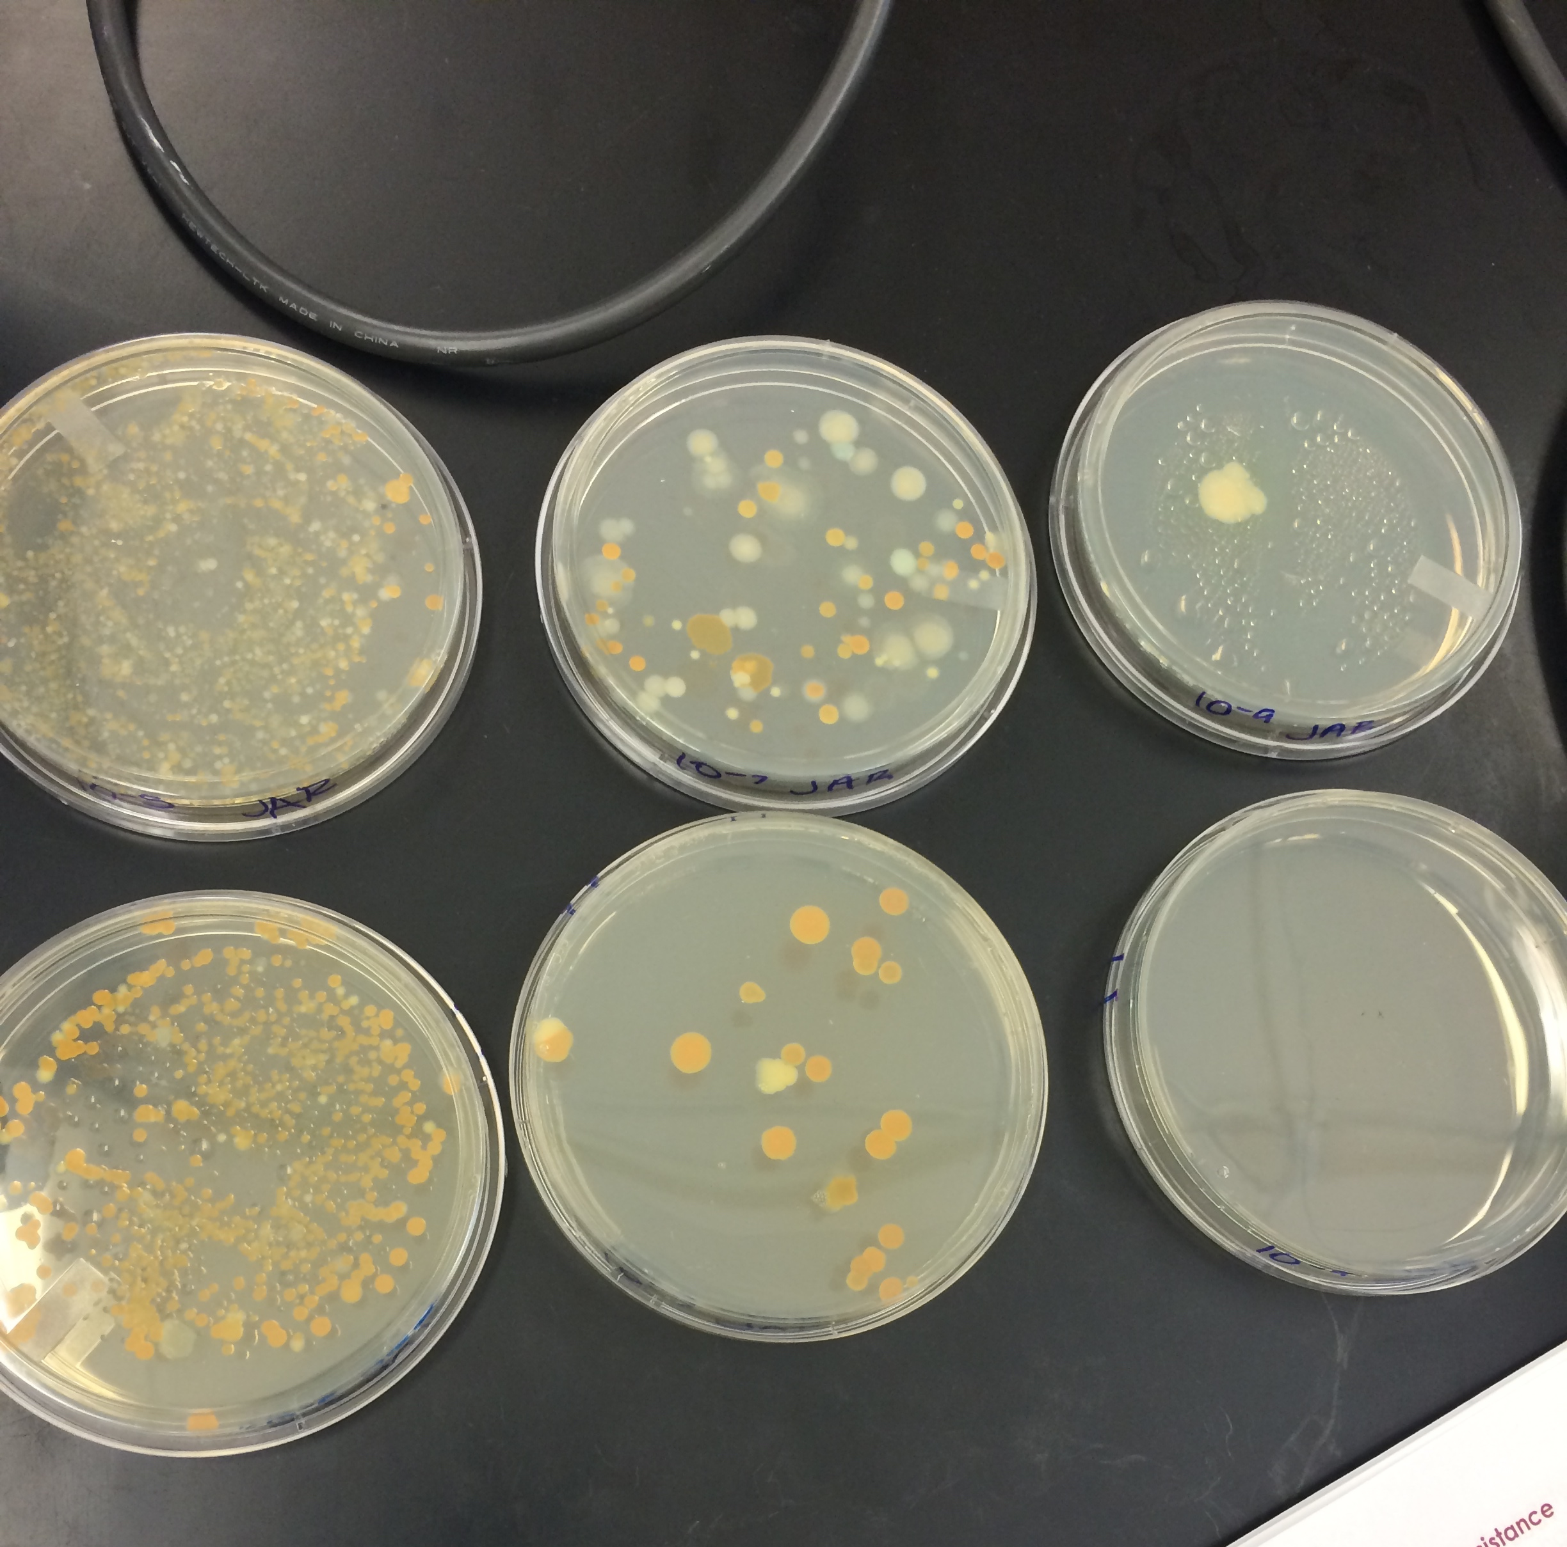
Figure 1. All six agar plates with the tetracycline treated plates below. Both row increase in dilution from left to right.

Upon closer examination, there were differences between the tetracycline treated plates. There was less growth on the tetracycline plates. It was concluded that not all of the bacteria that was found from the transect was antibiotic resistant, which led to only 2/3 species surviving on the tetracycline plate.

Dilution | Agar Type | Colonies Counted | Conversion factor | Colonies/mL
10⁻⁵ | Nutrient | Lawn 1300 | x10⁵ | 1.3e8
10⁻⁷ | Nutrient | 75 | x10⁷ | 7.5e8
10⁻⁹ | Nutrient | 1 | x10⁹ | 1e9
10⁻⁵ | Nutrient + tet | 3.4 x 10² | x10⁵ | 3.4e7
10⁻⁷ | Nutrient + tet | 19 | x10⁷ | 1.9e8
10⁻⁹ | Nutrient + tet | none | x10⁹ | none
Table 1: 100- fold serial dilutions results

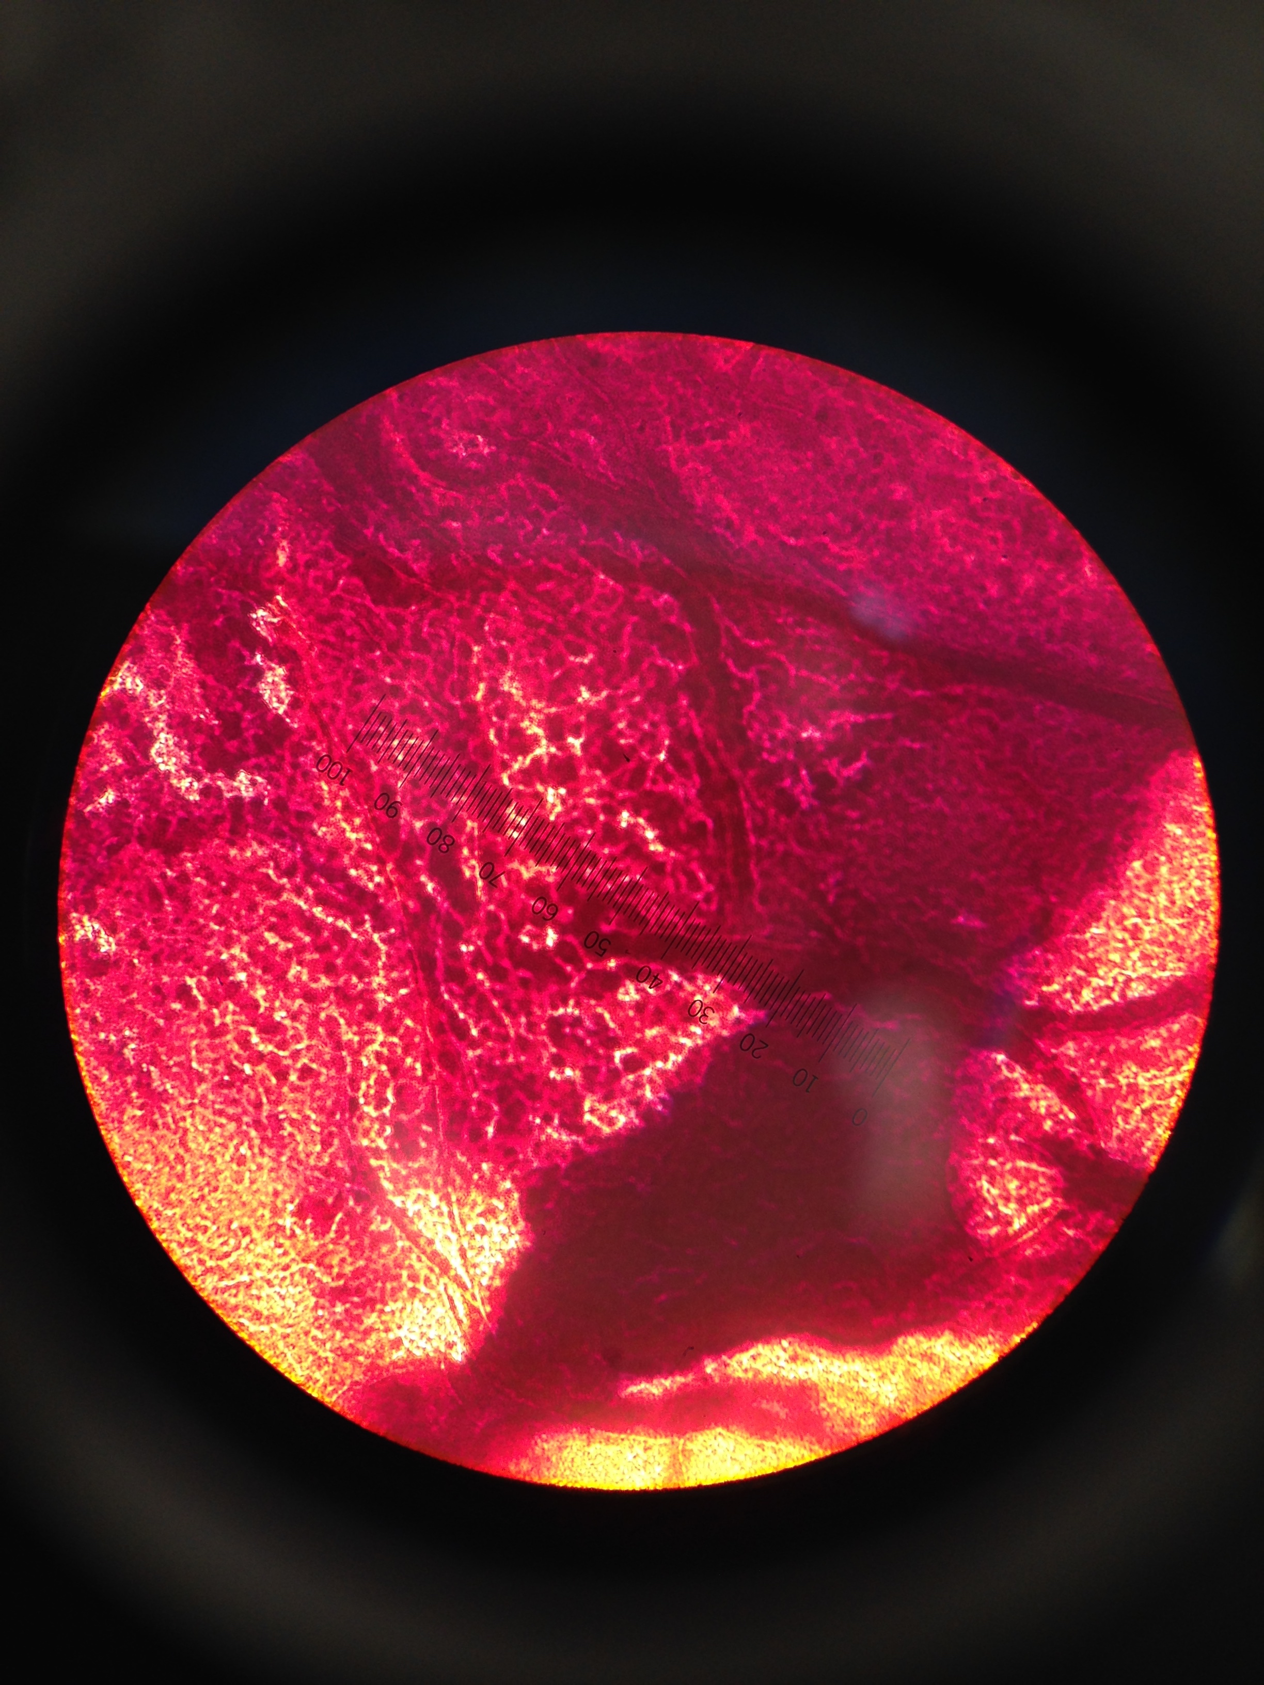
Figure 2. Sample of colony that has been stained observed under a microscope. This sample is from the 10⁻⁷ colony label blue. The colonies were blue, flat, smooth, glistening, and punctiform undulate. It was a gram stain negative.

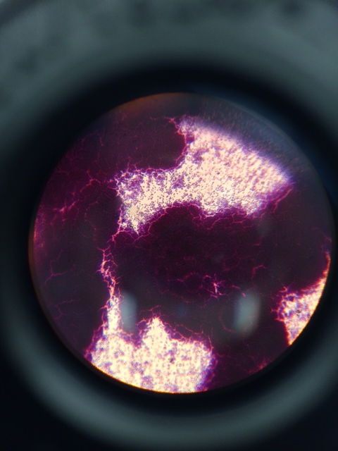
Figure 3. This slide is of the bacteria taken from 10⁻⁷ colony. It was white, smooth, glistening, flat, and punctiform undulated. It was cocci and rod shapped, small and swimming. As seen above it was gram positive.

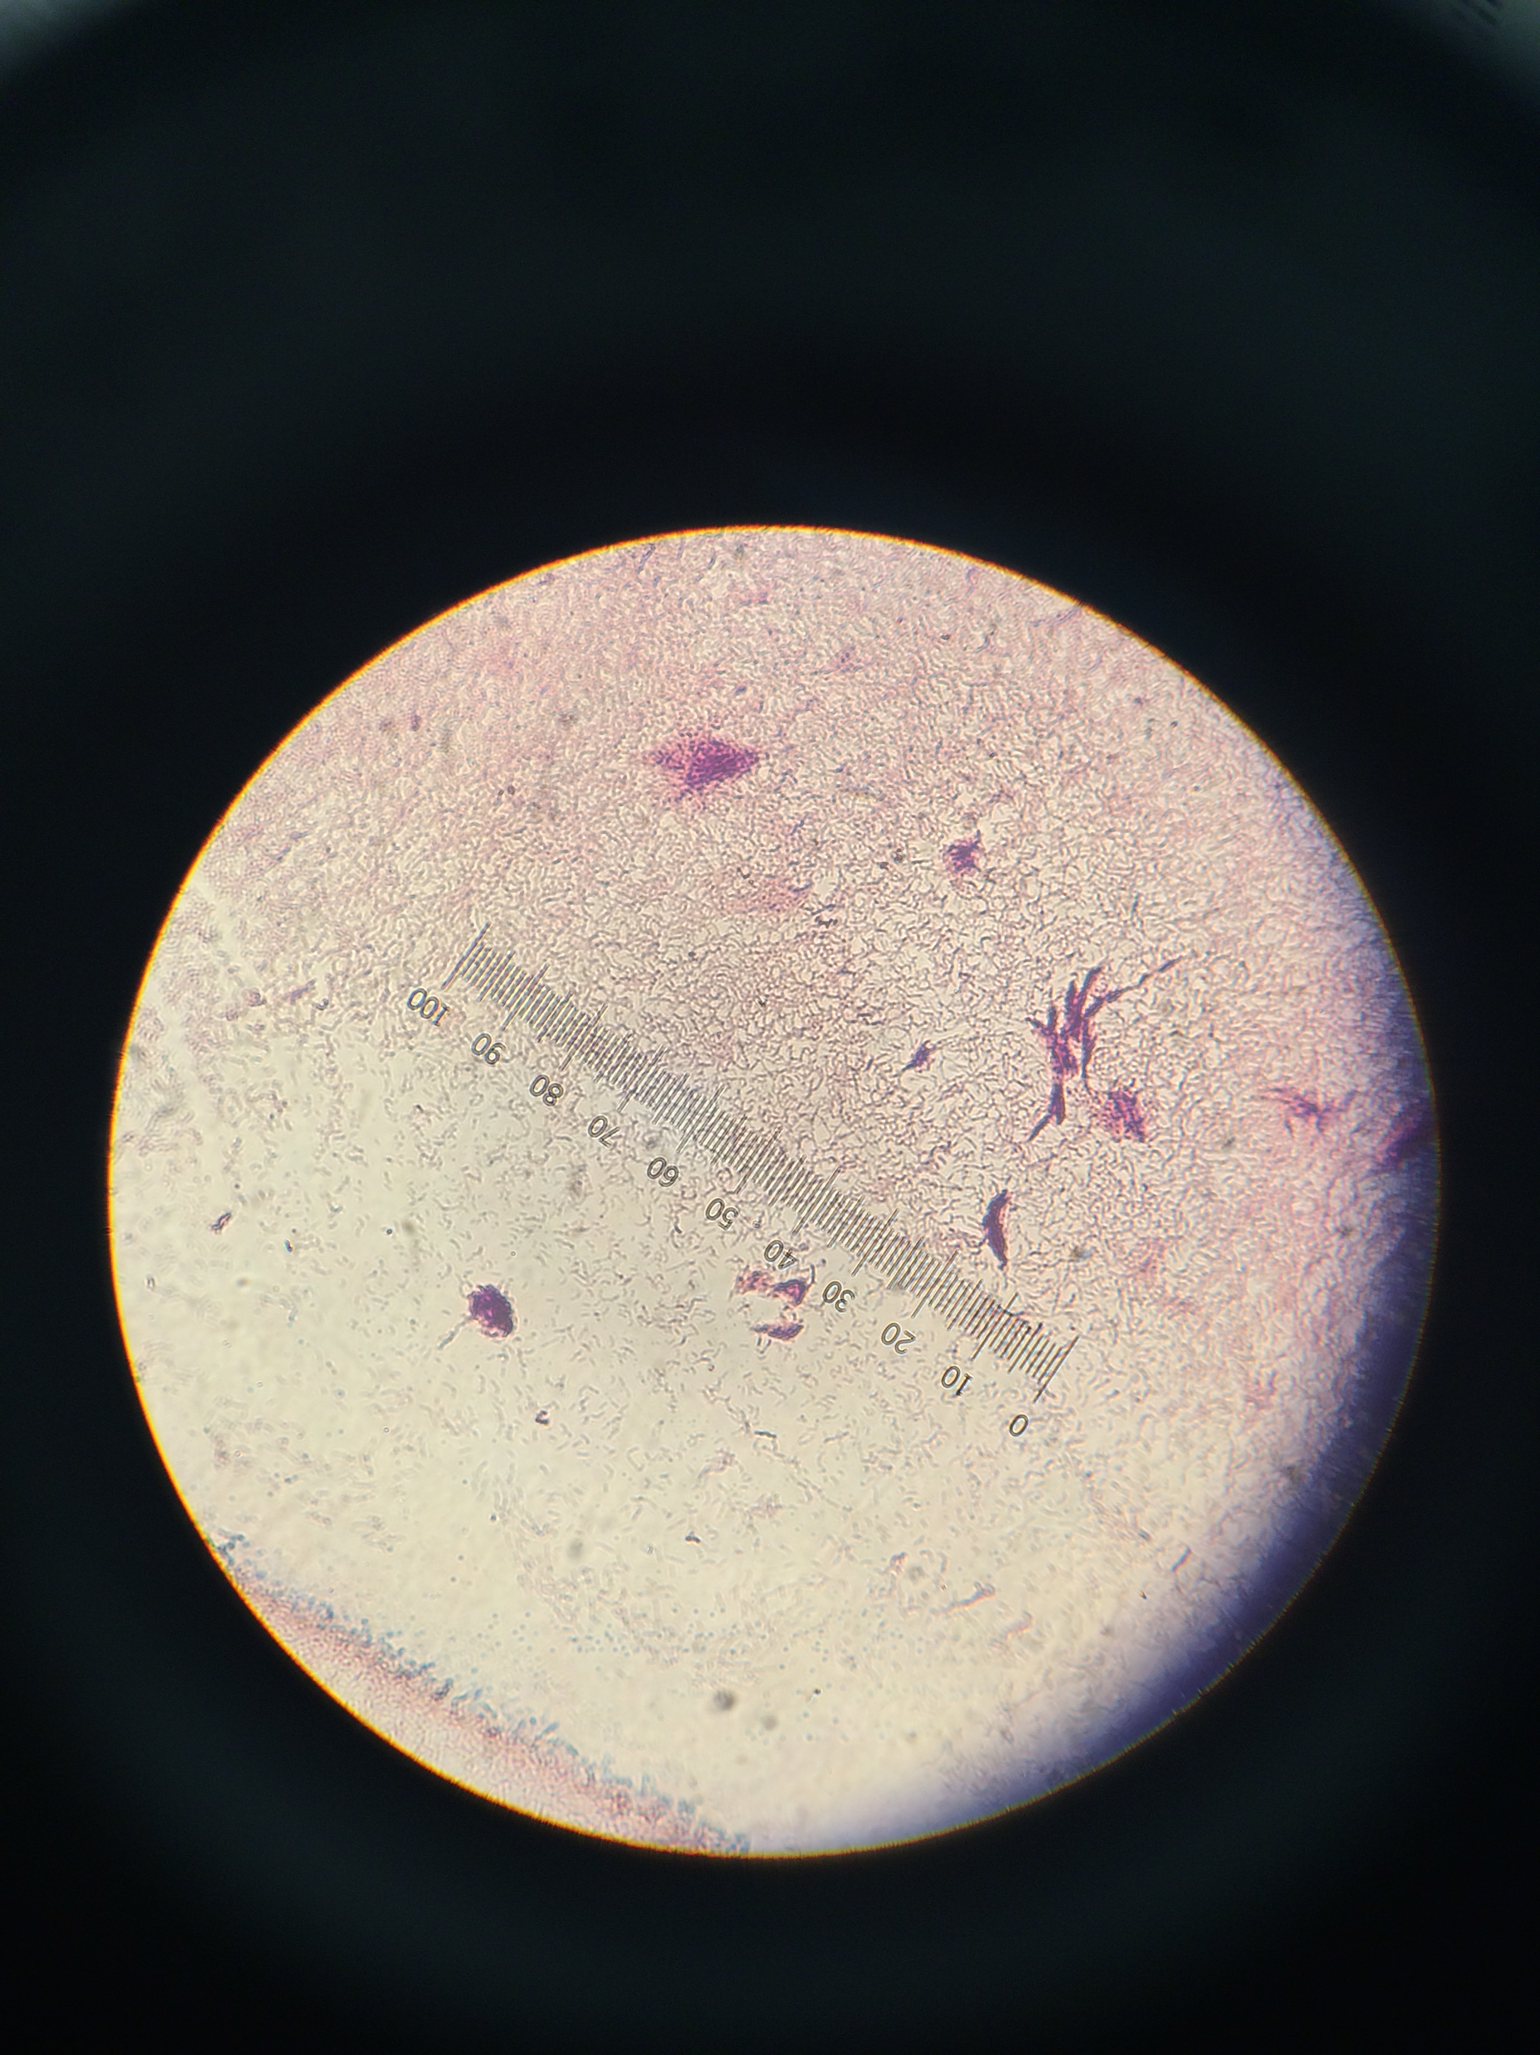
Figure 4. This sample is from the tetracycline colony yellow from the 10⁻⁷ agar plate. It was yellow, smooth, glistening, flat, and punctiform entire. The cells were rod shaped, swimming/floating, and Brownian. It was gram positive.

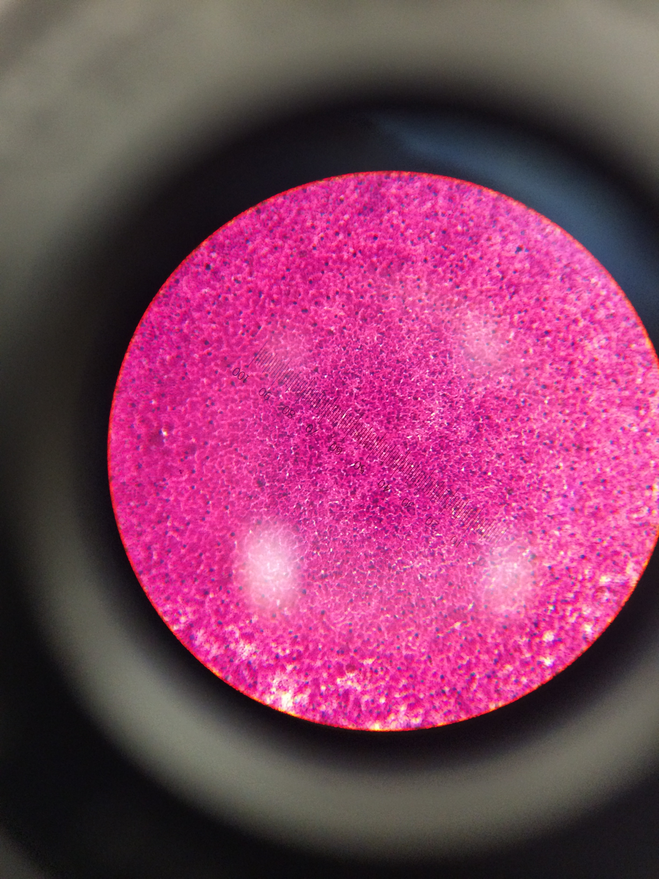
Figure 5. The last plate that was observed was from the 10⁻⁷ colony. Prior to staining it was white, flat smooth, glistening, punctiform entire and rod-shaped. It was swimming/ floating slowly in unison and was Brownian. The gram stain was negative.

Conclusions and Future Instructions

There were significant differences between the amount of bacteria that had grown on the two different types of plates. The tetracycline affected the bacteria so much that as shown in figure 1 the 10⁻⁹ tetracycline treated plate had no growth. The 4 colonies that were visible were mostly white, with a little yellow and a couple of blue ones. After characterizing the four chosen species, it was interesting to see the differences amongst them.

For next week, the four specimens were prepared for PCR amplification to allow for the sequencing of the 16S gene.

