1/15/2014
Lab 1: Niches at AU

Objective- The objective of this lab was to see how biotic and abiotic factors of a niche effect natural selection. The purpose of this lab is to see how organisms can evolve over time. Before looking at our transects we observed three different types of algae that illustrate the Volvocine Line, which will help us later on when we study the organisms in our 20 by 20 foot transects. My hypothesis is that

Materials and Methods-
- Before going to our transects, we observed three types of algae (Volvox, Chlamydomonas, and Gonium) under the microscope. While observing we noted the number of cells in our field of view, the size of the colony, and any reproductive or functional specialization of cells.
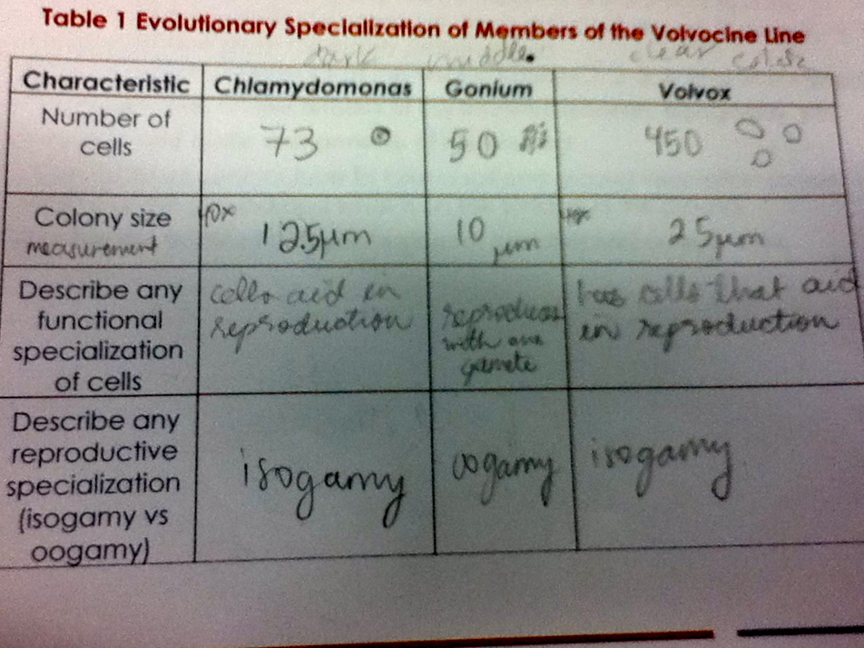

- After this we went to go observe our transect. It is located right before the amphitheater and near the Bender Arena. It is surrounded by vegetation and there are benches for people to sit. We observed biotic and abiotic factors on our transect.
- Next, before going back to the lab we took some vegetation from our transect in a sterile 50ml conical tube so that we could do a hay infusion.
- In order to do the hay infusion, we added 500ml of water, 0.1 gram of powdered milk, and the contents of our conical (which included wet soil, mulch, dead leaves and tan colored twig looking leaves) tube to a beaker. After this we transported the contents into a jar.
- Next, we let it sit until the next lab.

Observations and Data-
Biotic factors we observed were one bird, plants, and shrubs. Most of the tall plants where planted more towards the middle of the transect and surrounding it where purplish colored shrubs. Abiotic factors we observed were wet mulch, soil, sunlight, cigarette buts, rocks, a sprinkler, a coca cola paper cup, and two lampposts. It was also very chilly outside and it is not very busy with people walking. Most of the dead leaves were found on the wet mulch under the shrubs, very little were on top of the shrubs.

Conclusion-
Ultimately, today’s lab will help us study microorganisms living in our transect. I believe that we will find some bacterial organisms living in our transect next lab. In the future it may be interesting to take a sample of soil deeper in the ground. There may be more organisms living deeper in the soil to observe.

Kenia Michelle Fernandez-Ortiz

