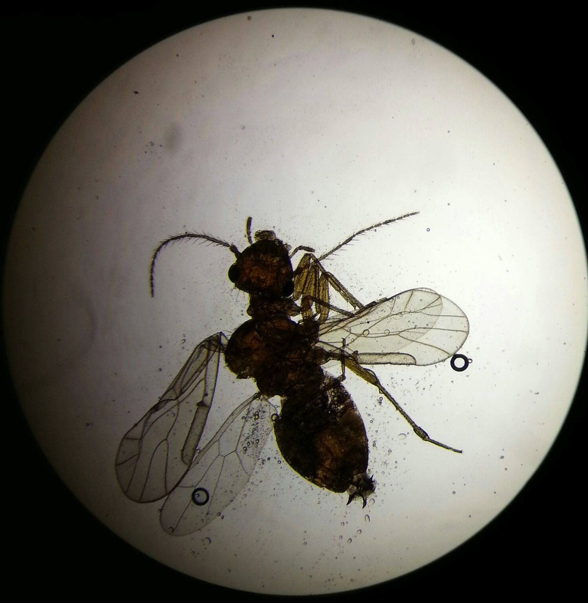
Dichotomous Key Prediction:
Phylum: Arthropoda
Class: Insecta
Order: Hymenoptera (wasp, bee or ant)
- 1-6 legs, wings, two sets, no scales on wings, chewing mouthpart, membranous wings, tarsi five segmented, hind wing smaller
Groups Prediction: a type of flying ant
- segmented body, ant antennae, pinchers on butt

Flying Ant Gnat
Invertebrates from Berlese Funnel
Invertebrate #1

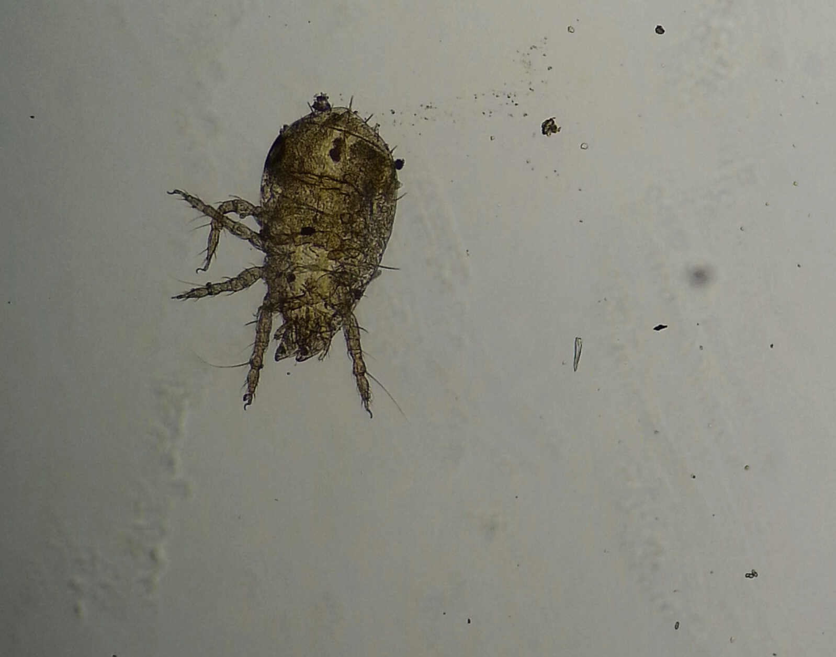
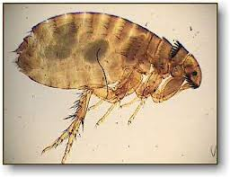
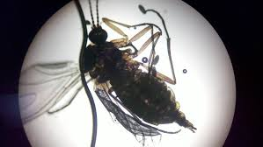
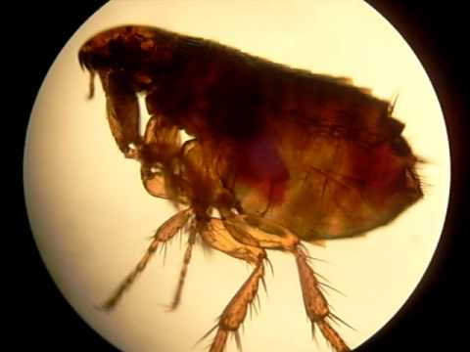
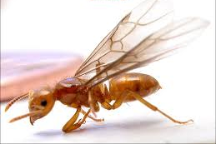
Invertebrate #2
Dichotomous Key Prediction:
Phylum: Arthropoda
Class: Insecta
Order: Collembola (springtail)
- 1-6 legs, no wings, chewing mouthpiece, specimen live bird and animals or plants, free-living, appendages on abdomen, forked tail beneath abdomen used for jumping
Group Prediction: Mite or Flea
- when using our intuition to answer the questions, the results were a louse on the dichotomous key

Flea Deer Tick

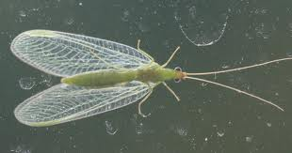
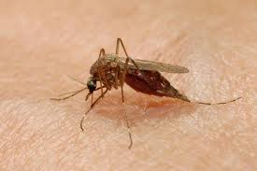
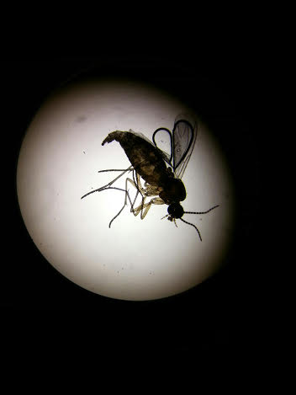
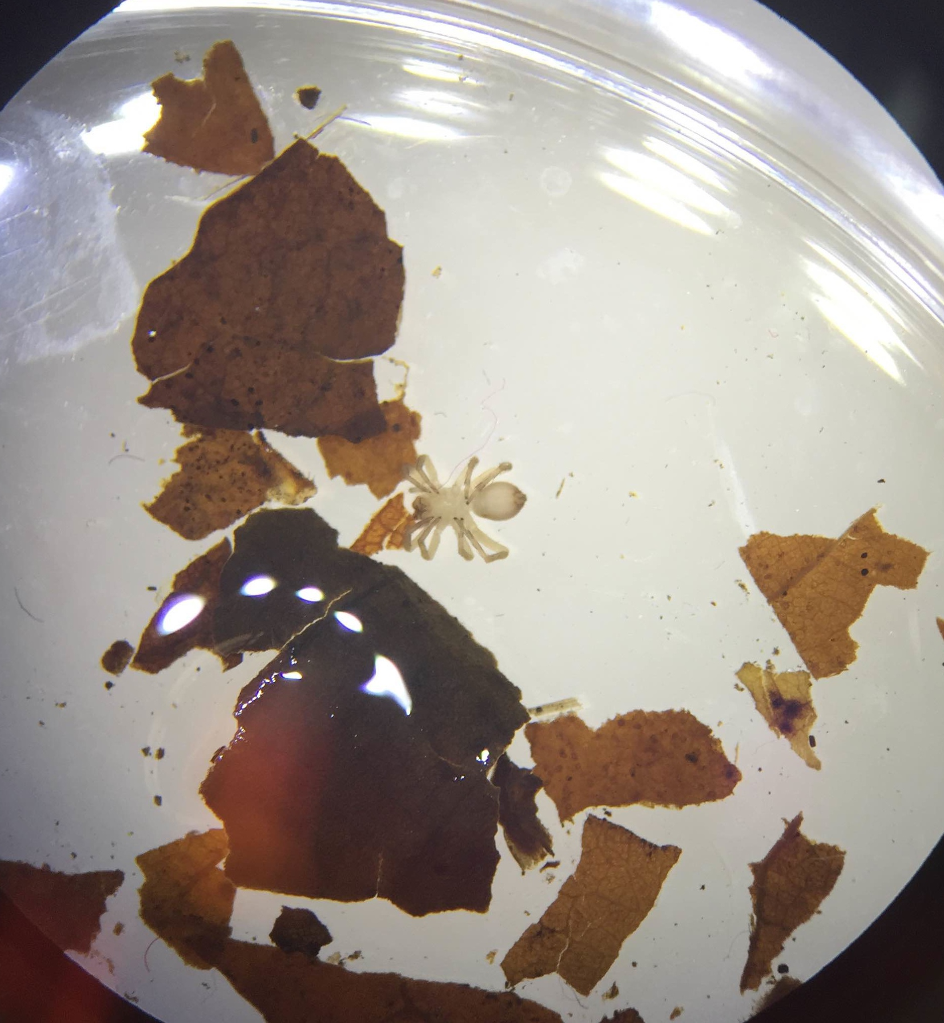
Dichotomous Key Prediction:
Phylum: Arthropoda
Class: Insecta
Order: neuropteran (Lacewing)
- 1-6 legs, wings, two sets, no scales on wings, chewing mouth part, tarsi 5 segmented, wings same size, abdomen not scorpion like, eyes prominent but small
Group Prediction: mosquito

Lacewing Mosquito

Invertebrate #4

Dichotomous Key Prediction:
Phylum: Arthropoda
Class: Arachnida
Order: Aranaeae (spiders)
- 8 legs, segmented, no modification of front legs

Group Prediction: spider

Spider 0 from dichotomous key
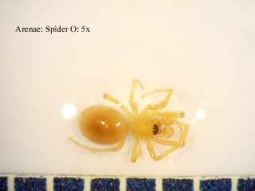
Invertebrate #3

