12 May 2011 Das Lab

3100 Genetic Analyzer (ABI) User Guide

- Working with Plate Assemblies

- Prepare sample (without bubbles) in 96-well-“Optical plate” fit for ABI3100 sequencer.
Put clean & dry septa strip on the sample plate, ensure that the septa strip lies flat on the plate.

- Prepare plate assemble as below

(Important; The plate retainer holes must align with the holes in the septa strip)

Placing the Plate onto the Autosampler
1. Close the oven and front doors.
2. Press the Tray button. Please wait until the autosample-unit come to the front and stop.
3. Open the front doors.
4. Place the plate assembly on the autosampler in position A or B for the 3100.
5. Ensure the plate assembly fits flat in the autosampler. Failure to do so may allow the
capillary tips to lift the plate assembly off of the autosampler.
6. Close the instrument doors.

Note:
- There is only one orientation for the plate, with the notched end of the plate base away from you.
- Closing the doors returns the autosampler to the home position, placing the tips of the
capillaries in buffer.

2) Instrument check

  - Sequencer machine light is on and green status light is ON and constant before proceeding.
  - For good result, user should run samples with fresh H₂O and 1X-running buffer

Replacing the buffer

1. Verify the oven and instrument doors are closed.
2. Press the Tray button on the outside of the instrument to bring the autosampler to the forward position.
3. Wait until the autosampler has stopped moving, then open the instrument doors.

4. Remove the cathode buffer reservoir and water reservoirs from the instrument.

5. Dispose of remaining fluids and rinse out the reservoirs with deionized water.
6. Rinse the cathode reservoir with 1X running buffer, and then fill to the line with 1X running buffer (about 16 mL).
7. Fill the two water reservoirs (No. 2 & 3) to the line with quality deionized water (about 16 mL).

8. Place a clean reservoir septa on each reservoir, and dry the outside of the reservoirs using a lint-free wipe.
9. Place the reservoirs into position on the autosampler as shown below.
10. Close the instrument doors.

Note: Closing the doors returns the autosampler to the last known position, placing the tips of the
capillaries in water or buffer.

2.3) Filling the Anode Buffer Reservoir
Change the anode buffer:
• Every 24 hours
• Before each run or batch of runs
• Every time you fill the polymer block with new polymer

1. Remove the anode buffer reservoir by firmly pulling down and twisting slowly.
2. Discard the used buffer appropriately.
3. Clean and rinse the reservoir with deionized water, and then rinse with buffer.
4. Fill the anode buffer reservoir to the fill line with fresh 1X running buffer (about 9 mL).

5. Put the anode buffer reservoir on the instrument.
6. If the reservoir fills with fluid, repeat this procedure to discard and replace the running

2.4) Check polymer before use
  - Polymer is enough for your run; 1 ml is enough for 1 plate (96 samples) or 6 run
  - No bubbles in polymer line
  - No signs of leaking polymer

3) Data Collection software Check

- Open the software “3100 Data Collection” on desktop. The Window as below will be displayed as below;

4) Software setting : Required File for Sequencing Analysis

Note: File-Naming Convention
Some alphanumeric characters are not valid for user names or file names. The invalid characters are below:
Spaces \ / : * ? " < > |

  - Instrument Protocol
- Click GA Instrument > ga3100> Protocol Manager

- In the Instrument Protocol section, Click “ New”
- Type a name of protocol
- Select “ Regular “ in the Type drop-down list.
- Choose Run Module “Rapid36_POP6_1”
- Choose Dye set “Z_BigDyeV3”
- Click “OK”.

4.2) Creating an Analysis Protocol

4.2.1) In Analysis Protocol section of Protocol Manager (Bottom section), Click “New”.
4.2.2) Select “Sequencing Analysis”
4.2.3) In general tab;
a) Enter a unique name and description for the new protocol.
b) Choose “ Write .Seq File” the software will generate ABI format file.

4.2.4) Select Basecalling tab.
Choose Basecalling : Basecaller-3100POP6RRV2.bcp
DyeSet Primer: DT3100POP6{BDv3}v1.mob

4.2.5) Click “OK” to save the protocol

  - Set the Results Group for Sequencing Analysis

A Results Group is a component within Data Collection that organizes samples and certain user settings under a single name. It is called a Results Group because it is used to analyze, name, sort, and deliver samples that result from a run.

Creating a Results Group
1. In the Tree pane of the Data Collection Software, click GA Instruments > Results Group.

2. Click ”New”
The Results Group Editor window displays.

3. Complete the General tab:
a. Type a Results Group Name. The name can be used in naming and sorting sample files.
It must be unique. Type: “Das”.

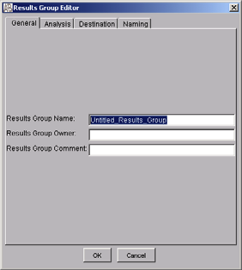

4. Select the Analysis tab, then:
a. Select Sequencing Analysis from the Analysis Type drop-down list.
b. In the Analysis Actions section, select Do Autoanalysis, if you want your data
automatically analyzed after a run.

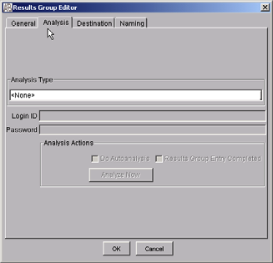

5. Select the Destination tab, then use the default destination.

For Group Name: Das_Lab, The data destination is a default, located at
E:\AppliedBiosystems\ucd\datacollection\Data\ (shortcut is at desktop)

6. Click “OK”

Note:

- Transfer your data by jump-drive which locate at USB port, in front of CPU and drive name is drive H: \

- For Das Group;

2.1) Data folder will be in format = Plate name_Run date_Run number
ex; 050911_Ann_TexasRed_2011-05-09-20_0005
| -------- Plate name -----| -Run Date--|-Run No--

2.2) File name will be in format = Well No_Sample name_Seq run number.
ex; A01_P4P6TexasRed_01.ab1
Well No-| -sample name--| -Seq run no.ab1

4.4) Creating and Completing a Sequencing Analysis Plate Record

4.4.1) Creating a Sequencing Analysis Plate Record
1. In the Tree pane of the Data Collection Software, click GA Instruments > Plate Manager.
2. Click “New” The New Plate Dialog dialog box opens.
3. Complete the information in the New PlateDialog:
a. Type a name for the plate.
b. Type a description for the plate (optional).
c. Select your sequencing application in the Application: SequencingAnalysis in drop-down list.
d. Select 96-well in the Plate Type drop-down list.
e. Type a name for the owner “Das”.
f. Click “OK”. The Sequencing Analysis Plate Editor opens.

4.4.2) Completing a Sequencing Analysis Plate Record

1. In the Sample Name column of a row, enter a sample name ; such as Texas Red, then click the next cell.

2. In the Priority column, the value 100 automatically display in the Priority column.
Change the priority value, if desired (see page 262, ABI 3100 -manual).

3. In the Results Group 1 column, select “Das” from the drop-down list.

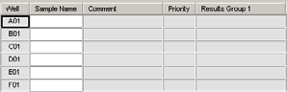

4. In the Instrument Protocol 1 column, select a protocol “RapidSeq36_Pop6_1”

5. In the Analysis Protocol 1 column, select a protocol “3100POP6_BDTV3_KBDeNovo_V5.1” from the drop-down list.

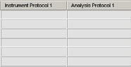

6. To complete the rest of the plate record based on the samples loaded in your plate, do one of the following:

• For the same samples and protocols –Highlight the entire row, then select Edit >
Fill Down.

• For the different samples and protocols –Complete the manually.

7. If you want to do more than one run, then select Edit > Add Sample Run.
Additional Results Group, Instrument Protocol and Analysis Protocol columns are added to the right end of the plate record. You can add additional runs by selecting Edit > Add Sample Run again.

9. Complete the columns for the additional runs.

10. Click “OK”.

4.5) Linking and Unlinking a Plate

The procedure below describes how to link a plate on the autosampler to the plate record you have created. This must be done before a plate can be run.

Searching for Plate Records
1. In the Tree pane of the Data Collection Software,
click GA Instruments > ga3100 > instrument name > Run Scheduler.

2. Search for your plate record. There are two search options, Choose Find All.
All plates in the database display in plate record section.

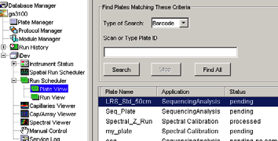

Linking a Plate

Select the plate record you want to run, then click the plate position indicator that corresponds to the plate you are linking.

The plate position indicator changes from yellow to green when linked and the green run button is active.

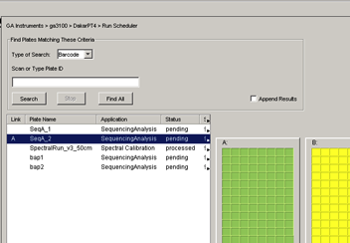

4.6) Running the Instrument
Launching the Run
Starting the Run
1. Verify the active spectral calibration matches your dye set and capillary array length.
To change the active spectral calibration, refer to
“Activating a Spectral Calibration”, page 59 in the manual.

To create a new spectral calibration, refer to
“Creating a Spectral Instrument Protocol” page 41 in the manual.

2. If you want to review the run schedule before beginning the run, click
GA Instruments > ga3100 > instrument name > Run Scheduler > Run View.

- Click the green button in the toolbar.

4. The Processing Plates dialog box opens, then click OK.

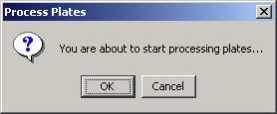

5. The software automatically performs a run validation:
• if the validation passes, the run starts
• if any of the validation test fails, the run
does not start (use the troubleshooting table, “Run Validation” on page 165 in the manual)

4.7) Controlling the Run
Controlling the Run Using the Toolbar
Use the toolbar at the top of the data collection software window to control the run.

4.8) Viewing Data During a Run
Run Scheduler > Plate View
In the tree pane of the Data Collection Software, click GA Instruments > ga3100
> instrument name > Run Scheduler > Plate View.

Note: The Run Scheduler and Plate View windows display the same information.

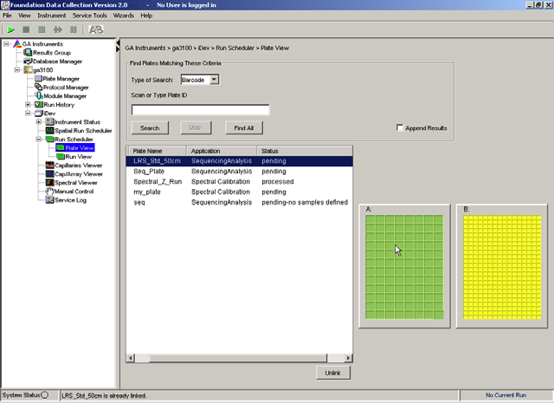

4.9) Run Scheduler > Run View
In the tree pane of the Data Collection Software, click GA Instruments > ga3100
> instrument name > Run Scheduler > Run View to monitor the status of the scheduled runs.

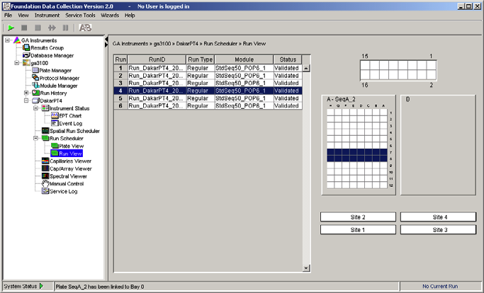

4.10) Instrument Status
In the tree pane of the Data Collection Software, click GA Instruments > ga3100
> instrument name > Instrument Status to monitor the status of the instrument or the current run.

4.11) Instrument Condition Group Box
The color of the box provides a quick way to check the status of the item to the right. See
the table below for a definition of each color.

Events Box The Events box lists the:
• Instrument’s recent actions
• Status of each capillary as passed or failed at the end of a spectral calibration
• Calibration data at the end of a spatial calibration
Some of the events listed in the Events box provide information for service engineers.
Errors Box The Errors box lists errors that have occurred during the current run.
Some of the error messages provide information for service engineers. A “fatal” error
usually requires that you restart the data collection software.

