Michelle Blemker
Christopher Rhodes
April 27, 2011

Analysis of the 4.3 kb Region of Mycobacteriophage HelDan

Introduction:
Bacteriophages are the most abundant living entity on the planet. Scientists who have studied bacteriophage theorize them to have numerous possible medical and biological applications for the future, as well as be a key component to bacterial evolution; however, they have not attracted much scientific scrutiny. To contribute to an understanding of the diversity of mycobacteriophage in the environment, we have begun to collect, isolate, and analyze mycobacteriophage from the Ballona Wetlands as part of the HHMI Phage Discovery Project.
Of the phage genomes collected and sequenced during our research in the Discovery lab the one we found most intriguing and the focus of this paper was the phage HelDan. During it’s sequencing, the HelDan genome presented with a genomic anomaly in which a 50:50 ratio of two separate genome sequences was collected: one at a length of 46 kb, named HelDan Short (HDS), and the other at a length of 50 kb, named HelDan Long (HDL). Though initially thought to be contamination, after further investigation it was found that the two genomes shared 100% sequence similarity across their entire genomes except for a 4.3 kb region located on the HDL genome which shared zero sequence similarity. Due to the immense similarity between the two sequences it was concluded that the two genomes were highly related to each other and

Materials and Methods:
The most commonly used resource in our analysis is blast. It was used to compare DNA sequences and amino sequences against other Mycobacteriophages and helped determine the function of some genes. The application Apollo was used to incorporate all of our genomic annotations of HelDan Long. Another resource used was Phamerator. This helped us compare nucleotide and predicted gene sequences side by side, and also determine evolutionary divergences.

Results:
From the beginning, we determined through the use of blastn that the added 4.3 kbp sequence did not related to any genes in M. Smegmatis, the host bacteria. Secondly, we determined that the 4.3 region did not match any one specific phage’s genome (Figure 1). The sequence matched a combination of different phages in differing subclusters, but all belong to cluster A.

Also, it was discovered that gene 69 in HelDan Long matched a transcription regulator comparable to Mycobacteriophages Peaches, Eagle, and Shaka. It is the only gene in the region with a known function, and acts as an HTH regulator that binds to a stoperator sequence and prevents phages of similar genomics from being expressed if superinfection occurs. Before and after the 4.3 kbp insertion there is a 9 bp direct repeat; meaning there is a nine base pair sequence (GGCGCGAAG) before and after the start and end of the added sequence. Through further analysis we discovered that this sequence is only present once in the region of HelDan Short. This sequence could serve as markers for the 4.3 sequence.

Figure 1: Percent Identity of each gene in the 4.3 region of HelDan. Results from blastn.

While comparing similar phages we came across the phage Rockstar, harvested in Monroe, Louisiana. It also belongs to the A3 subcluster. Running HelDan Long, HelDan Short, and Rockstar through Phamerator showed that the two phages were highly similar, about 93% (Figure 2). Interestingly, when comparing HelDan Long to Rockstar, part of the 4.3 kbp region of HelDan Long matches with Rockstar, and the genomic variance doesn’t begin until about 1 kbp downstream compared to HelDan Short. This section of dissimilarity between HelDan Long and Rockstar is about 2.8 kbp. Also, genes 68 and 69, 67 and 68, and 69 and 81, of Rhoker and HelDan, respectively, are matching genes not found in HelDan Short. Running both Rockstar and HelDan Long through blast showed that sequences stopped matching exactly at the beginning of the 2.8 kbp region (43670 bp).
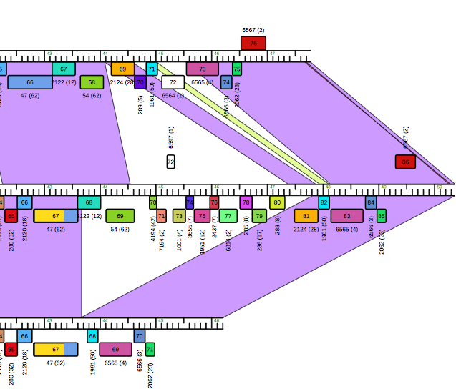
Figure 2: Phamerator comparison of Rockstar (top), HelDan Long (middle), and Hel Dan Short (bottom). The dissimilarity starts later downstream in Rockstar than HelDan Short. Also, there is a gene common between Rockstar and HelDan Long that is not found in HelDan Short.

Discussion:
Works Cited:

