Effect of varying Dexamethasone concentration on chondrocyte differentiation as shown by measuring transcript and protein levels of Collagen I and Collagen II

Mashaal Sohail
Peter Bojo

The significance of the field of cartilage tissue engineering lies in its potential to treat Osteoarthritis, a widespread disease that causes cartilage tissue degradation and joints inflammation. Cartilage is composed of specialized cells called chondrocytes and it is, therefore, crucially important to understand the factors associated with chondrocyte phenotype development in order to engineer cartilage tissue in vitro. Previous work has reported the role of Dexamethasone (DEX) in promoting chondrocyte differentiation and Collagen II (CNII) production (1). Alternatively, Yamashita et al (2) have suggested that DEX can cause inhibition of TGF-β-induced cell growth and type II collagen mRNA expression. We were, therefore, interested in observing the effects of no DEX (0μM ) and three-folds the regular concentration of DEX (300μM) in stem cell culture on chondrocyte differentiation in mesenchymal stem cells (MES). We based our evaluation of chondrocyte phenotype development on transcript and protein levels of Collagen I (CNI) and Collagen II (CNII). Previous work has also suggested that SOX9, a transcription factor that activates type II procollagen expression during chondrocyte differentiation, is enhanced by DEX (3). We planned our experiment to test this claim while determining the effects of DEX on chondrogenesis. We hypothesized that high Dexamethasone would promote chondrocyte differentiation through enhancement of SOX9 and, therefore, expected to see an increase in SOX9 levels and higher chondrocyte differentiation in the MSCs grown in a higher concentration of Dexamethasone.
Results
MSCs (at a density of 1.75 * 10^6 cells/mL) were grown in alginate scaffolds (Sigma, 1%) in two separate samples, containing 0μM and 300μM of DEX in their 3D bead cultures, respectively. We aimed to investigate the effects of high and low Dexamethasone concentrations on chondrocyte phenotype induction by observing cell morphology and viability as well as assessing Collagen I, Collagen II and SOX9 levels.
We observed effects on cell viability using the Live/Dead® fluorescence assay from Molecular probes, one week after initiating our cell cultures. The cells, as observed under the fluorescence microscope, appeared mostly alive, round and fairly dense, in both the low DEX (Figure 1a) and high DEX (Figure 1b) samples as determined by using the SYTO 10 dye (left, figure 1) and Ethidium dye (right, figure 1). Thus, we did not determine any significant changes in cell viability, morphology or density due to the high or low concentration of DEX using this assay.

a) O Dex

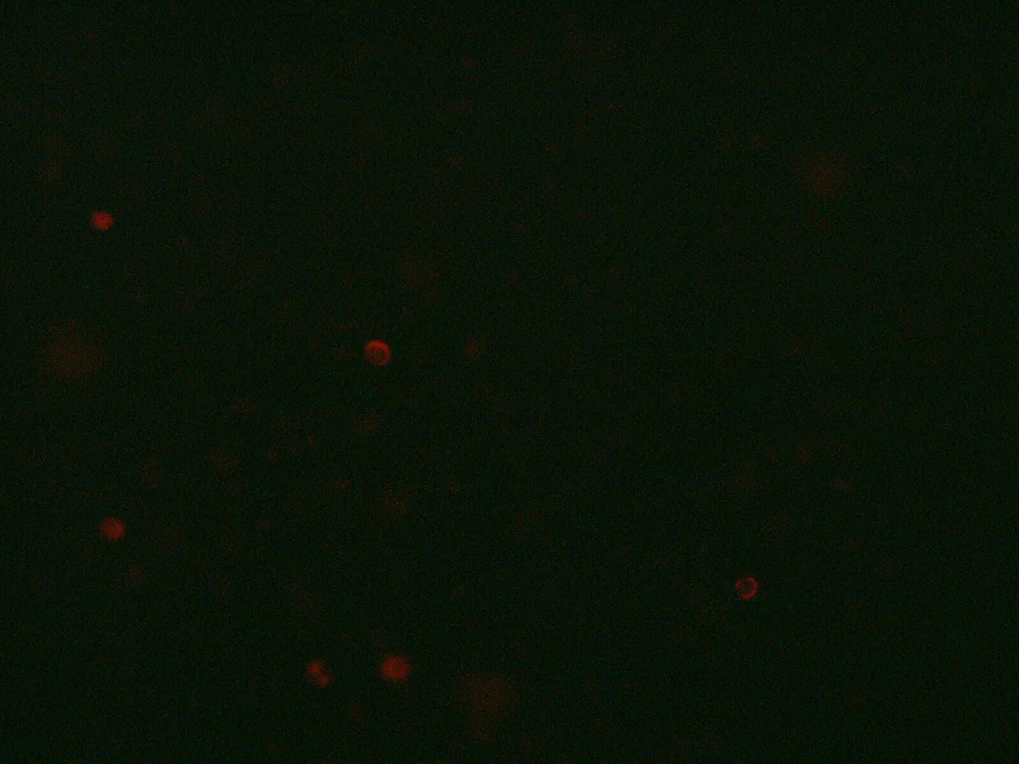

b)300 Dex


Figure 1: Cell viability was determined to be similar for O Dex and 300 Dex samples using Live/Dead Assay. Cell viability was monitored for O Dex (a) and 300 Dex (b) samples using SYT0 10 dye (left) and Ethidium dye (right). Fluorescence is emitted in both the green and red (left) and only red channels (right) in both (a) and (b). The photographs exhibit similar viability (mostly alive) and density (fairly dense) traits for both 0 Dex and 300 Dex samples.
We proceeded to collect data for our stem cell phenotype experiment. After another 5 days, the cell lysates were prepared and the cell counts for the two samples were determined (10^5 cells/mL in 0 DEX, 1.44 * 10^5cells/mL in 300 DEX). The counts suggested that the cell viability was unaffected by Dexamethasone concentration. RNA was isolated from the cell lysates to produce cDNA for Collagen I, Collagen II and SOX9 by performing RT-PCR for these genes as well as for the GAPDH housekeeping gene which served as a ‘loading’ control (8.3ng of RNA was used for each cDNA synthesis; A260/A280 values of 1.16 and 1.45 were determined for the 0 DEX and 300 DEX samples respectively, implying the presence of impurities with the RNA).
The cDNA samples were run on a 1.2% agarose gel that helped determine relative levels of CNI, CNII and Sox9 in the O Dex sample (Figure 2). We were unable to determine these ratios for the 300 Dex sample as no results for that sample appeared on the gel, possibly due to improper loading or low amounts of pure mRNA isolated (and, therefore, cDNA synthesized). For the O Dex sample, in lane 2, a band for Collagen I can be seen above the band for GAPDH. In lane 4, the band for Collagen II is barely visible over the band for GAPDH. In Lane 6, no band for SOX9 is observed but a band for GAPDH is visible. This information was analyzed using ImageJ – we subtracted for background, normalized using GAPDH values and, finally, calculated a CNII/CNI ratio of 0.367. Given that a high CNII/CNI ratio indicates chondrogenesis, a low ratio like the one we determined indicated a MSC phenotype and suggested little chondrocyte phenotype induction. This result seemed to indicate that 0 DEX concentration did not promote chondrogenesis suggesting importance of DEX in the chondrogenesis process (1). The lack of presence of a SOX9 band could be attributed to the same reason and suggested the possible significance of DEX in SOX9 enhancement, as reported by Noda et al (3).

Lane1 Lane2 Lane3 Lane4 Lane5 Lane6 Lane 7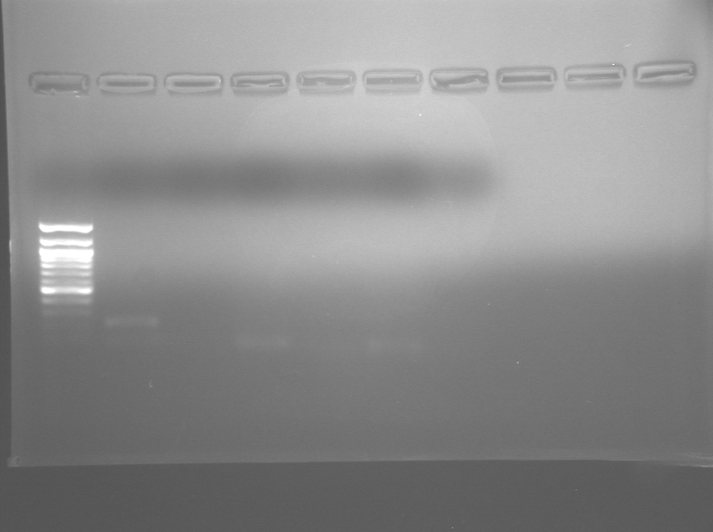
Figure 2: RT-PCR gel with collagen I, collagen II, and SOX9 transcripts for 0 Dexamethasone samples. 300 dexamethasone samples are also run in lanes 3,5,and 7, but do not show any product. Lane 1 is a DNA ladder, lane 2 is a collagen I 0 Dexamethsone, lane 4 is a collagen II 0 dexamethasone, lane 6 is a SOX9 0 dexamethasone.. Col I is observed in Lane 2 above the GAPDH band, Col II is not observed in lane 4 above the GAPDH band and SOX9 is not observed in lane 6 above the GAPDH band.

Antibodies against CNI and CNII were used in an indirect ELISA on the cell lysates of the two samples. There was fairly good agreement between the raw values for the different replicates for both the standards and the samples. Background corrected absorbances for the standards were plotted against 10ug/mL of collagen I (Figure 3) and the slope and intercept were used to calculate actual protein concentrations for the two samples using their background subtracted absorption values (~0.05). The values of CNI determined for 0 Dex and 300 Dex using this analysis were 1.2μg/mL and 1.1μg/mL respectively. No measurable amounts of CNII were determined for either sample and we were, therefore, unable to calculate CNII/CNI ratios. Our results suggested that chondrocyte phenotype was not induced in either of our samples, regardless of the DEX concentration. These results seemed to corroborate the transcript level results for 0 Dex from the RT-PCR which also indicated higher relative levels of CNI as compared to CNII, indicating low chondrocyte phenotype development.

Figure 3: ELISA standard curve for Collagen I. Background corrected absorbances are plotted against 10ug/mL of collagen I. Equation of fit and R-squared value are included on the graph. The corrected experimental ELISA absorbances were about .05, resulting in about 1.2ug/mL collagen concentration.

Discussion
We had set out to determine the effects of DEX concentration on chondrocyte phenotype development in MES by determining transcript and protein levels of CNI and CNII and transcript levels of SOX9. We had expected to see an increase in chondrocyte differentiation as indicated by an increase in CNII production (1) and an enhancement of SOX9(3). Our results seemed to suggest that DEX didn’t play much role in affecting cell viability and morphology as these traits appeared fairly constant across the two samples. We found a higher amount of CNI relative to CNII produced, on both the transcript and protein level, in the 0 DEX sample. For the 300 DEX sample, we found a higher relative amount of CNI as compared to CNII on the protein level. These results seemed to suggest that the concentration of DEX did not have much effect on promoting chondrogenesis. However, it is hard to draw a valid conclusion just based on these results. Future work would need to replicate these results on both the transcript and protein level for CNI and CNII. Moreover, the experiment would allow for a much more valid determination of a trend if carried out over a range of DEX concentrations rather than over just two. More sensitive techniques for quantifying transcript (q-pcr) and protein levels (Direct ELISA) would add to the validity of future experiments as well. We would also like to note that our assay certainly did not provide the full picture to make our claim. Further validation could be achieved by determining proteoglycan (~15-30% of cartilage tissue) content in the different samples to determine levels of chondrogenesis. Our results, therefore, point towards some ideas regarding the effects of DEX on chondrocyte differentiation and SOX9 expression, but would need to be further tested and validated through the suggested future work before a valid conclusion can be made.

References

1) Assia Derfoula, Geraldine L. Perkinsa,b, David J. Halla,b, Rocky S. Tuana. Glucocorticoids Promote Chondrogenic Differentiation of Adult Human Mesenchymal Stem Cells by Enhancing Expression of Cartilage Extracellular Matrix GeneS. Stem Cells Vol. 24 No. 6 June 2006, pp. 1487 -1495

2) Y. Miyazakib, T. Tsukazakic, Y. Hirotab, A. Yonekurab, M. Osakib, H. Shindob and S. Yamashitaa. Dexamethasone inhibition of TGFβ-induced cell growth and type II collagen mRNA expression through ERK-integrated AP-1 activity in cultured rat articular chondrocytes. Osteoarthritis and Cartilage. Volume 8, Issue 5, September 2000, Pages 378-385

3) Sekiya I, Koopman P, Tsuji K, Mertin S, Harley V, Yamada Y, Shinomiya K, Nifuji A, Noda M. Dexamethasone enhances SOX9 expression in chondrocytes. J Endocrinol. 2001;169:573–579.

