Figure 1  t0=0; % Time start  t1=1; % Time end  c0=10; % Initial concentration  y0=10; % Initial cell pop  S0=[c0;y0]; % State vars initial  q=0.1; % outflow rate  u=10; % inflow concentration  r=10; % rate of growth  K=100; % carrying capacity  Vmax = 100; % Max volume | 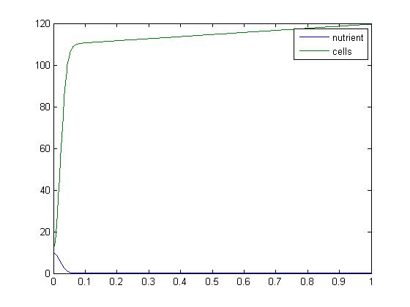
Figure 2  t0=0; % Time start  t1=1; % Time end  c0=0; % Initial concentration  y0=10; % Initial cell pop  S0=[c0;y0]; % State vars initial  q=0.1; % outflow rate  u=10; % inflow concentration  r=10; % rate of growth  K=100; % carrying capacity  Vmax = 100; % Max volume | 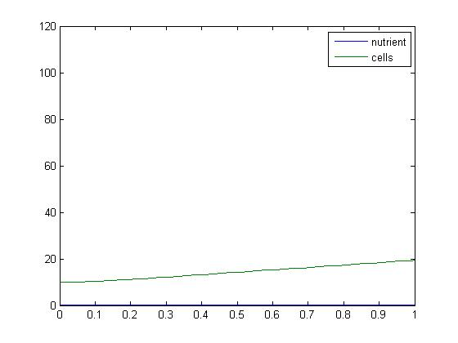
Figure 3  t0=0; % Time start  t1=1; % Time end  c0=0; % Initial concentration  y0=10; % Initial cell pop  S0=[c0;y0]; % State vars initial  q=1; % outflow rate  u=10; % inflow concentration  r=10; % rate of growth  K=100; % carrying capacity  Vmax = 100; % Max volume | 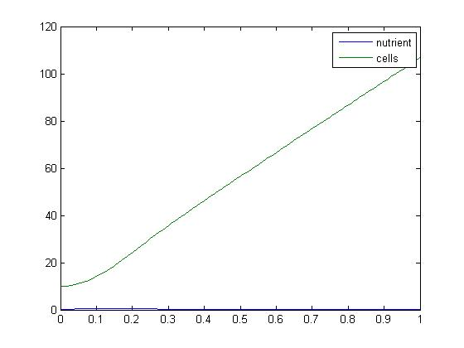
Figure 1 shows a spike in cell population, then the numbers level off once they deplete most of the nutrients. Figure 2 represents an initial nutrient concentration of 0. The number of cells increases very slowly as the nutrients slowly enter the system. However, Getting the nutrients into the chemostat faster (Figure 3) shows a steady growth in the number of cells.
Figure 4  t0=0; % Time start  t1=1; % Time end  c0=10; % Initial concentration  y0=1; % Initial cell pop  S0=[c0;y0]; % State vars initial  q=0.1; % outflow rate  u=10; % inflow concentration  r=10; % rate of growth  K=100; % carrying capacity  Vmax = 100; % Max volume | 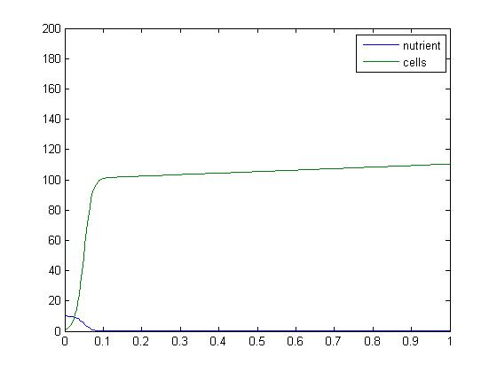
Figure 5  t0=0; % Time start  t1=1; % Time end  c0=10; % Initial concentration  y0=1; % Initial cell pop  S0=[c0;y0]; % State vars initial  q=1; % outflow rate  u=10; % inflow concentration  r=10; % rate of growth  K=100; % carrying capacity  Vmax = 100; % Max volume | 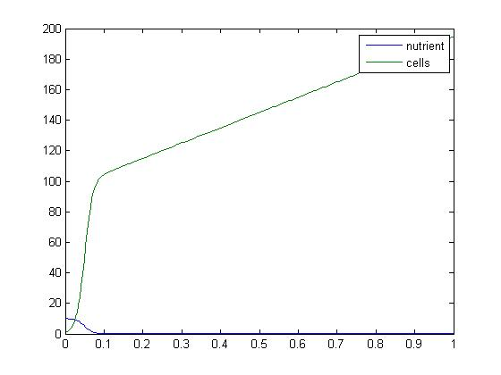
Figure 4 represents an initial cell concentration of one. The population still spikes up, but the leveling off occurs at a lower population than in figure 1 (note change in y-axis scale here). In figure 5 the inflow rate (and therefore the amount of nutrients in the system) was increased, allowing the cell population to increase past the 110 count in figure 4. However, there is still the knee where the initial higher concentration of nutrients is depleted and the increase in cells proceeds at a slower rate.

Figure 6  t0=0; % Time start  t1=1; % Time end  c0=10; % Initial concentration  y0=10; % Initial cell pop  S0=[c0;y0]; % State vars initial  q=.1; % outflow rate  u=10; % inflow concentration  r=10; % rate of growth  K=100;  a=.1; % factor for c-capacity  Vmax=100; % max volume | 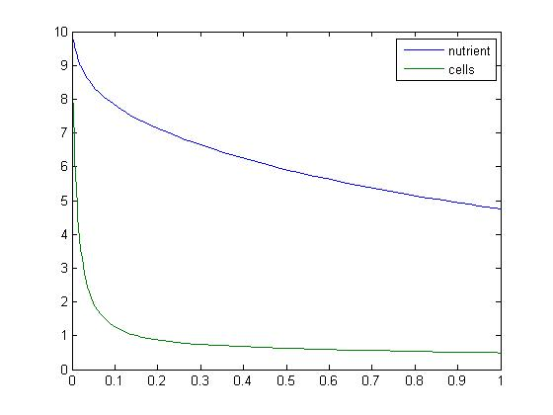
Figure 7  t0=0; % Time start  t1=1; % Time end  c0=10; % Initial concentration  y0=10; % Initial cell pop  S0=[c0;y0]; % State vars initial  q=1; % outflow rate  u=10; % inflow concentration  r=10; % rate of growth  K=100;  a=.1; % factor for c-capacity  Vmax=100; % max volume | 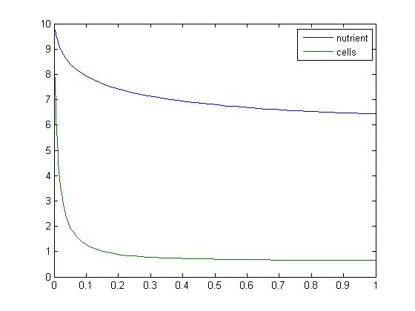
Figure 8  t0=0; % Time start  t1=1; % Time end  c0=.1; % Initial concentration  y0=10; % Initial cell pop  S0=[c0;y0]; % State vars initial  q=1; % outflow rate  u=10; % inflow concentration  r=10; % rate of growth  K=100;  a=.1; % factor for c-capacity  Vmax=100; % max volume | 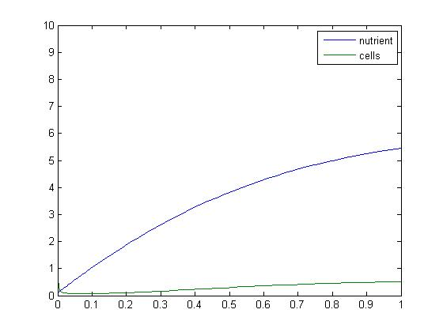
Figure 6 represents the logistic growth curve in which carrying capacity increases linearly with nutrient concentration. Increasing the inflow and outflow rates increases the nutrient content, however the cell population does not increase fast enough to offset the outflow of cells (figure 7). Minimal initial concentration of nutrients means a very slow population growth (figure 8).

Figure 9  t0=0; % Time start  t1=1; % Time end  c0=10; % Initial concentration  y0=1; % Initial cell pop  S0=[c0;y0]; % State vars initial  q=1; % outflow rate  u=10; % inflow concentration  r=10; % rate of growth  K=100;  a=.1; % factor for c-capacity  Vmax=100; % max volume | 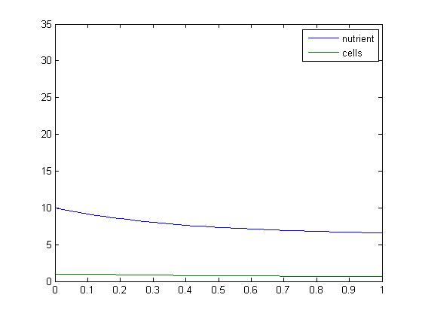
Figure 10  t0=0; % Time start  t1=1; % Time end  c0=10; % Initial concentration  y0=1; % Initial cell pop  S0=[c0;y0]; % State vars initial  q=1; % outflow rate  u=100; % inflow concentration  r=10; % rate of growth  K=100;  a=.1; % factor for c-capacity  Vmax=100; % max volume | 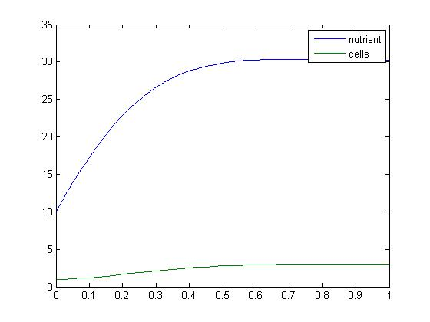
Figure 11  t0=0; % Time start  t1=1; % Time end  c0=10; % Initial concentration  y0=10; % Initial cell pop  S0=[c0;y0]; % State vars initial  q=1; % outflow rate  u=100; % inflow concentration  r=10; % rate of growth  K=100;  a=.1; % factor for c-capacity  Vmax=100; % max volume | 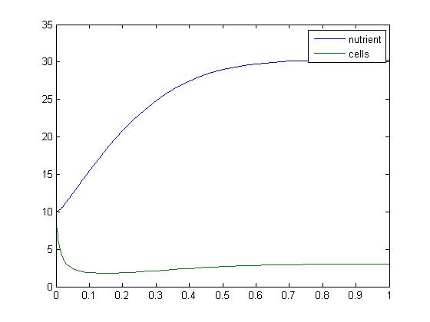
Figure 9 shows the population growing very slowly when the initial concentration is one cell. Starting with one cell, and increasing the concentration of the incoming nutrients increases the growth rate, but it does not spike (figure 10). Starting with 10 times as many cells, with the higher nutrient flux, ends up at the same level of cells as in figure 10 – there is a dip in the number of cells that I cannot explain (figure 11).

Figure 12  t0=0; % Time start  t1=1; % Time end  c0=10; % Initial concentration  y0=10; % Initial cell pop  S0=[c0;y0]; % State vars initial  q=1; % outflow rate  u=100; % inflow concentration  r=10; % rate of growth  K=100;  a=.01; % factor for c-capacity  Vmax=100; % max volume | 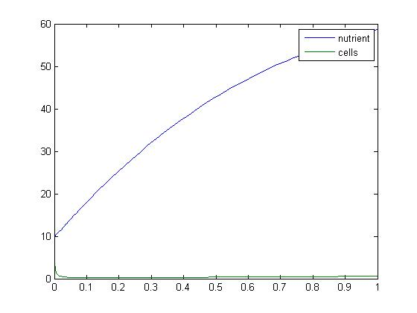
Figure 12 shows the increased population growth when the factor for the carrying capacity is decreased.

