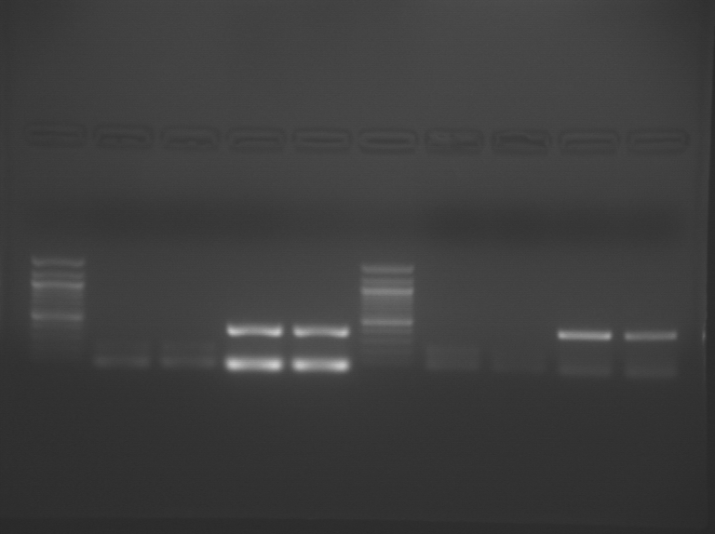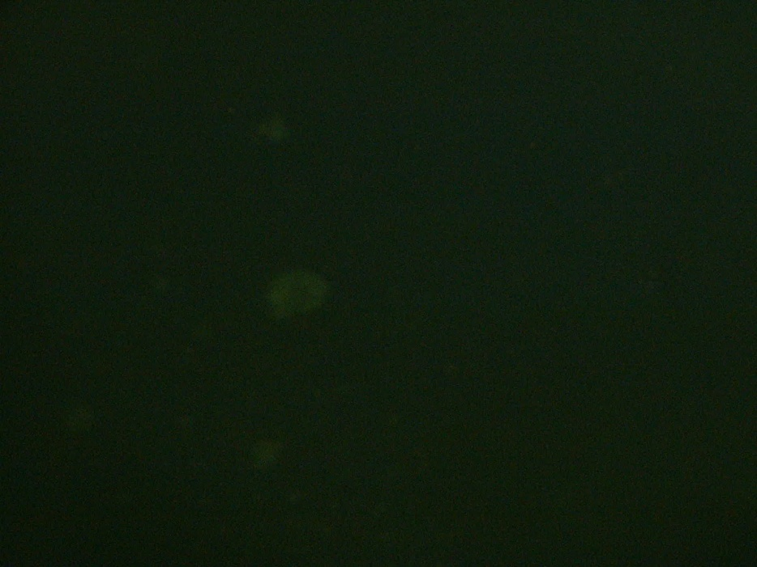
Figure 3: Live/Dead Assay on 50 mM [Ca] sample at 10X
Fluorescence microscopy of one alginate bead from 50mM [Ca ion] sample. Live cells are green while dead cells show up red.
Figure 1: Gel of RT-PCR products
Lanes: 1- 100 bp ladder, 2- 50mM [Ca ion] sample targeting Collagen I, 3- 1000 mM [Ca] sample targeting Collagen I, 4- 50mM [Ca] sample targeting Collagen II, 5- 1000mM [Ca] sample targeting Collagen II. First band in lanes 2 and 3 is Collagen I, while the first band in lanes 4 and 5 is Collagen II. Second band of each lane if GAPDH(internal control).

Collagen II
Collagen I
Ladder

Figure 2: Collagen I and II graphed standards and computed trendlines

