Capture-Release Substrate Development for Application in Peripheral Blood Stem Cell Harvest

The use of adult stem cells is being increasingly examined as a potential therapeutic in the treatment of numerous diseases. The harvesting of these cells is far from optimal as current methods of harvest can have strongly negative effects to donors. Historically, harvest involves a painful procedure in which mesenchymal stem cells are extracted directly from the bone marrow of the donor[1]. More recently, a procedure which induces stem cells which are native to the bone marrow to migrate into the peripheral blood stream has been introduced [1,2]. This allows the cells to be harvested along the lines of a typical blood donation. While this is a welcome development, the isolation of stem cells from blood does not allow the blood to be reintroduced to the donor. Only a finite amount of donor blood can be processed and donors are limited in the frequency they are able to donate. A manner of harvesting stem cells which reduces the burden on donors and increases the frequency for one to donate is much desired.
Research by Peyton et al and others indicates that there is an optimal substrate stiffness to maximize cell spreading for a given ligand condition. Cell spreading area is generally assumed to be an indicator of cell adhesion[3]. We propose to develop a substrate capable of switching from an optimal adhesion modulus to a low, release modulus by exploiting photo-degradable hydrogels. With this capability, the substrate could be used in the capture and then release of cells via the switching adhesive property of the substrate. Among many other applications, we propose to specifically optimize these substrates to selectively bind MSCs by protein coupling the photo-labile hydrogels. This technology could be applied in a system wherein donor blood cycles through an apparatus—similar in fashion to a dialysis machine—allowing for selective MSC capture and return of donor blood. Upon sufficient capture the gel’s modulus could be induced to change, releasing the captured cells into a desired media without the use of trypsin (derived from animals) or other processing steps.

Aim 1: Determine optimal conditions for preferential MSC adhesion on PEG-PC gels.
Hypothesis: Protein and stiffness conditions which model natural bone marrow tissue will preferentially bind MSCs over other components of blood.
Method: Identify modulus conditions that maximize MSC adhesion. Additionally couple combinations of Collagen I, Collagen III, Collagen IV, Fibronectin and Laminin to the PEG-PC gel surface to determine optimal protein composition for MSC adhesion of a given gel modulus.

Aim 2: Identify modulus conditions that induce release of MSCs from photolabile PEG-PC substrates.
Hypothesis: Required modulus change in photolabile PEG-PC gels can be achieved through a defined UV exposure time.
Method: Create a UV-Modulus profile based on defined exposure times and stress-strain measurements. Utilize profile to determine required exposure time to achieve target modulus change.

Aim 3: Characterize MSC capture and release potential of photo-labile substrate developed in Aims 1 and 2 through brightfield imaging.
Hypothesis: MSCs will detach from the substrate as continued UV exposure degrades the PEG-PC gel and will exhibit normal MSC behavior post substrate release.
Method: MSCs will be seeded to the substrate system, the PEG-PC gels photodegraded with UV light and the MSC release characterized with brightfield imaging. Longer term characterization of MSC culture behavior will be examined through brightfield imaging following substrate release.
Significance

1. Mesenchymal Stem Cells (MSC) are commonly found in bone marrow and are able to differentiate into many essential human tissues, but isolation has been an obstacle for medical researchers.
Multipotent stem cells (MSCs) are a valuable therapeutic in the treatment and repair of several tissues, however current means of MSC harvest and isolation are ardous, painful, and inefficient. MSCs are valuable because they can differentiate into critical tissues including bone, cartilage, muscle, ligament, tendon, and adipose, Figure 1[5]. They can also differentiate into beta-pancreatic islet cells, essential for the storage and release of insulin, a hormone that helps control glucose levels in the bloodstream [6]. MSCs are important for tissue engineering, as they have been shown to have the ability to migrate to a site of injury in animals. It is believed their migratory mechanism involves chemokine receptors, and being able to use this migratory mechanism may be used in the future to correct inherited disorders of mesenchymal tissues [7]. In addition, MSC have been shown to be potentially useful in the area of tumor drug delivery. MSC can suppress pulmonary metastases through production of interferon beta in the tumor itself [8]. Also, MSC can be engineered through infection with an adenoviral vector encoding human interleukin-2 and then be injected into the tumor. This has also been shown to enhance survival of tumor-bearing animals [8]. Thus, MSC have huge potential in the area of medicine, and specifically tissue engineering and regeneration.

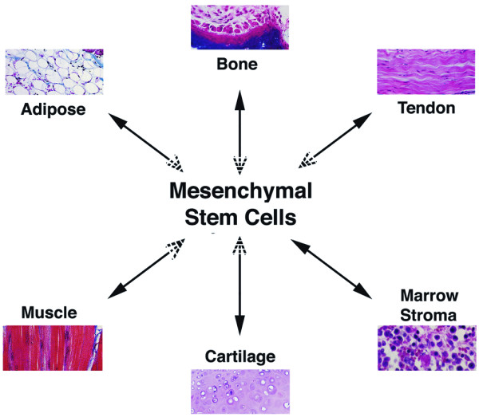
MSCs are tough to isolate, and hence finding a proper protein/substrate combination that can specifically bind and then release MSCs from a surface may be a revolutionary discovery in medicine for reasons described above. They are only present in about 1 of 10,000 nucleated bone marrow cells.⁷ They are also present in foatal tissues, including circulating blood, cord blood, placenta, amniotic fluid, heart, skeletal muscle, adipose, synovial tissue, and pancreas. Today, bone marrow is still the best-characterized source of MSCs [8].
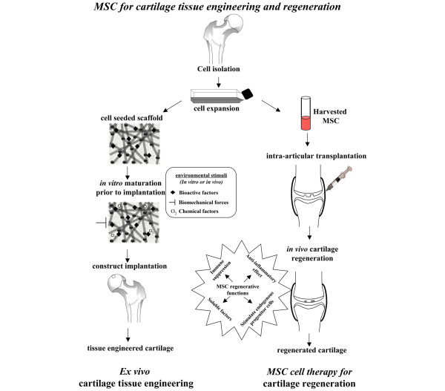
MSCs can either be characterized morphologically or by presence of markers. Morphologically, they have a large, round nucleus surrounded by chromatin. MSC specific markers include CD105, CD73, CD34, CD45, and CD141 MSCs have also been shown to grow extremely slowly both in vitro and in vivo. Gregory et al. showed that adding dickkopf-1 inhibits the Wnt signaling pathway, and thus increases proliferation [9]. This is an important advancement, as growth of MSCs is just as important as isolation.
Figure 1. MSC tissue derivatives [7]

2. Mesenchymal Stem Cells can be used to treat many common arthritic conditions.
Arthritis is very common, particularly as osteoarthritis and rheumatoid arthritis [7]. MSCs have been proven effective in many arthitic treatments, two of which are shown in Figure 2. MSCs could also potentially be used to repair each of the MSC derivative tissues discussed above.

3. Mesenchymal Stem Cells can be taken from a peripheral blood sample after treatment with growth factors to induce stem cell migration out of the bone marrow and into the blood.
Our grant seeks to isolate MSCs from peripheral blood. MSCs are very rare in the bloodstream; however, filgrastim injections induce stem cell migration from the bone marrow into the bloodstream (REFRENCE). We propose to take this MSC enriched donor blood and capture MSCs with our specialized substrates and subsequently release them for harvest. The harvested MSCs can then be provided to appropriate patients, ex. someone undergoing chemotherapy. The MSC would then differentiate into a target tissue (one of the tissues discussed above) [10].
Figure 2. MSC based treatments of osteoarthritis [7]

Innovation
1. Identifying conditions under which MSCs bind to PEG gels will improve PEG selectivity for MSCs.
The limiting step in our MSC isolation scheme is the initial capture of the cells. Since MSCs are found in low concentration in bone marrow, and lower concentrations in blood even with donor injection with filgrastim. As such, optimum cell binding parameters will be crucial to the feasibility of our approach. Data generated in small-scale experimentation will quantify MSC binding to PEG-PC gels with various gel elasticities and protein coatings. This data will indicate what binding conditions are best, and exactly how well MSCs do bind under these optimal conditions on the benchtop scale. This quantification can also provide a control value for scaled-up binding quantification experiments.

2. Altering the modulus of photlabile gels eliminates the use of cytotoxic proteases.
Current methods of releasing bound cells are dependent on the use of proteases such as trypsin and dispase to cleave cell-surface junctions. These proteases are toxic to cells, as they also cleave many other intercellular proteins and binding sites, thus resulting in a low yield of healthy, usable MSCs [11]. In a photolabile PEG gel, UV irradiation causes polymer cross-linking to decrease, increasing the flexibility of the polymer and decreasing the stiffness of the gel [12]. The photodegradation technique has been proven to maintain cell viability [12]. By implemeneting a photodegradable hydrogel in place of a robust polymer surface for MSC capture, MSCs will not be harmed upon release, resulting in a higher yield of viable MSCs. Additionally, the absence of cytotoxic proteases also allows filtered blood to be reintroduced to the bloodstream, giving way to the possibility of a dialysis type MSC isolation system.

Approach

We seek to develop a photo-sensitive substrate that will preferentially bind MSCs, distinguishing them from other components present in blood collected from donors injected with filgrastim. We propose to then induce a modulus change of the substrate by UV exposure to induce MSC release.

Aim 1: Determine optimal conditions for preferential MSC adhesion on PEG-PC gels.
Hypothesis: Protein and stiffness conditions which model natural bone marrow tissue will preferentially bind MSCs over other components of blood.
- Determine modulus of PEG-PC gels which maximizes MSC cell spreading as well as modulus which minimizes or prevents MSC adhesion.
- Determine the ideal surface composition of proteins to preferentially capture MSCs to a PEG gel surface of ideal modulus.
1. Optimize modulus of PEG-PC gels to maximize MSC cell spreading and prevents MSC adhesion.
We will seek to optimize PEG-PC gel stiffness to allow for two conditions of our substrate. The first will maximize spreading of adhered MSCs to our engineered PEG substrate. The effect of substrate stiffness on cell phenotype, including adhesion, has been well documented in literature [13,14,15]. Further, cell spreading has been characterized as a key indicator of cell adhesion [14]. We seek to maximize the surface area of cells bound to our substrate by mechanically tuning our PEG-PC gels. Our “capture” condition is key to the success of our project and by maximizing the spreading of MSCs to our substrate we will further predispose our system to the isolation of MSCs from peripheral blood. Similarly, our “release” condition is vital to the collection of MSCs from the substrate after they have been isolated to the surface. Identification of conditions which reduce or eliminate MSC adhesion is desired.
We will synthesize a range of PEG-PC gels at moduli between 100Pa and 5kPa which is typical of bone marrow tissue. We will confirm stiffness of our gels through stress-strain measurements and observe MSC cell spreading in culture through bright-field imaging in order to quantify cell surface area. Modulus conditions which maximize MSC spreading will be selected for the capture condition substrate. We will select our release condition as a modulus which exhibits adhesion of less than 5% of MSCs cultured with the substrate.

2. Protein surface composition for preferential MSC binding.
Surface receptors that are expressed by MSCs are well documented [16] and they rely on typical ECM proteins for adhesion. Further, we will employ combinations of Collagen I, Collagen III, Collagen IV, Fibronectin, and Laminin which have been well documented in literature to be the primary constituents of naturally occurring ECM within the bone marrow [17,18,19]. We will synthesize PEG-PC gels of optimal modulus and couple combinations of Collagen I, Collagen III, Collagen IV, Fibronectin, and Laminin to the gel surface though Sulpho-SANPAH and protein coupling. We will seed MSCs onto the coated PEG-PC gels and examine the adhesion of MSCs to the cell surface through brightfield imaging and quantify the percentage of cells that have attached to our substrates.
Once binding conditions that maximize MSC adhesion to the PEG-PC protein coated gels have been determined, we will culture MSCs along with other cellular components of blood such as red blood cells, macrophages and platelets, to ensure that MSCs outcompete blood components in terms of substrate binding. Because our substrate design is based on naturally occurring bone marrow, we believe that the tested conditions will allow preferential MSC binding since MSCs are native to bone marrow tissue. We will characterize binding behavior of all cell types through brightfield imaging and quantifying the composition of adhered cells. We will accept conditions as preferentially binding MSCs if greater than 80% of total cells that adhere to the surface are MSCs.

Preliminary Data
PEG-PC hydrogels of two elasticities (112 kPa ±11 and 530±25 kPa) were coated with10ug/cm2 of either collagen I, collagen III, or fibronectin. Each substrate was UV sterilized and seeded with about 10,000 passage 20 hTert MSCs. Cell growth was observed 36 hours post-inoculation. Preliminary data suggests that MSCs grow best on the higher modulus gel coated with collagen III compared to the other proteins. However, the data does not show a the MSCs having a clear preference soft or hard gels seeing as the growth changes also depending on the protein present. Nevertheless, assuming that optimal growth substrates are similar to optimal capture substrates, these results serve as a launching point in our efforts to identify optimal substrate elasticity and protein coating for MSC capture. Future work will investigate a range of stiffness about 530kPa and explore synergistic/antagonistic effects that may occur by coating with multiple proteins at various concentrations in addition to collagen III.
Figure 3: PEG –PC gels of two moduli (112 kPa ±11 and 530±25 kPa) were coated with 10ug/cm2 of either collagen I, collagen III, or fibronectin and seeded with an equal number of MSCs. Bright-field cell counts conducted 36 hours post-inoculation revealed MSCs grow best on the harder gel coated with collagen III compared to the other conditions.

Aim 2: Identify modulus conditions which induce release of MSCs from photo-labile PEG substrates.
Hypothesis: Required modulus change in photolabile PEG-PC gels can be achieved through a defined UV exposure time.
- Create a profile of substrate modulus vs. UV exposure time for photolabile PEG-PC gel system and determine UV exposure time required to degrade photolabile PEG-PC gels from targeted capture condition modulus to targeted release condition modulus.
1. Create substrate modulus – UV exposure time for photolabile PEG gel system
We seek to employ PEG based photodegradable gel systems developed by Anseth et. al [12]. We will synthesize PEG-PC gels at the capture condition modulus which incorporate the photodegradable o-nitrobenzylether-based crosslinking agent. We will employ flood irradiation using a 405nm UV lamp to photodegrade our gels at 1 minute intervals. Stress-strain measurements to determine modulus will be employed to obtain a robust profile of substrate modulus as a function of exposure time. We will use this profile to determine ideal exposure time required to reduce the modulus of the PEG-PC gel system from our target capture condition modulus to our target release condition modulus. We will perform separate experiments with the same gel system to photodegrade the gels directly from the capture condition modulus to the release condition modulus in one flood irradiation.

Aim 3: Characterize MSC capture and release potential of photolabile substrate developed in Aims 1 and 2 through brightfield imaging.
Hypothesis: MSCs will detach from the substrate as continued UV exposure degrades the PEG-PC gel and will exhibit normal MSC behavior post substrate release.
- Characterize capture and release of the substrate system for cultured MSCs through endpoint optical assays.
- Observe capture and release of the substrate system MSCs in the presence of cellular components of peripheral blood through endpoint assays.
- Observe processed MSCs in culture to ensure normal phenotypic response.
1. Observe the capture and release functionality of the engineered substrate system using endpoint assays.
We will determine the success of our engineered substrate system by observing the behavior of cultured MSCs on the capture condition and characterizing their release from the substrate upon UV exposure through optical brightfield imaging. We will synthesize PEG-PC photolabile gels [12] at the target modulus and couple them to the optimized surface protein cocktail as determined in Aim1 using Sulpho-SANPAH protein coupling. We will seed MSCs on the substrate and quantify the number of adhered MSCs using bright field imaging. We will flood irradiate the substrate and cultured cells with a UV lamp at 405nm for the amount of time determined in Aim 2 to induce the change in modulus necessary to achieve the desired release condition modulus. We will use endpoint assays through brightfield imaging to quantify the adhesion of MSCs after modulus changes. We will determine success in this step if greater than 90% of MSCs that adhered at the capture modulus have released from the substrate.

2. Characterize the selectivity of the substrate system in the presence of other cellular components of blood.
The selectivity of the system will be characterized through endpoint analysis optical measurements through bright field imaging. MSCs will be cultured along with red blood cells, macrophages and platelets. Cell adhesion will be quantified using brightfield imaging, with particular attention to the number and type of cells which adhere to the substrate surface. At this stage we will change the cell media in the culture to remove any cells which have not adhered to the surface, replacing it with fresh media devoid of cells. Flood exposure at 405nm of the substrate for the exposure time determined in Aim 2 will induce the required modulus change to achieve the release condition. Brightfield images will be used to quantify the number and type of cells that remain adhered to the substrate. In addition we will place the culture media, including released cells into a fresh culture and allow them to incubate. We will quantify the type and number of cells present in these cultures. We will characterize the selectivity of the system based on the majority presence of MSCs in this culture as compared to other cellular blood components. Higher selectivity is desired, but we will characterize a culture with greater than 90% MSCs after processing to be a success.

3. Maintain processed MSCs in culture and observe cell phenotype and behavior.
It is critical that the substrate system we develop to separate MSCs from peripheral blood does not have a negative impact on the later development of MSCs if this method of isolation is to have its desired, therapeutic use. We will observe the proliferation and differentiation behavior in MSC cultures that have been processed through the use of our substrate system and compare them to MSCs used clinically. We will maintain parallel cultures of MSCs: MSCs which have been processed through our capture release substrate, and a control culture that has not been cultured or exposed in any way to our substrate system. We will observe proliferation of both cultures and compare the time it takes cells to come to confluency through multiple passages. If the cell cultures which were processed through our substrate system exhibit proliferation rates that match those of the control cultures through 5 passages, we will deem proliferation has not been negatively affected by our procedure.
We will evaluate if the cells have maintained their differentiation potential by directing the differentiation of a control culture and of culture of cells that have been processed with our substrate system. The directed differentiation of mesenchymal stem cells has been well documented in literature [20,21,22,23,24]. Engler et. al. has demonstrated the ability of MSCs to differentiate to specific linages based on substrate modulus [24]. We seek to replicate this experiment with two parallel cultures: a control culture of MSCs and with cultures of cells processed by our substrate system. We will create polyacrylamide gels with modulus below 1kPa to model brain tissue, 8-17kPa to model muscle tissue, and 25-40kPa to model bone tissue as described in Engler paper. We aim to examine the response of the MSCs through brightfield images to examine for morphological changes as the MSCs begin to differentiate. If the morphology changes in the control culture are mirrored by those in our processed cultures for all stiffness conditions, thus allowing the differentiation toward multiple (neuronal-like, myoblast-like and osteoblast-like respectively) lineages, then we will determine that no reduction in differentiation potential resulted from processing in our substrate system.

Benchmarks

1. Further experimentation testing more complex, possibly more selective markers is necessary to promote MSC binding to PEG-PC gels. Specific measures of UV light intensity and various wavelengths must be explored on top of duration of UV exposure. While a certain level of degradation must be achieved for optimal MSC release, excessive degradation and UV exposure may prove to be harmful to cells, and would certainly be detrimental to our goals.

2. The major potential pitfall of this research is the very ability to bind MSCs onto PEG-PC gels. With such low MSC concentration in blood, even after MCS migration from bone marrow, optimal MSC binding parameters in preliminary research may not result in sufficient MSC binding when applied.

